Google Cloud Machine Learning Engineer

# MLOps

Agenda

* Why and When to Employ MLOps
* Understanding the Main Kubernetes Components
* Introduction to Machine Learning Pipelines
* Training, Tuning and Serving on AI Platform
* Kubeflow Pipelines on AI Platform
* CI/CD for Kubeflow Pipelines on AI Platform

## Week 1: Why and When to Employ MLOps

### Concerns from data scientists:

* Keep track of the meaning of the model
* Versioning of different code, hyperparameters and evaluation metrics
* Keep track of which ideas have been tried and which haven’t
* Reproducibility: rerun the best model with a more through parameter sweep.

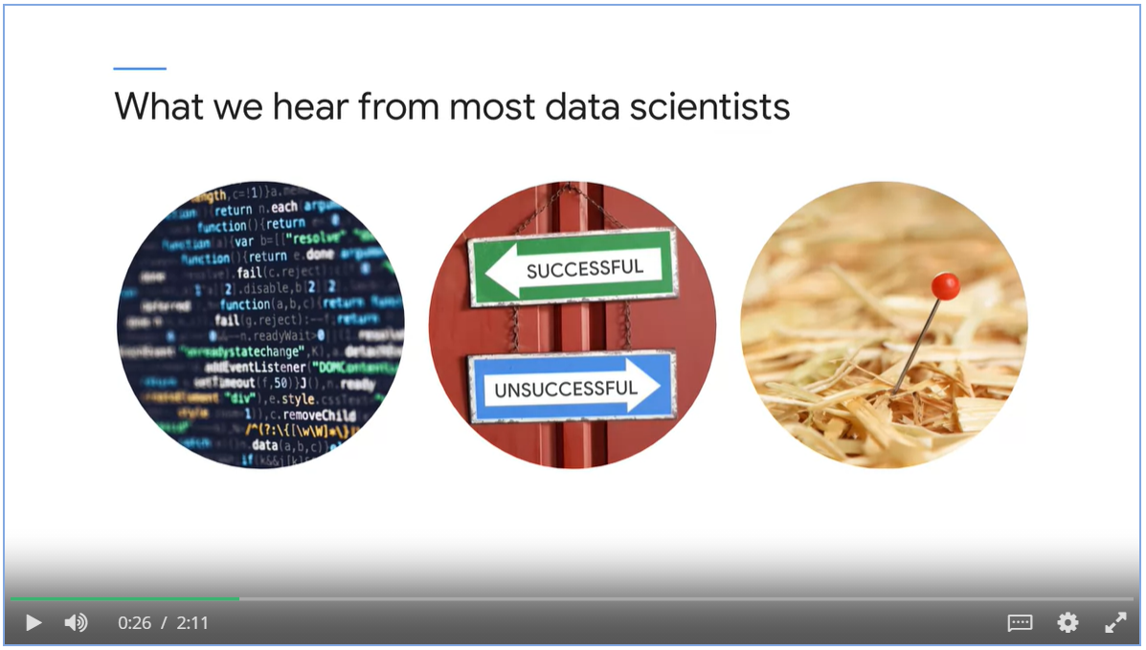

* Exam a machine learning system in the role as an operation person.
* Balancing time, resource and quality throughout the whole system.

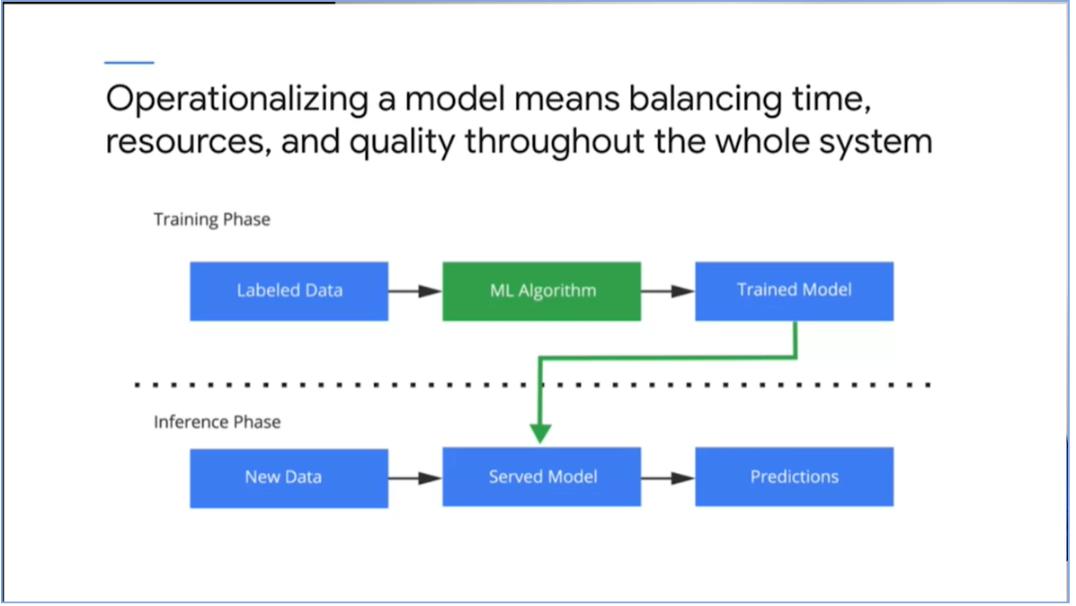

### Machine Learning Life Cycle

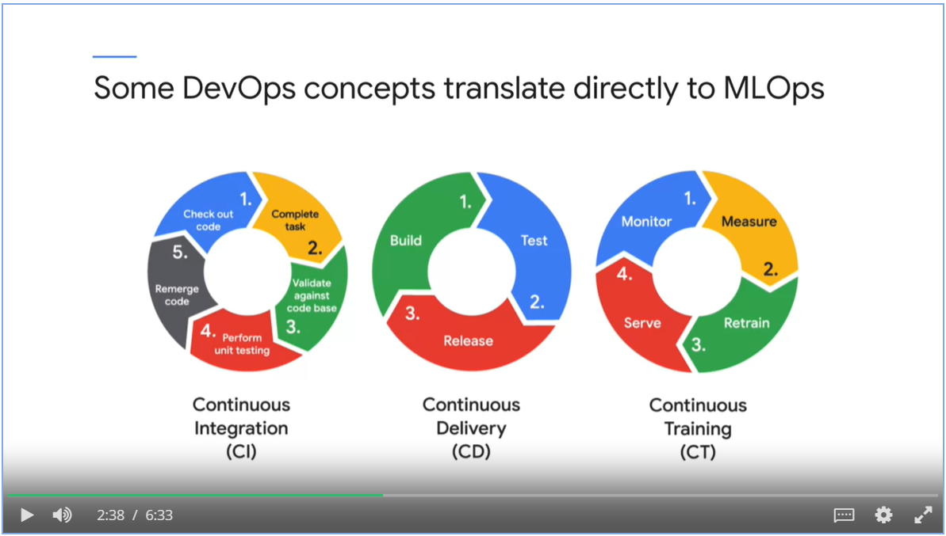

### MLOps differs from DevOps

* Not only testing and validating code, but also data, data schemas and models
* Consider the whole training pipeline
* Constantly monitor, retrain and serve the model

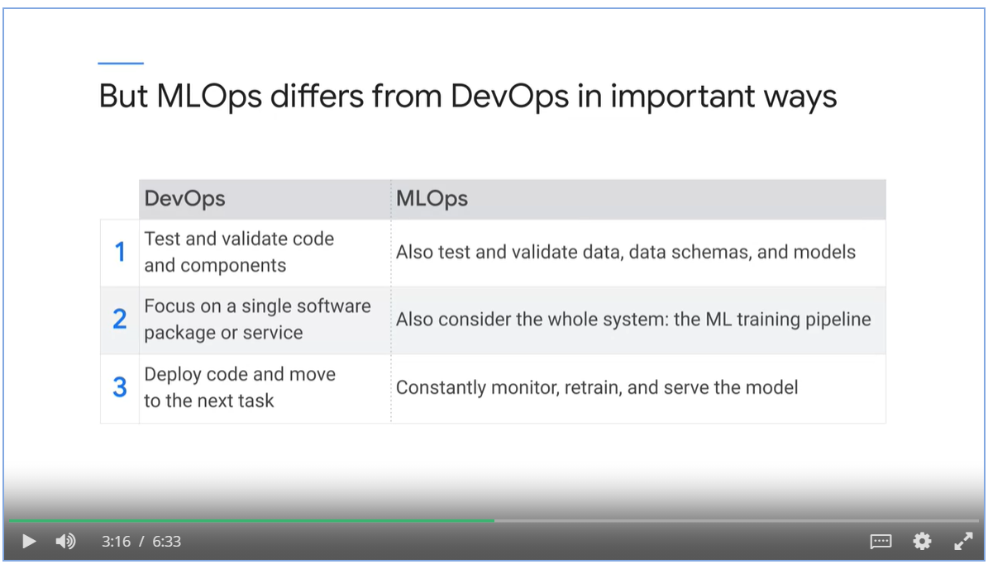

### ML systems can easily build up technical debt

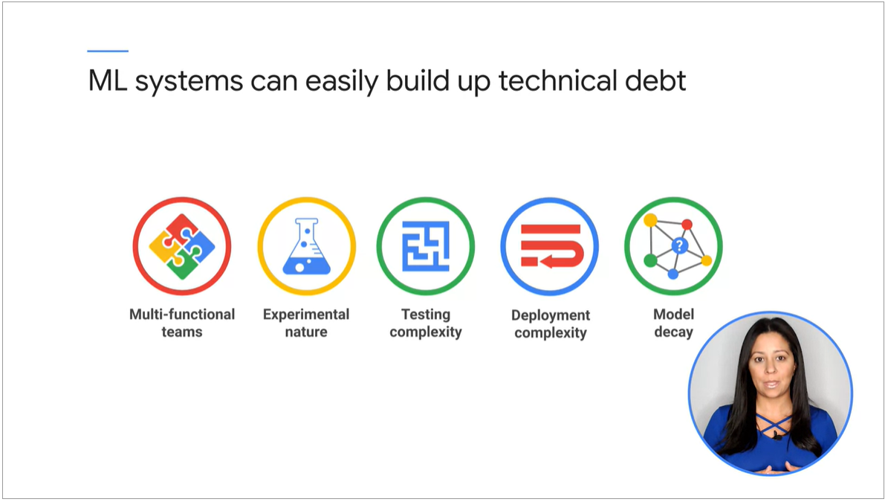

Phases of a machine learning project

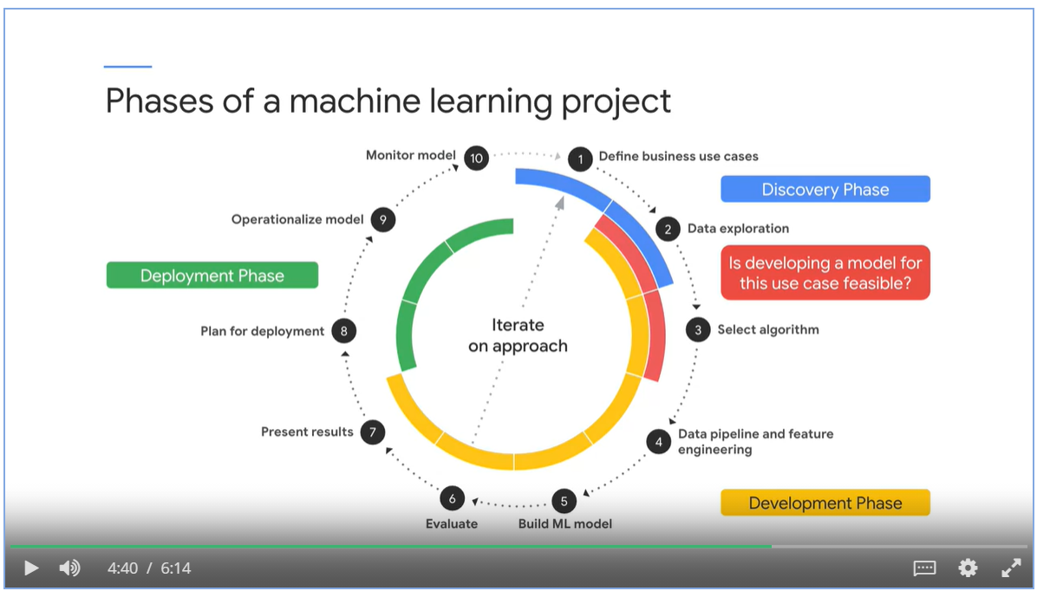

An ML pipeline contains well defined processes

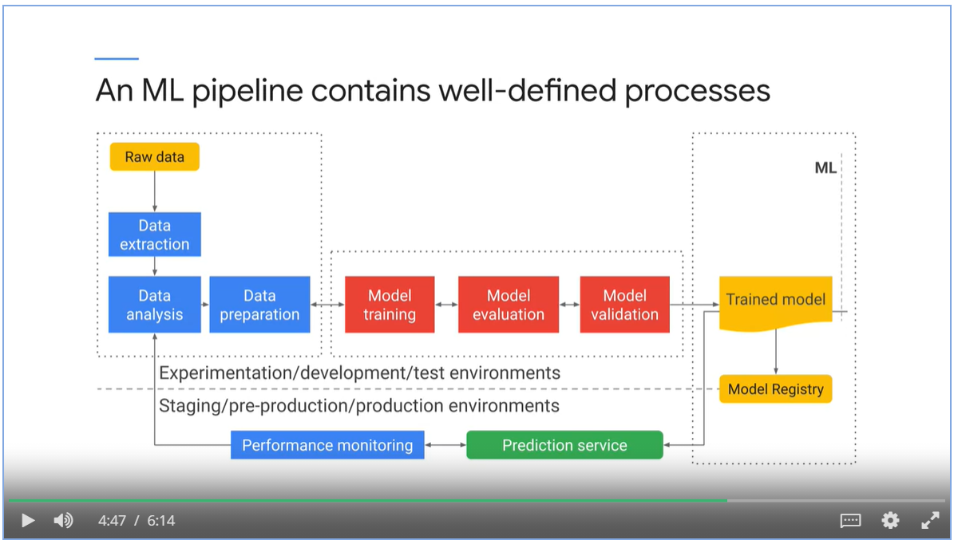

### Level of automation in ML projects

* Build and deploy manually
* Automate the training phase
* Automate training, validation and deployment

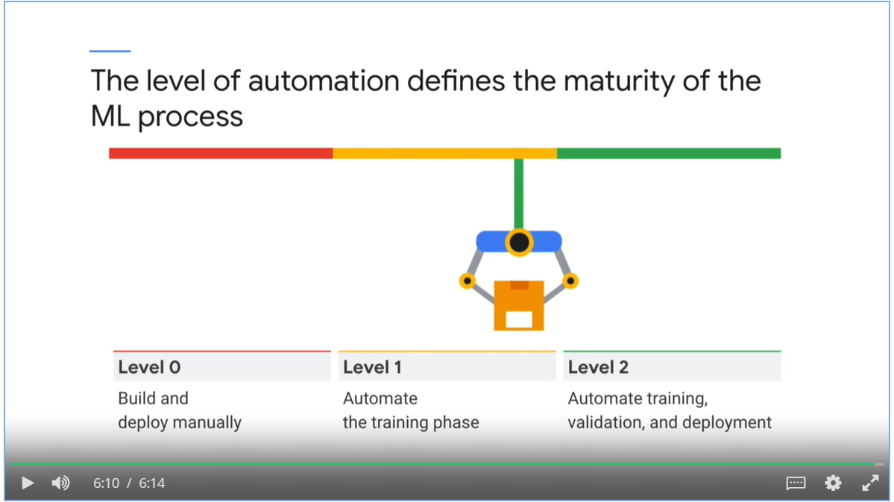

## Week 1: Introduction to Containers and Kubernetes

### Introduction to Containers

* Virtualization enables running multiple virtual servers and operating systems on the same physical computer.
* A hypervisor is a software layer that breaks the dependency of an OS with its underlying hardware.
* The images of the virtual machines can easily be moved around from one physical hardware to another.
* However, the application, dependencies and the kernel are still bundled together, hard to move it from one hypervisor product to another.

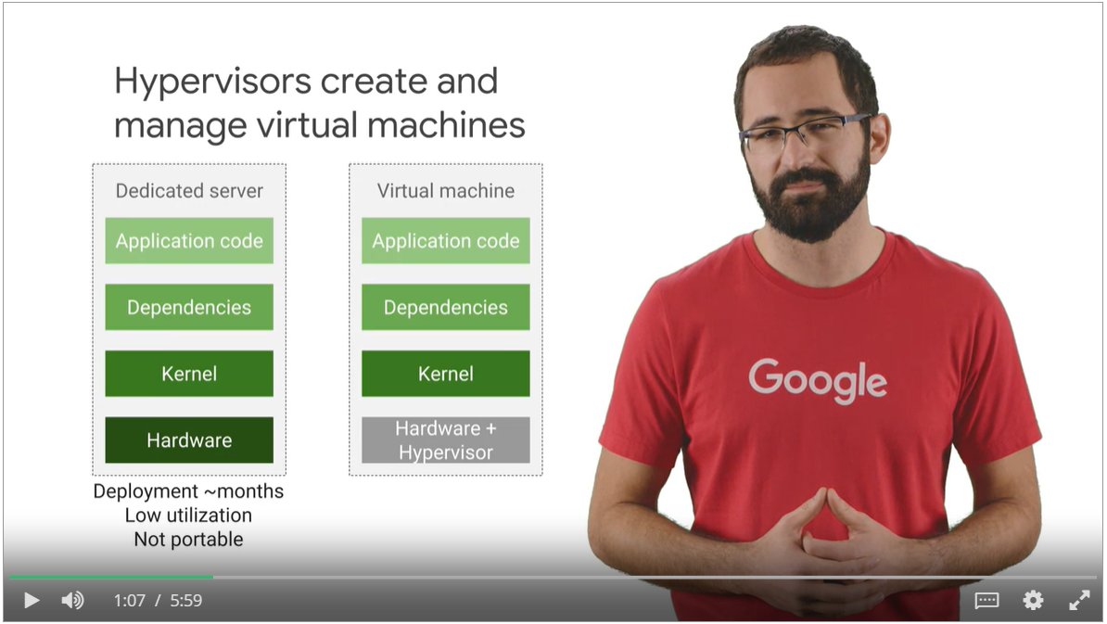

* Multiple apps run on same machine
* One app can starve out resources from another app
* Dependencies are mixed up

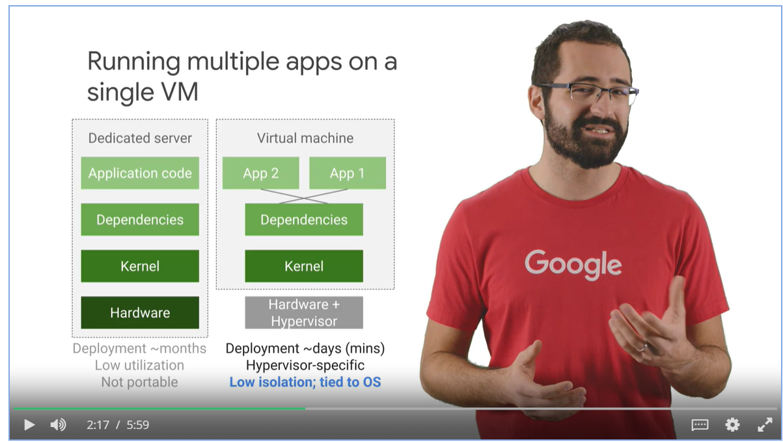

* One virtual machine per application
* Kernels are duplicated, updating kernel takes times
* Slow to start up new VMs and boot new OS

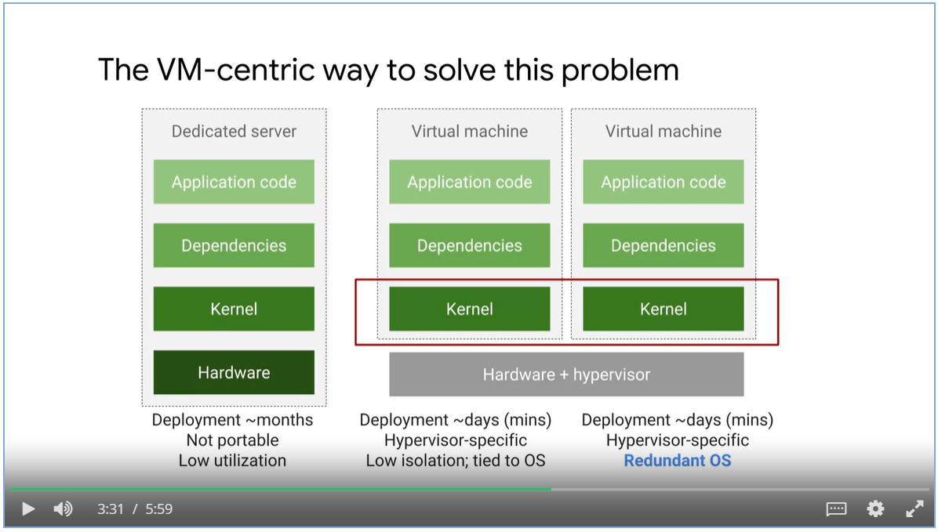

* Virtualize “User Space” only.
* A user space is all the code that resides above the kernel, including the applications and their dependencies.
* **Containers** are isolated user spaces per running application code.

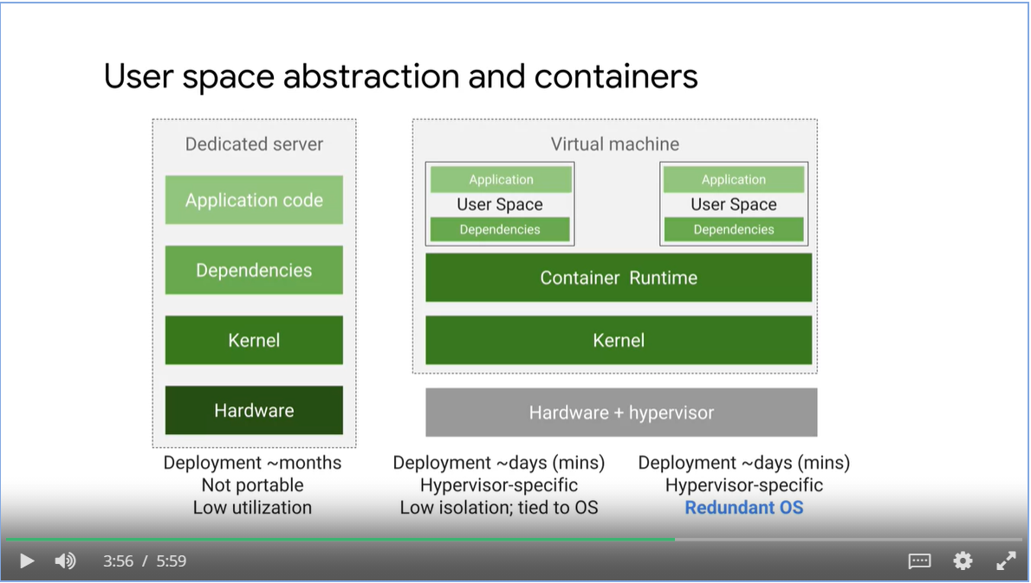

* Containers promotes app-centric development
* Developers don’t need to worry about software dependencies such as application runtimes, system tools, system libraries and other settings. The container execution engine makes it available for container images.
* Make incremental changes to a container based on a production image.
* Deploy quickly with a single file copy
* Align with microservice design pattern, that is, loosely coupled, fine-grained components.

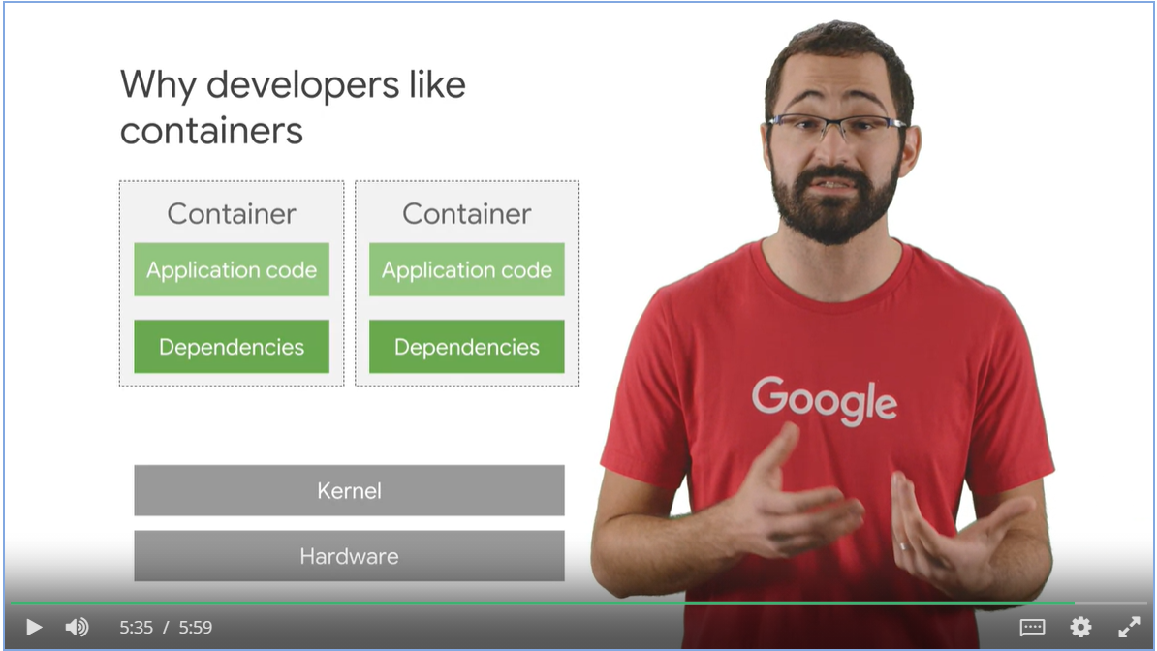

### Containers and Container Images

* Docker is tool that builds Container images
* It runs Container images
* Docker doesn’t offer a way to orchestrate those applications at Scale like Kubernetes does.
* Use Google Cloud Build to create docker formatted images.

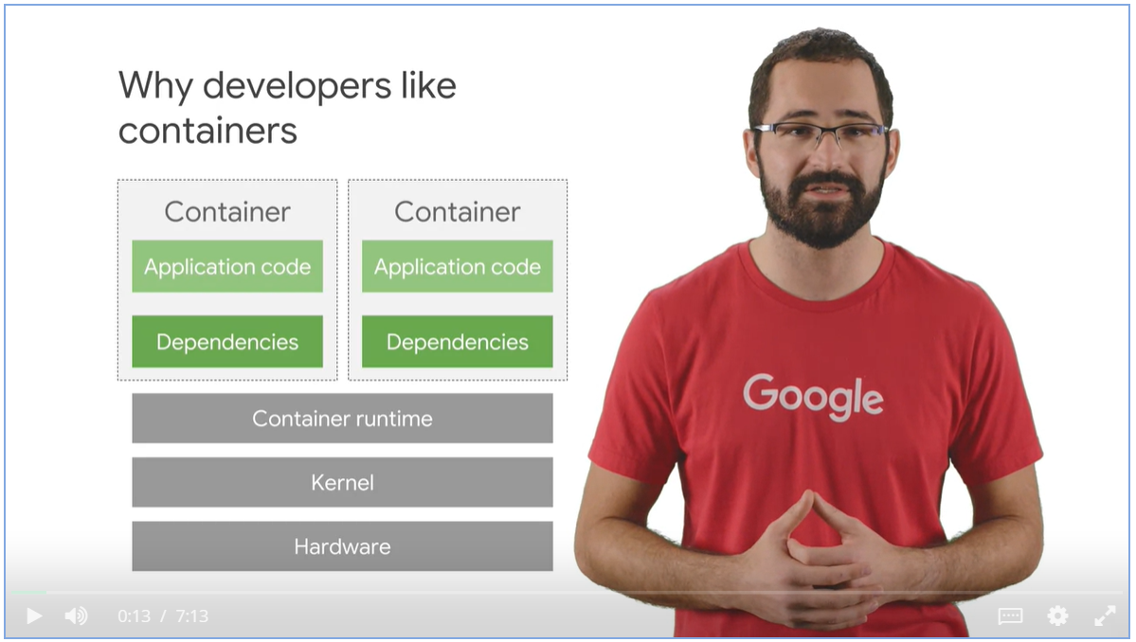

### Containers use a variety of Linux technologies

* Linux process, each has its own virtual memory address phase.
* Linux namespaces controls what an application can see, process ID numbers, directory trees, IP addresses and so on.
* Linux cgroups control what an allocation can use, its maximum consumption of CPU time, memory, IO bandwidth and etc.
* Union File systems efficiently encapsulate applications and their dependencies into a set of clean minimal layers.

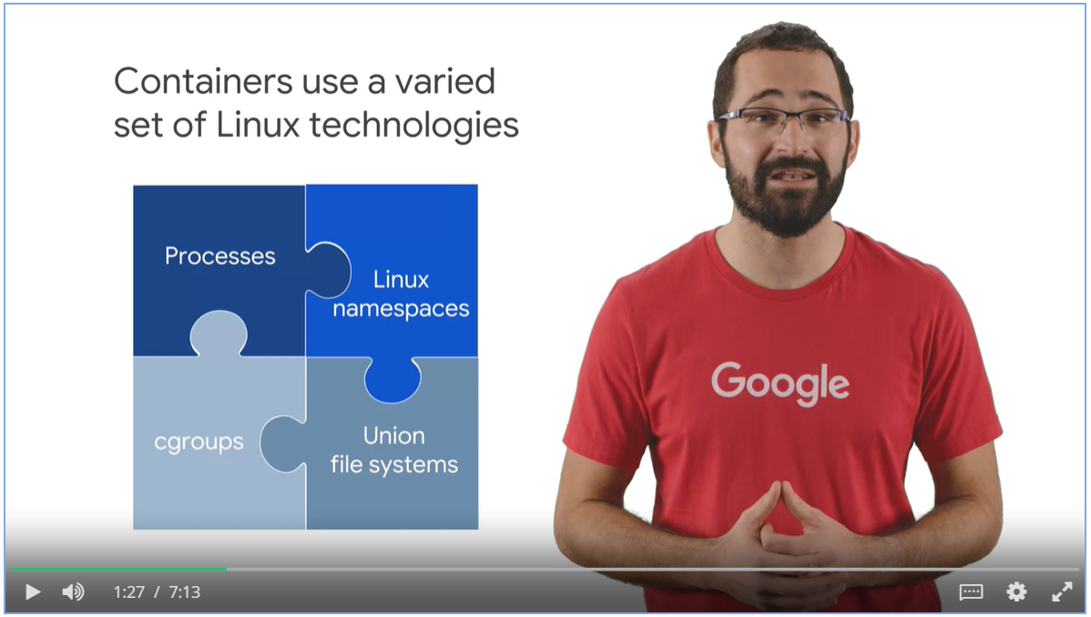

* Tools read from container manifest file and builds images in layered format.
* Each layer is read-only inside the image
* When running the image, it has a writeable ephemeral top-most layer.

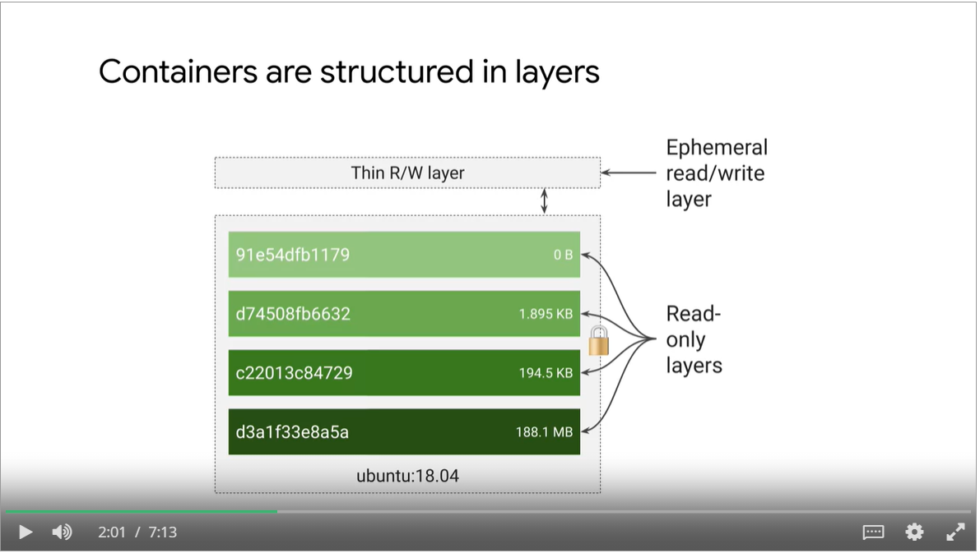

#### A Simple Docker Image

* Download ubuntu runtime, copy your application, compile your application, run your application
* We do not build container images by ourself
* Application packaging relies on a multi-stage build process in which one Container builds the final executable images. A separate container receives only what’s needed to actually run the application.
* The container runtime adds a thin writable layers and it is ephemeral, when the Container delete its content, the writeable layer is lost forever.

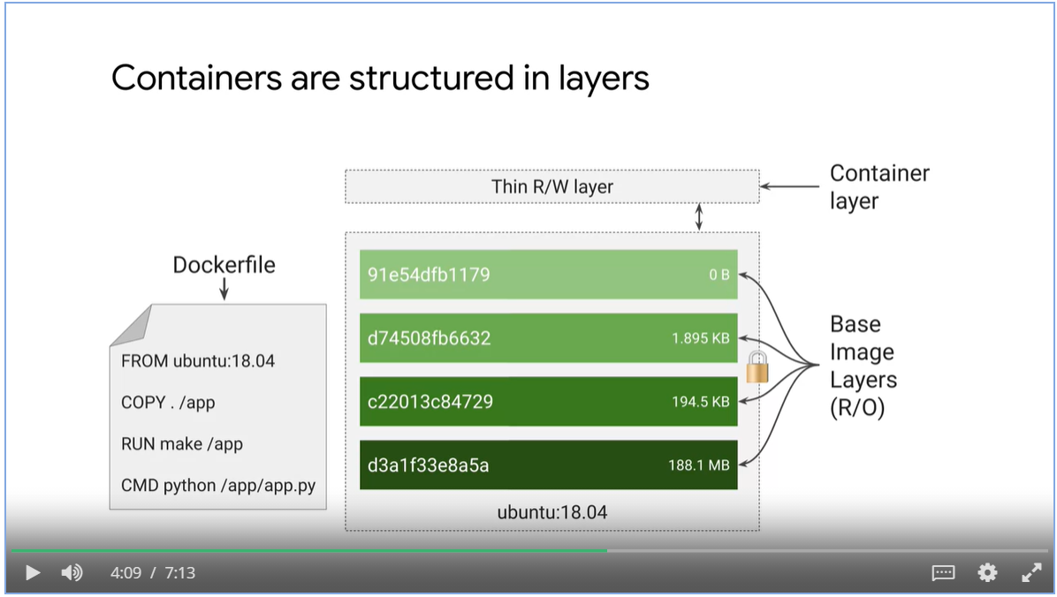

Containers promote smaller shared images

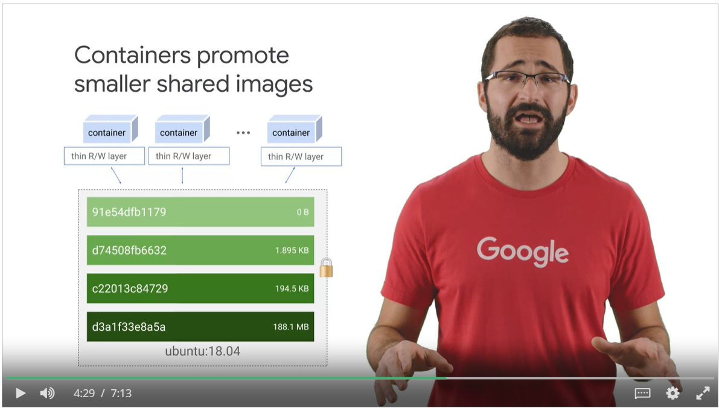

* Pull container images from a repository for unmodified use or start as a base for your own images
* Alpine is a popular Linux environment in a container, noted for being very small.
* NginX is a popular web server.
* Googles maintains a Container Registry, gcr.io.
  + Hosts open-source public images
  + Host private images integrated with Cloud IAM

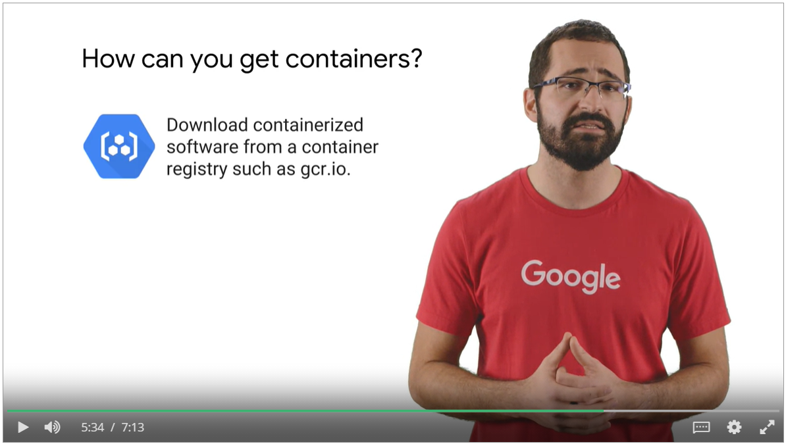

* Docker command is a popular why to build your own Container images
* However, you must trust the computer that you do your builds on.
* Google offer a managed service for building Containers that is integrated with Cloud IAM

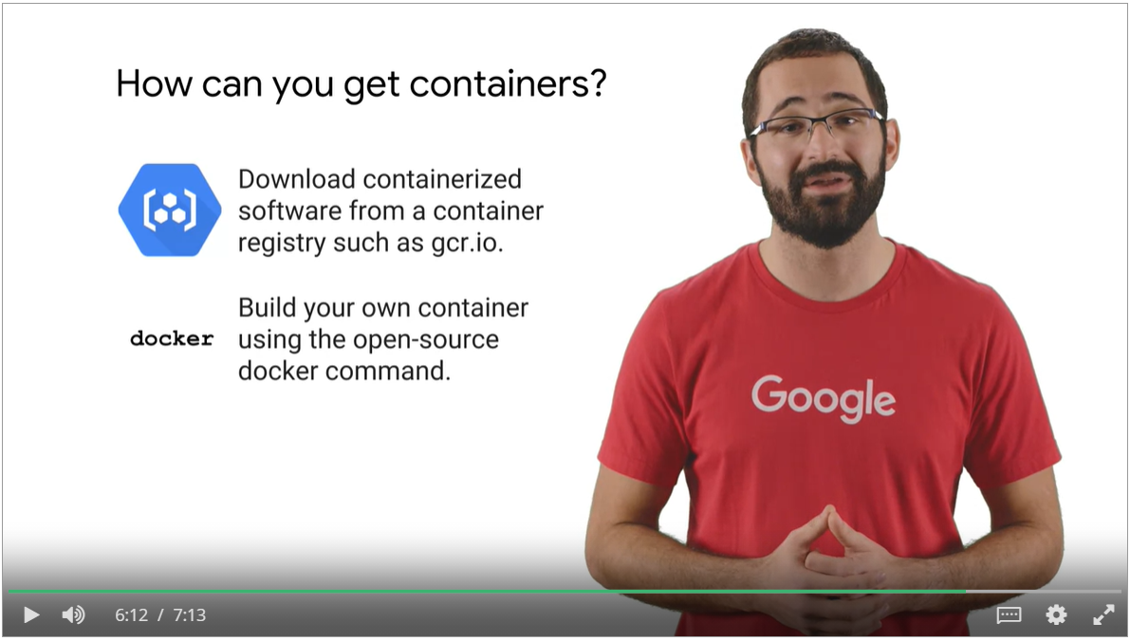

#### Google Cloud Build

* It fetches images from a variety of sources
* You configure build steps to fetch dependencies, compile source code, run integrated tests or use tools such as Docker, Gradle and Maven.
* Each build step and Cloud build runs in a Docker container.
* Then Cloud build delivery images to Cloud Functions, GKE and App Engine.

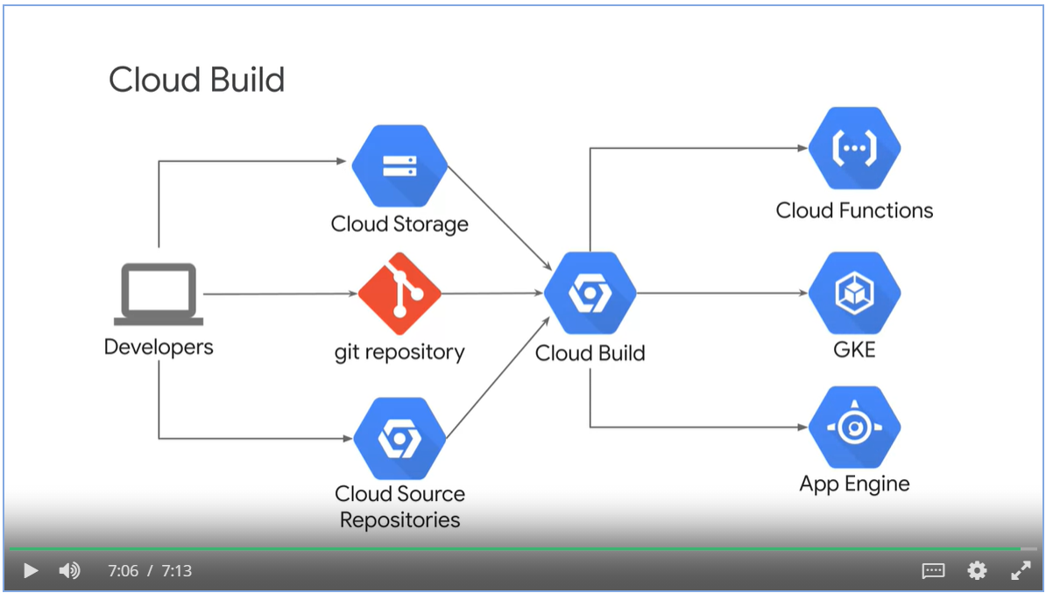

### Kubernetes for Container management

* Kubernetes is an open source platform that helps you orchestrate and manage your container infrastructure on-premises or in the cloud.

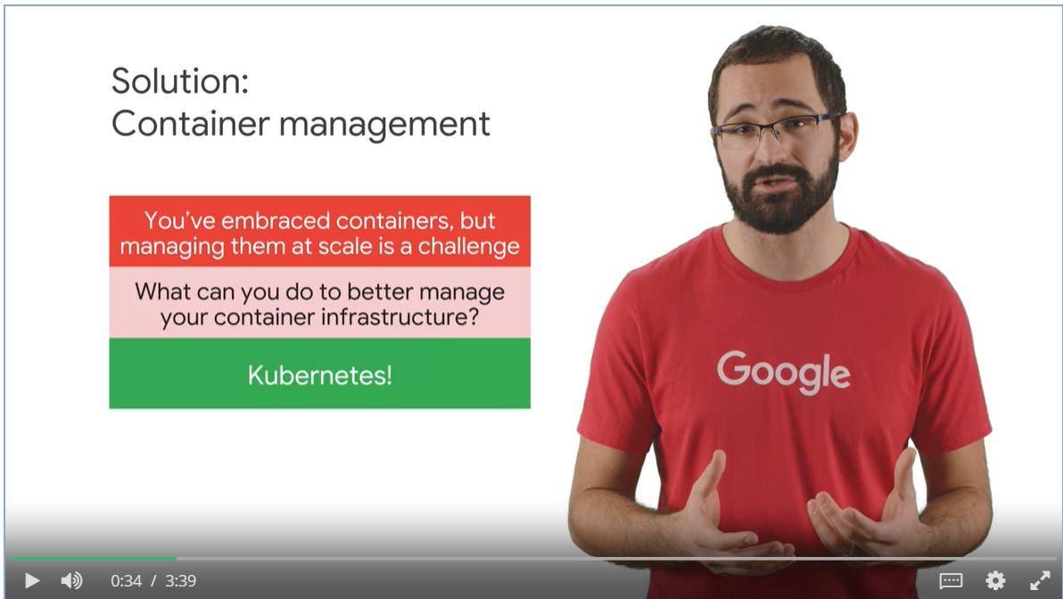

#### What is Kubernetes?

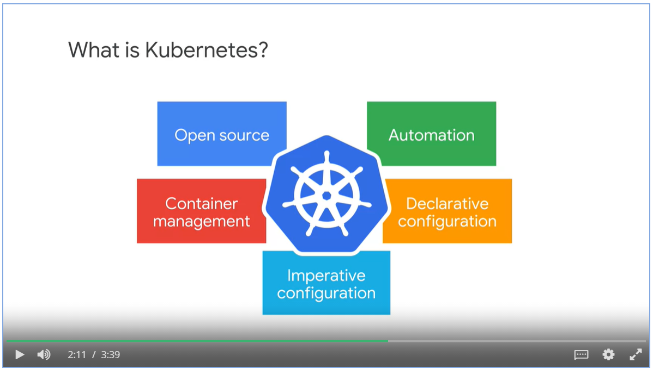

#### Kubernetes Features

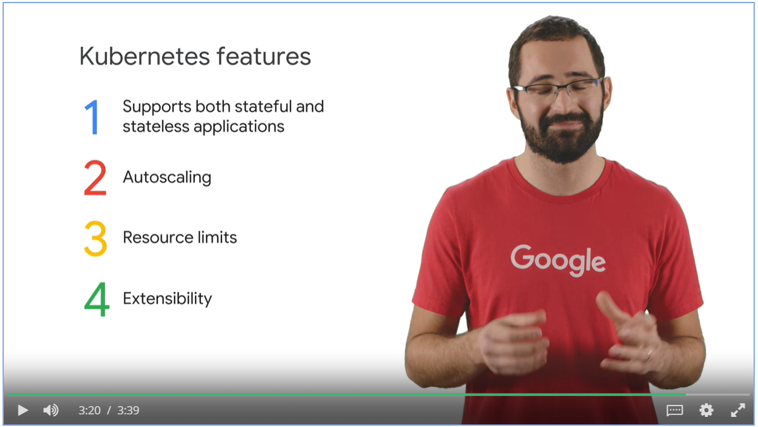

Google Kubernetes Engine

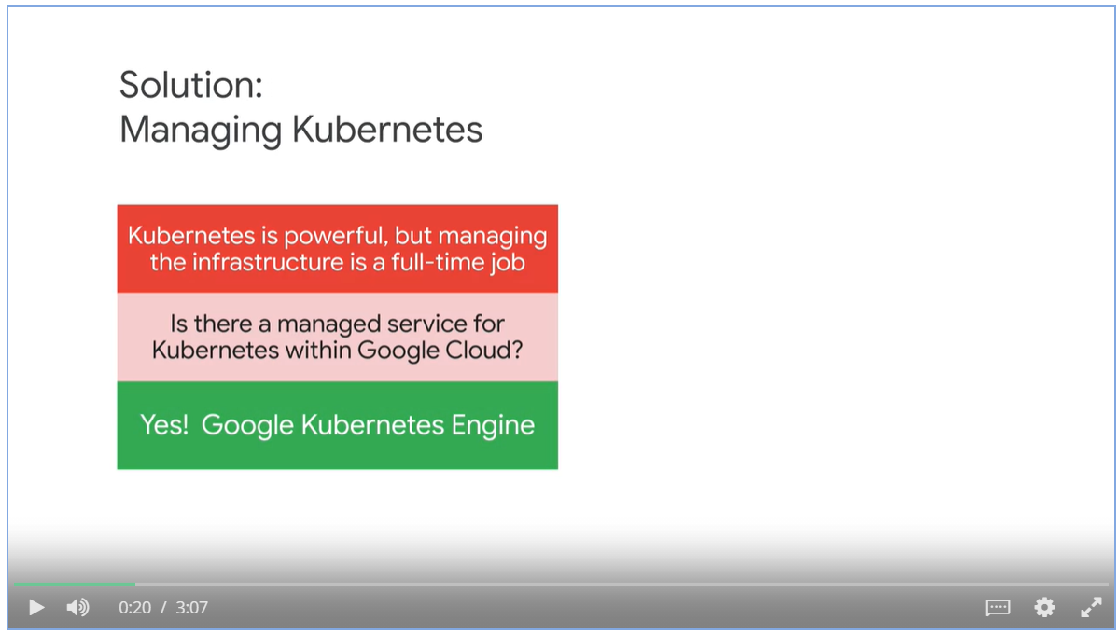

GKE is a component of the GCP component offerings.

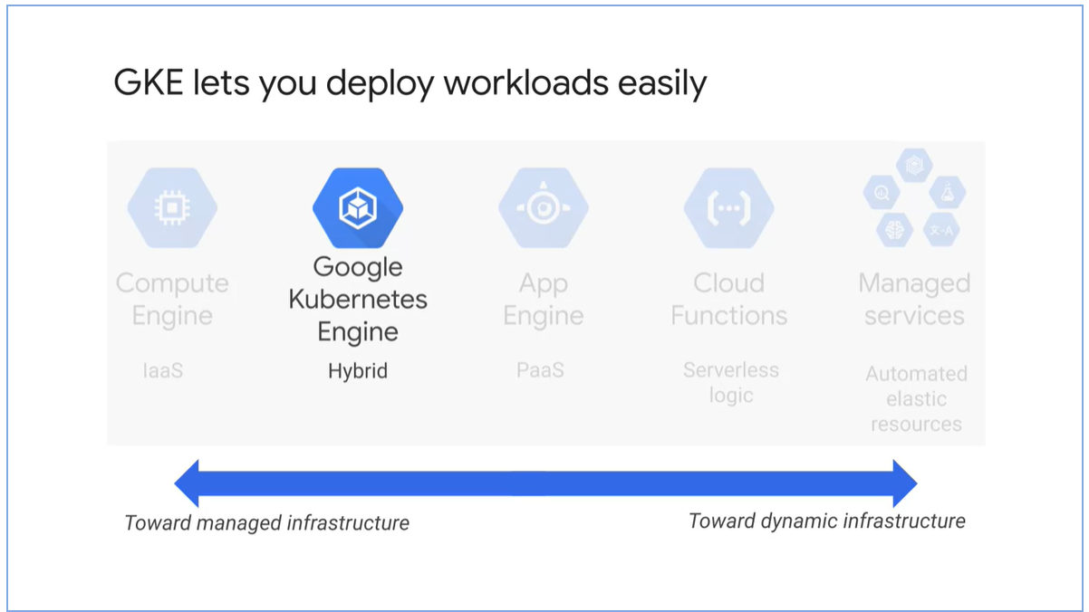

GKE features

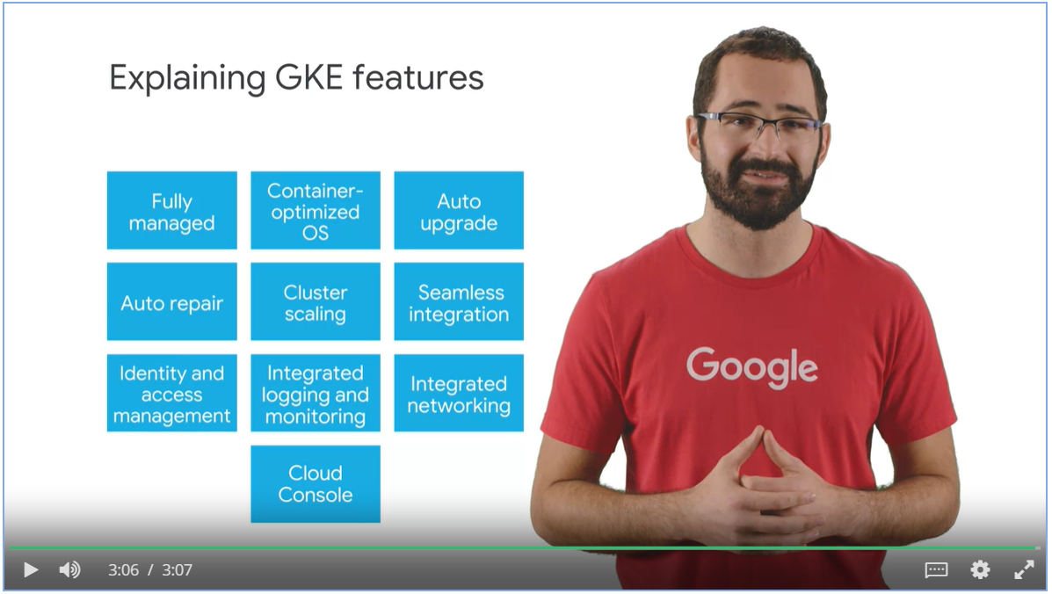

### Compute Options Detail

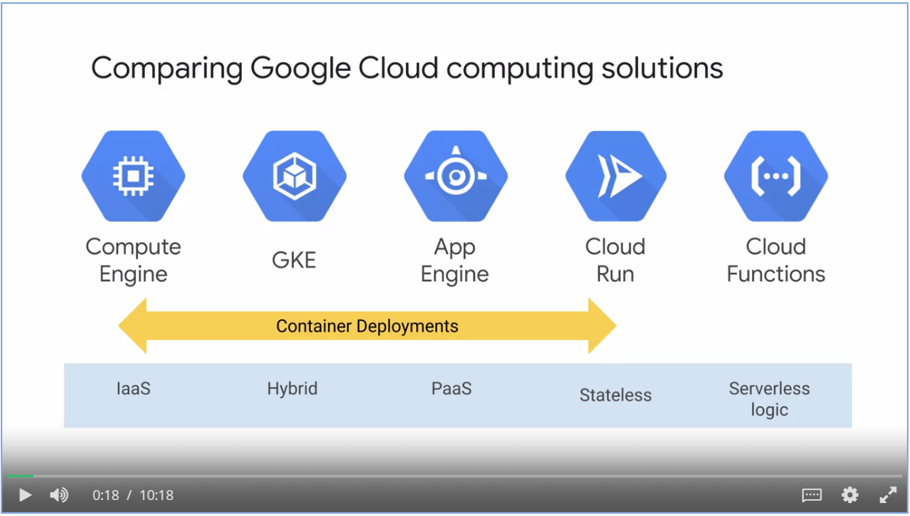

#### Compute Engine

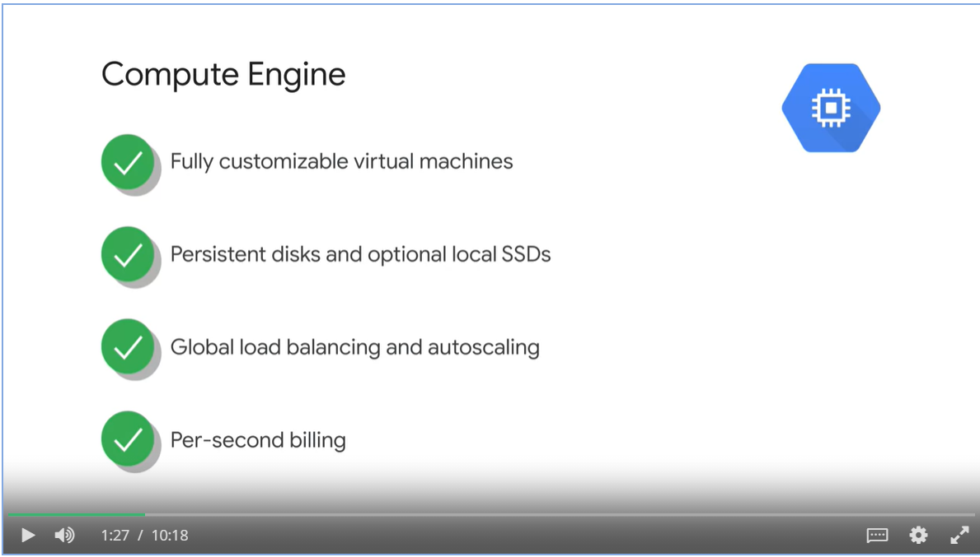

Use case

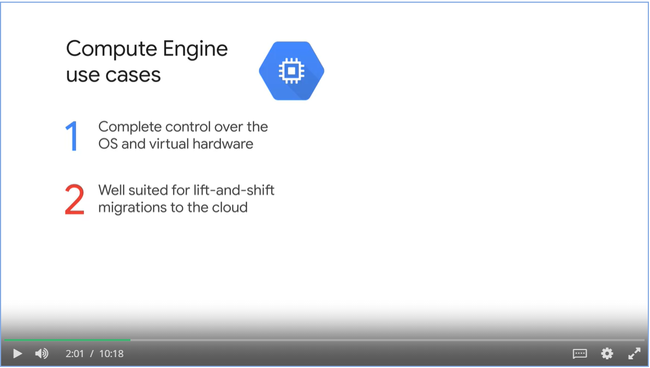

#### App Engine

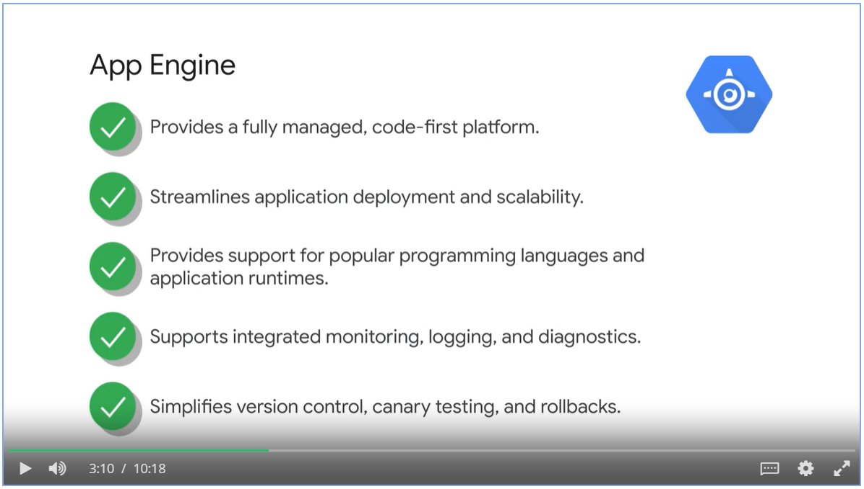

App Engine use cases

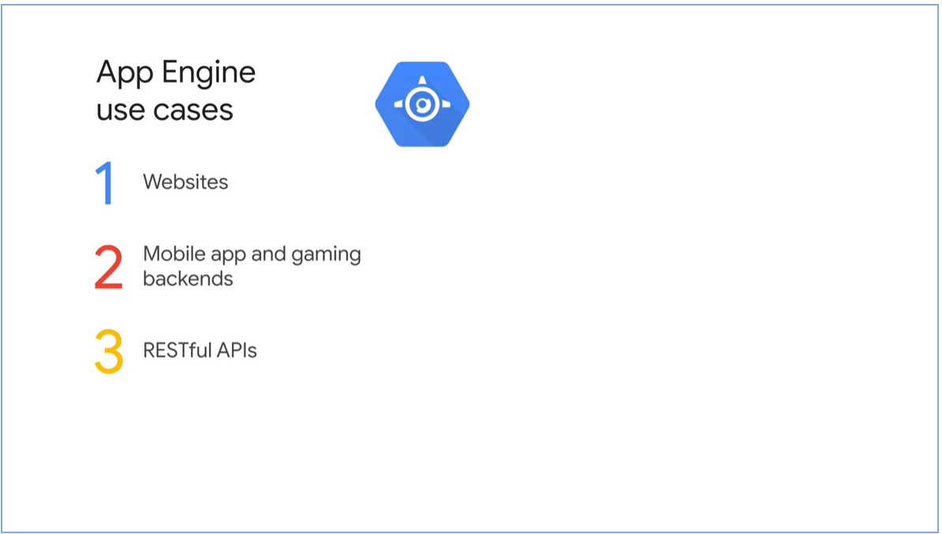

#### Google Kubernetes Engine

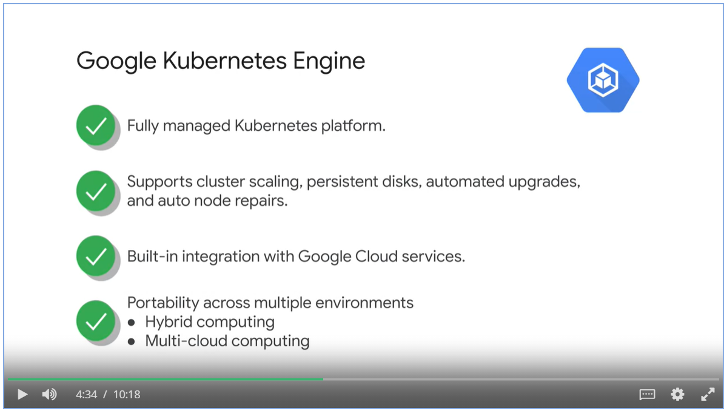

GKE use case

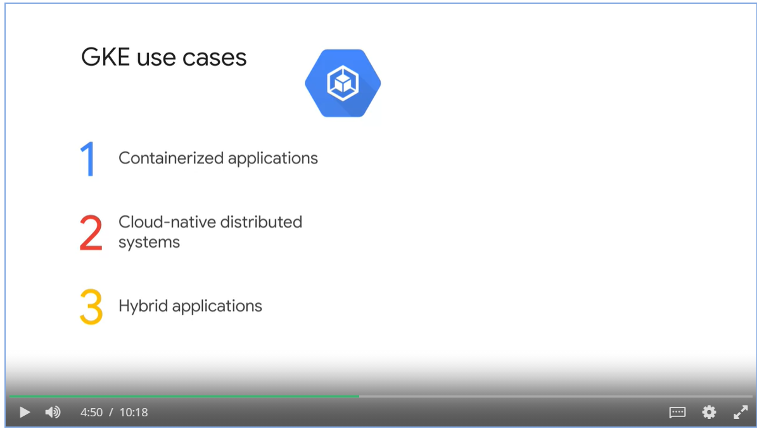

#### Cloud Run

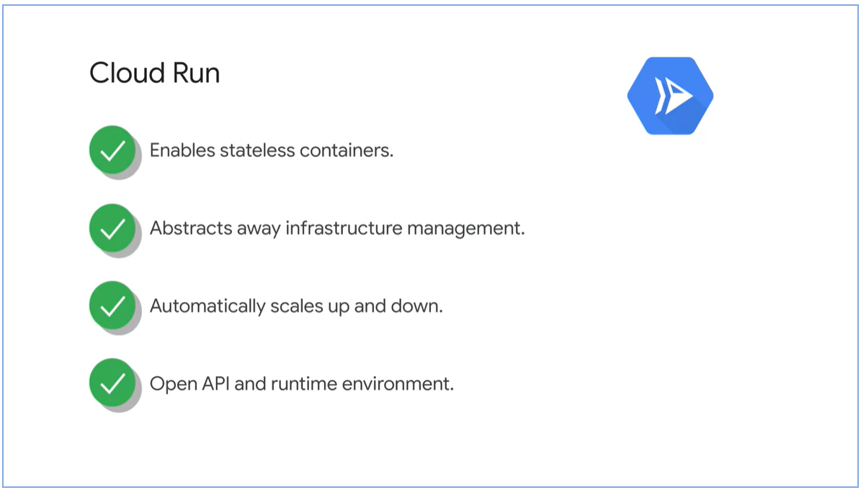

Cloud Run use cases

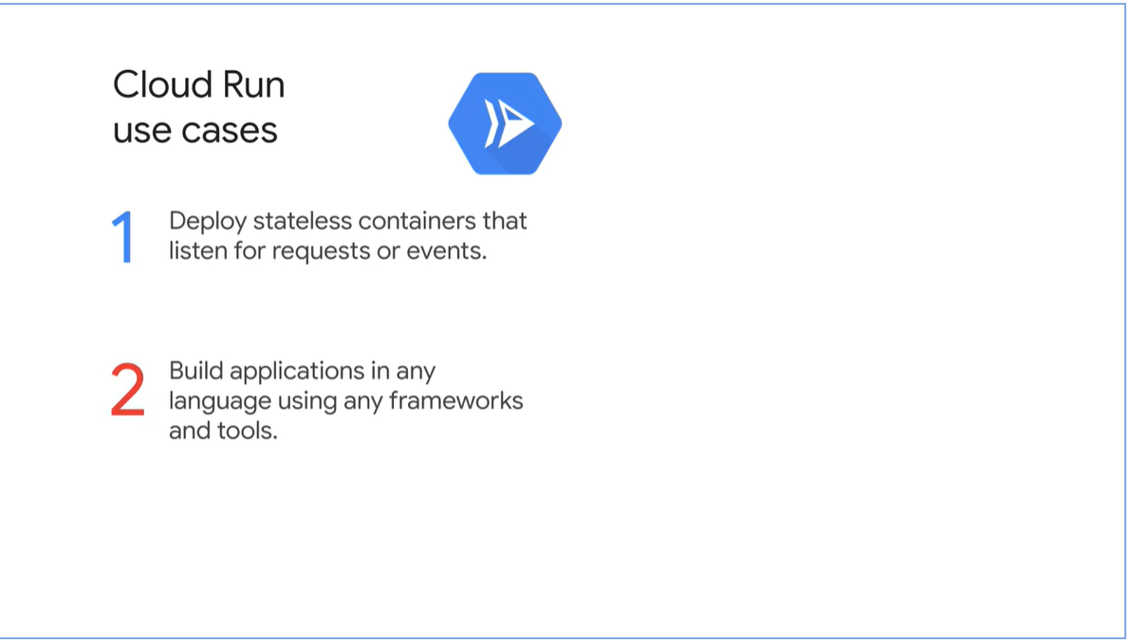

#### Cloud Functions

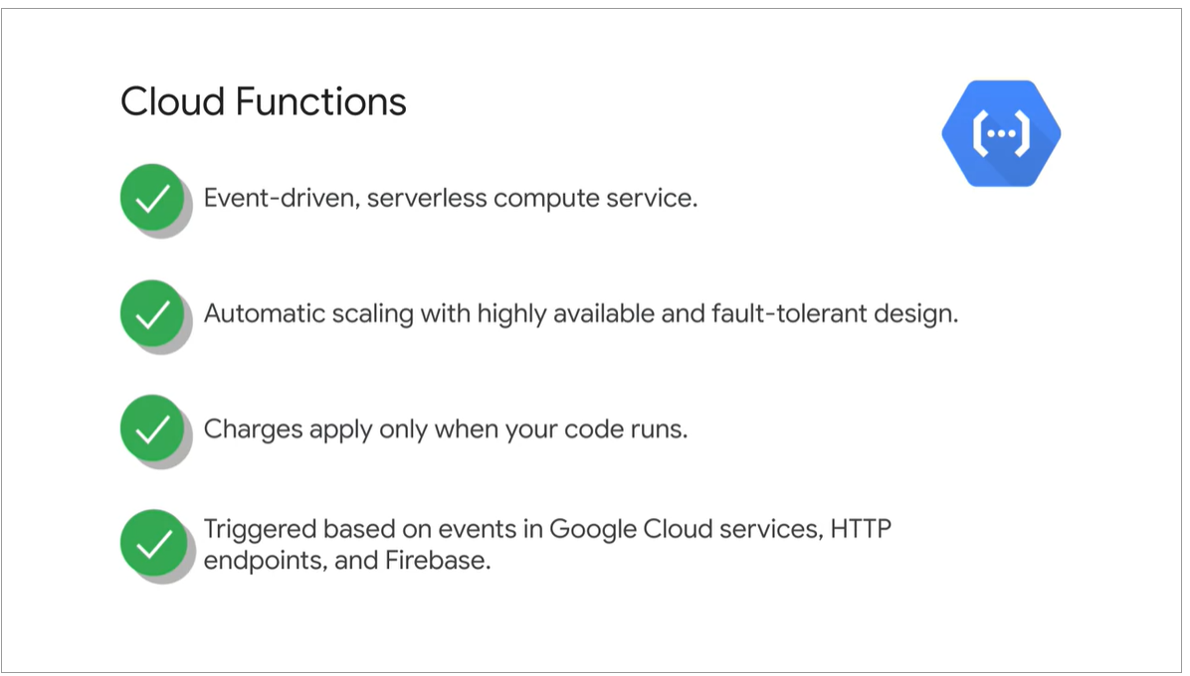

Cloud Functions use cases

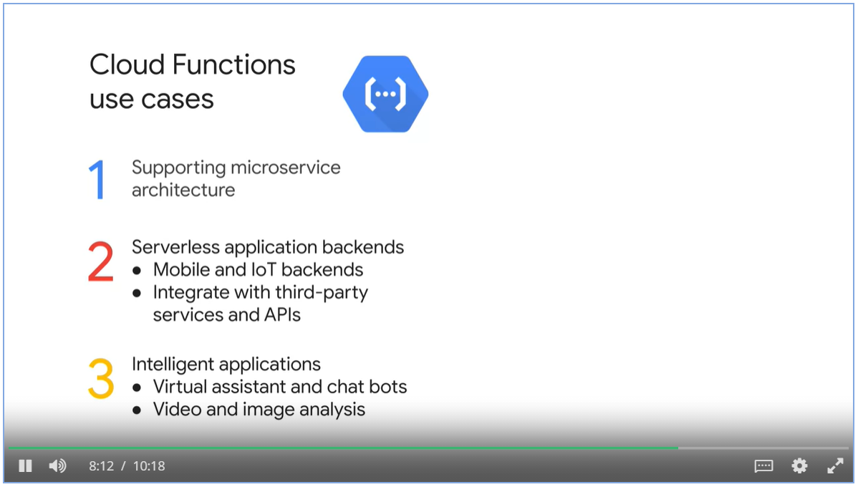

#### How to decide?

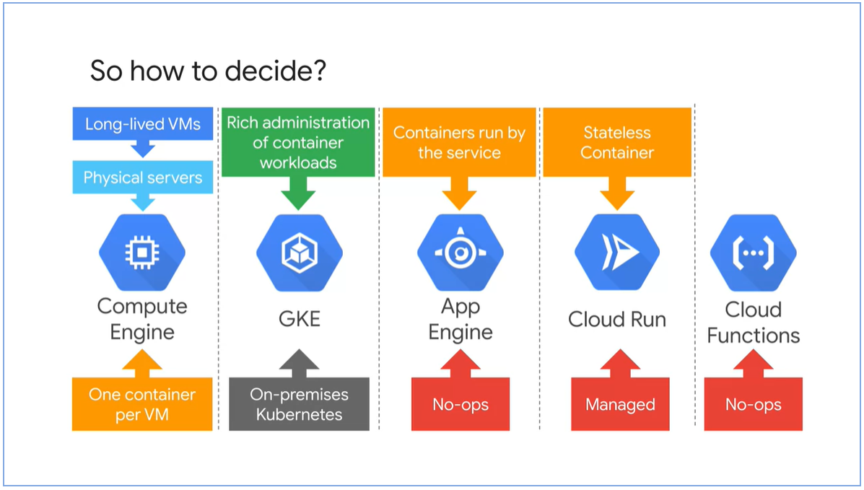

## Week 1: Kubernetes Architecture

### Kubernetes Concepts

#### Object Model and Declarative Management

* Kubernetes object is a persistent entity that represents the state of something running in a cluster.
* Object specs describes the desired state.
* Object status describes the current state.

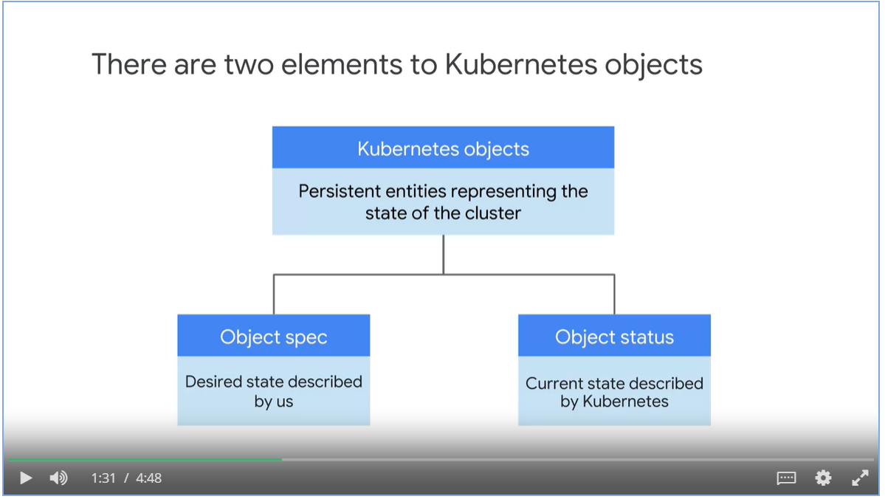

#### Pods

* Pods are the smallest deployable Kubernetes object.
* A pod embodies the environment where the container lives, one or more container can live in one pod.
* Each pod has a unique ip address, containers share the network namespace.
* Storage can be shared by containers live in the same pod. Storages can be shared across pod.

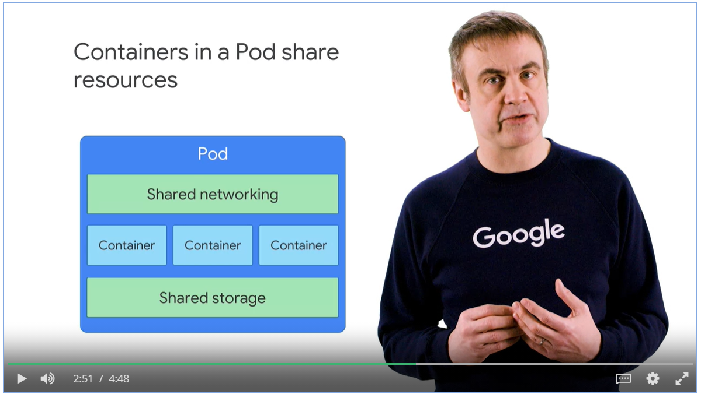

#### Example: Running three nginx containers

* You declare objects that represents 3 nginx containers
* Kubernetes launches those objects and maintains them.

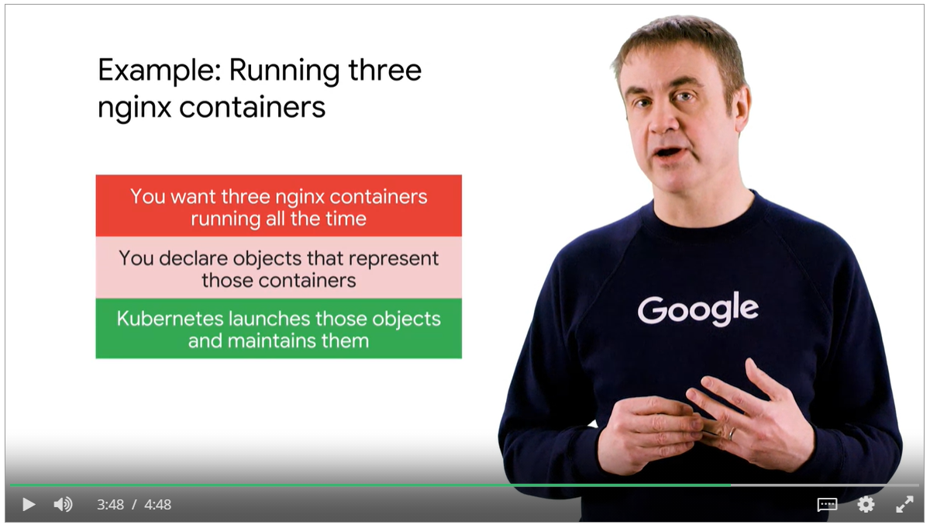

* Kubernetes constantly compares the current state with the desired state.
* Kubernetes Control Plane takes remediation actions so that the current state can match the desired one.

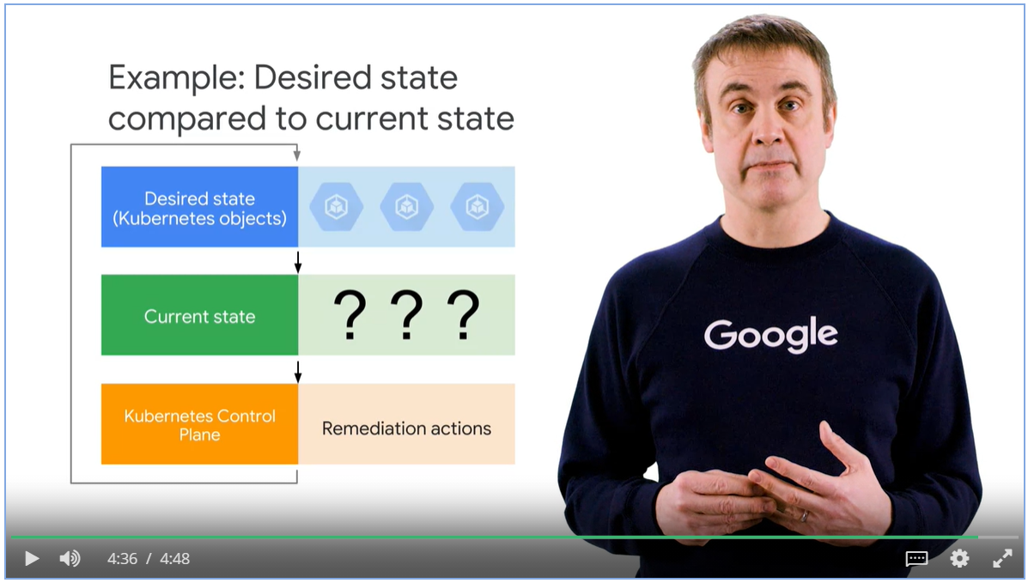

### Kubernetes Control Plan

* Master coordinates the cluster and nodes run pods
* kube-APIserver receives commands from kubectl, to view and change the state of the clusters, including launching pods.
* Etcd is the cluster’s database. It stores the state of the cluster. You don’t interact with etcd directly, but instead using kube-APIserver.
* Kube-scheduler is responsible for scheduling pods onto the nodes.
  + Choose nodes for pods based on the defined constraint
  + Memory constraint, version of software etc
  + Affinity specification, which cause groups of pods to prefer running on the same node, or vice versa

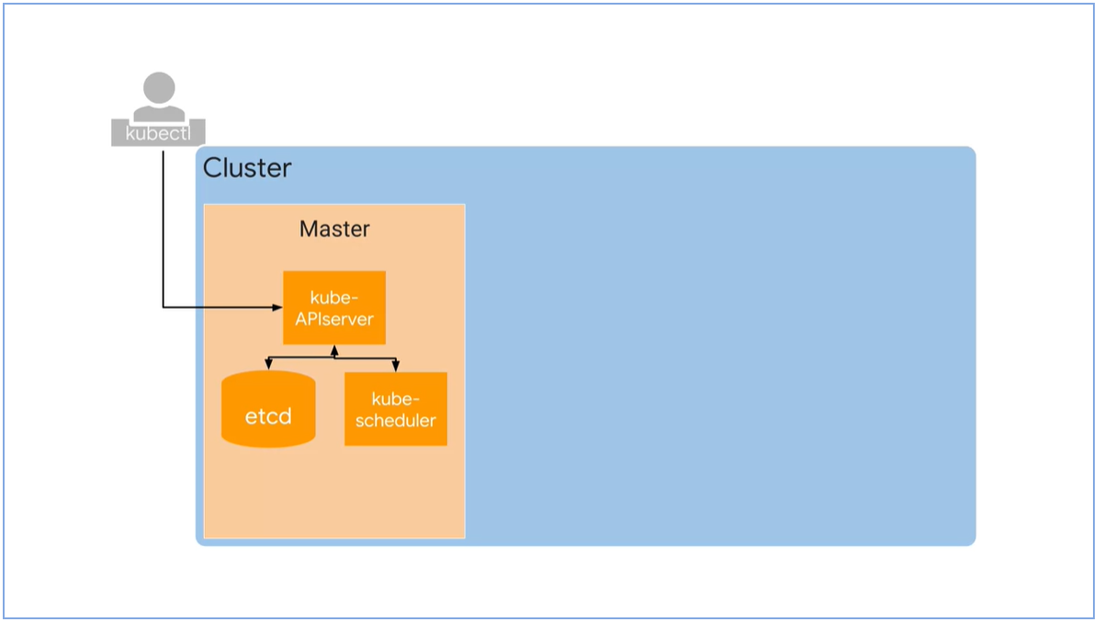

* Kube-controller-mangers monitors the state of the cluster, make changes to achieve the desired state.
* We use Kubernetes controllers to manage workloads, such as bringing pods into deployment and keep them running.

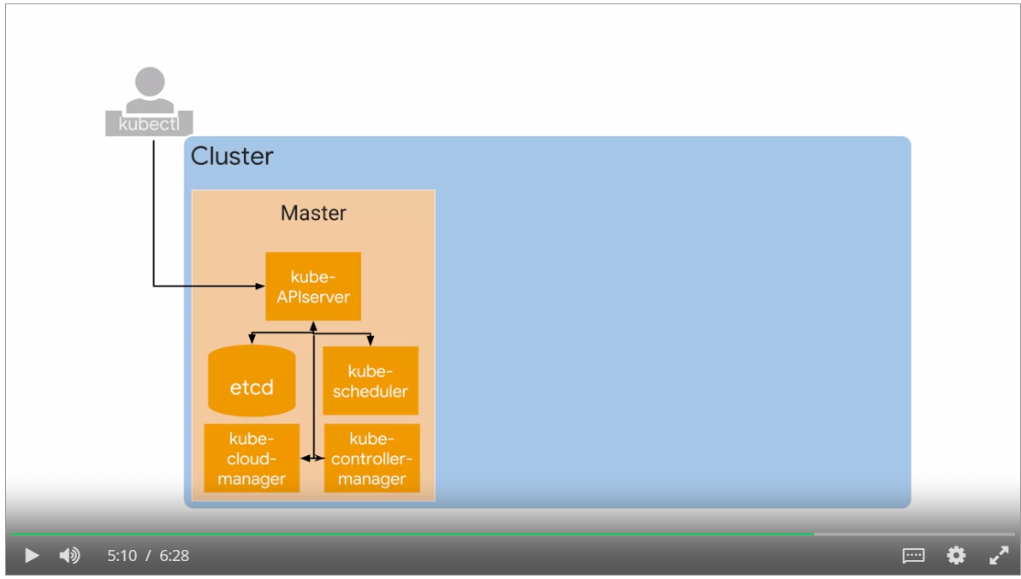

* Each node runs a small family of control-plane component too. For example, Kubelet.
* Kubelet acts as an agent. Kube-APIserver contacts the Kubelet to start a pod, Kubelet monitors and reports back to APIserver.
* Container Runtime is the software component that knowns how to launch a container from a container image.
* GKE uses container D, the runtime component of docker to launch containers.
* Kube-proxy’s job is to maintain network connectivity among the pods in a cluster.

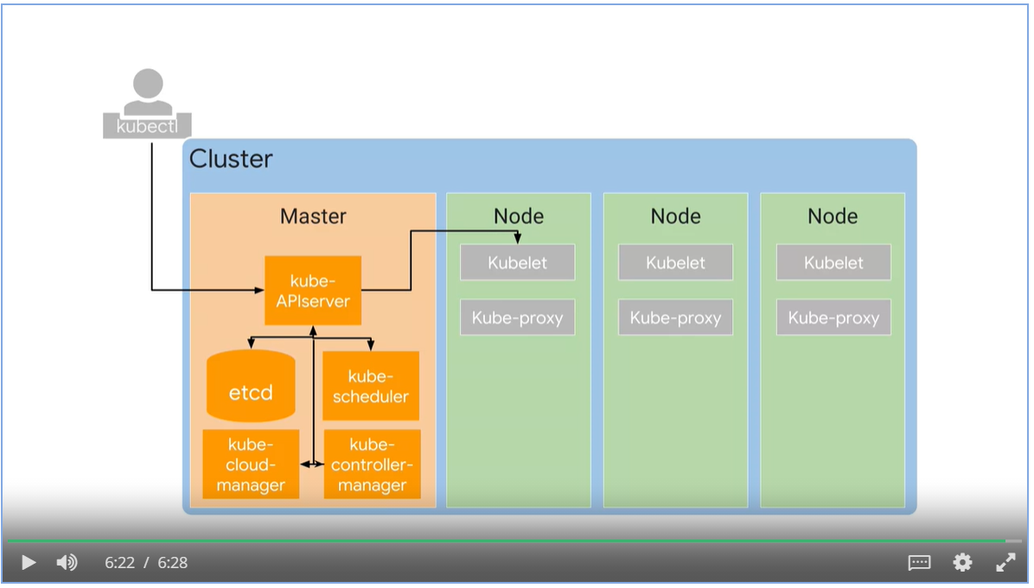

### Google Kubernetes Engine Concepts

#### GKE Abstractions

* GKE exposes an IP address to which we send all of our Kubernetes API requests.
* GKE take the responsibility for provisioning and managing all the master infrastructure behind it.
* GKE abstract away having a separate master.

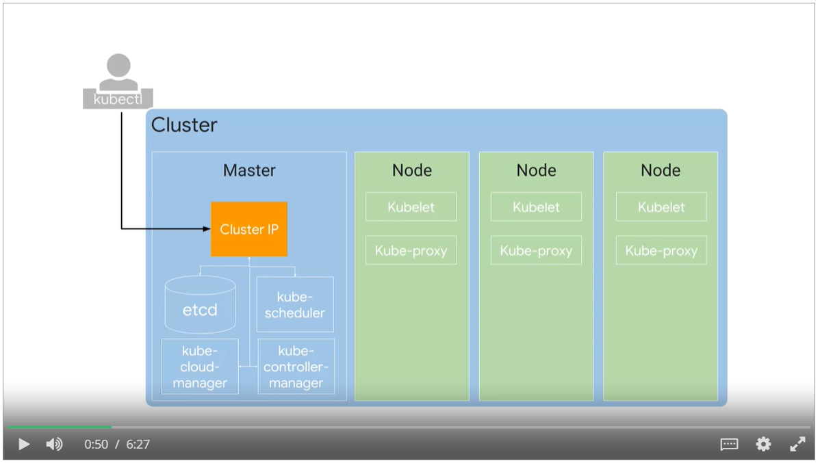

* Kubernetes doesn’t create nodes. Cluster admins create nodes and add them to Kubernetes
* GKE manages by deploying and registering Compute Engine instances as nodes.

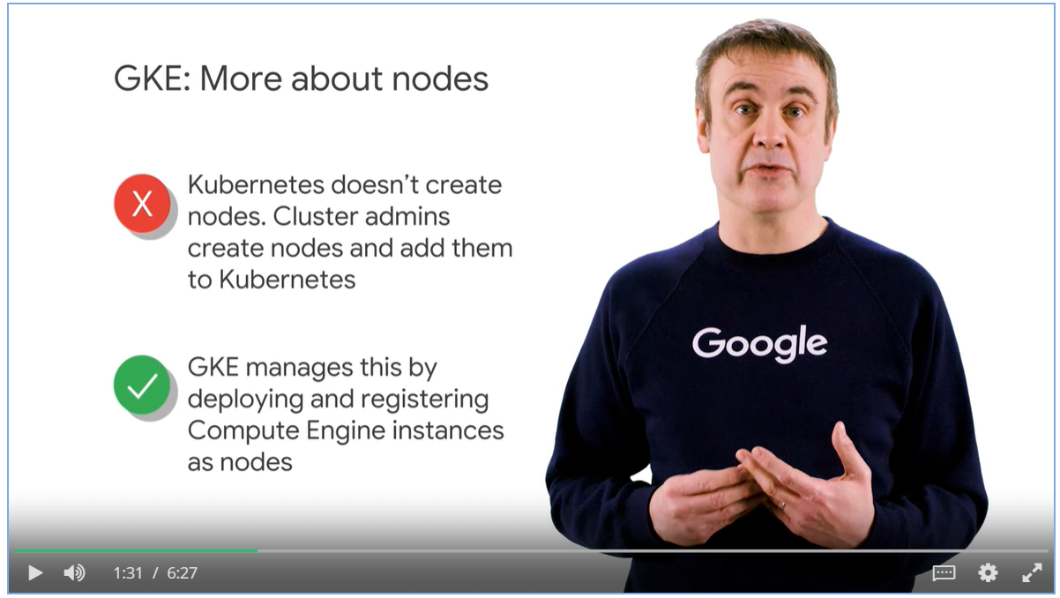

#### Compute Engine as Node

* Compute Engine instances are registered as node, you need to specify the machine types when creating nodes.

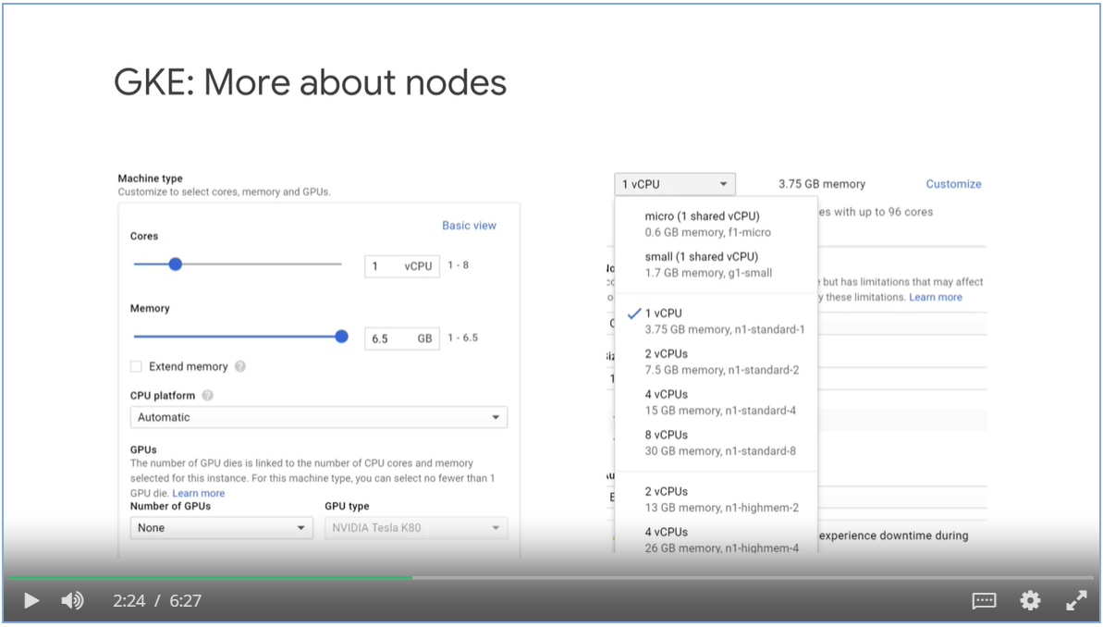

#### Node Pool

* You can assign several nodes with similar specs into a Node pool (a GKE feature, not Kubernetes)
* Enable automatic node upgrades, automatic node repairs and cluster auto-scaling on node-pool level

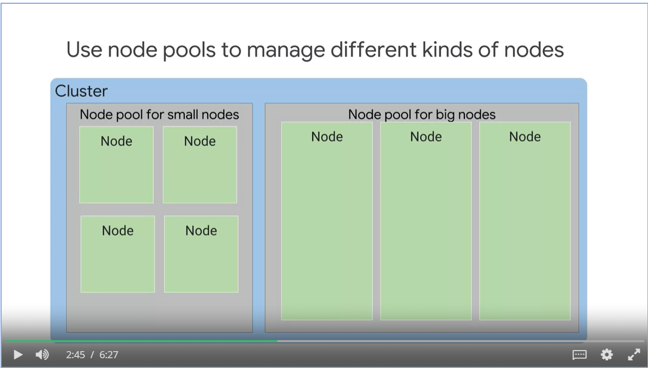

#### Regional Cluster

* By default, a cluster launches in a single GCP Compute Zone with three identical nodes, all in one pool.
* Use GKE regional clusters for better reliance and availability.

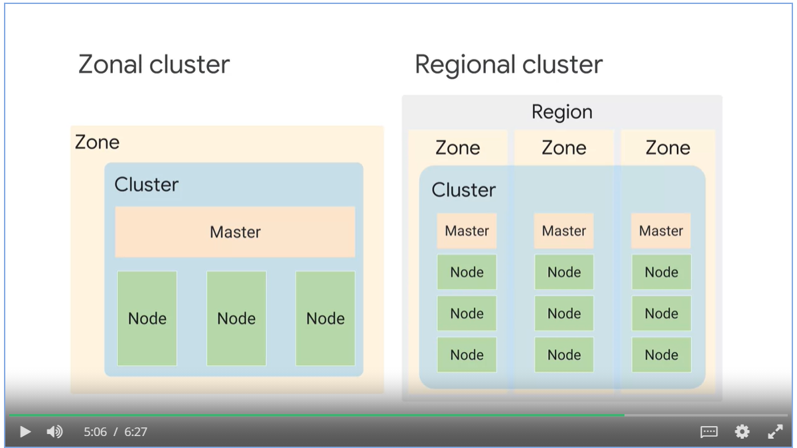

#### Private clusters

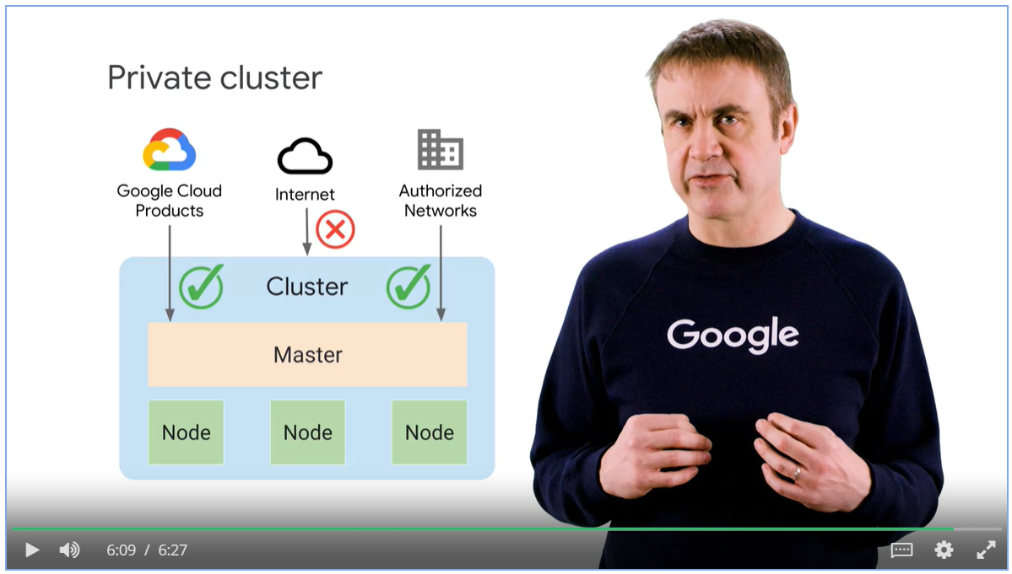

## Week 1: Deployments and Jobs

* Deployment describes the desired state of the pods.

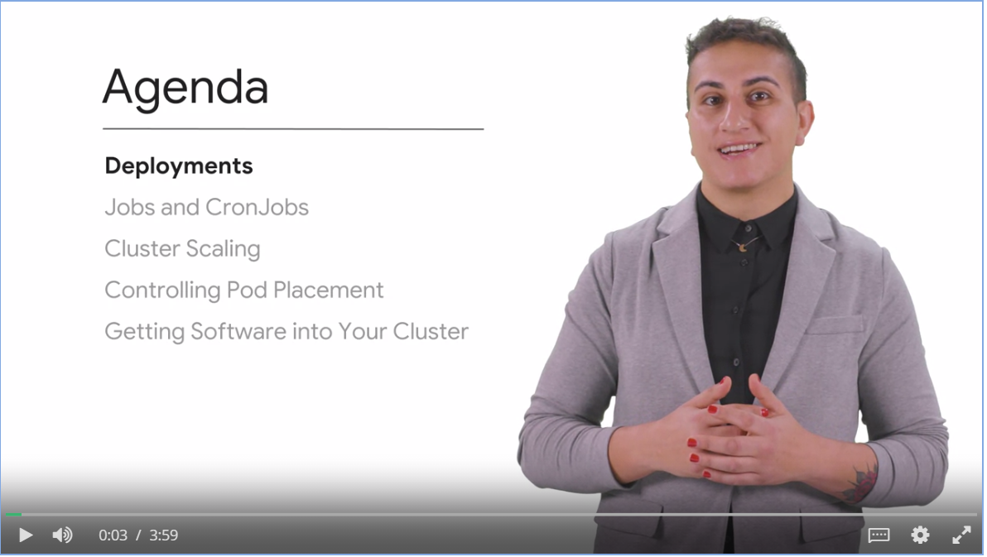

### Deployments

#### Deployment Usage

* Deployment declares a stat of pods. Every time you update the specification of the pods, a newer replica set is created to match the altered version of the deployment.
* If the newly created pods are unstable, we can rollback to previous revision.
* You can scale the pods manually or automatically.
* Well-suited for stateless applications.

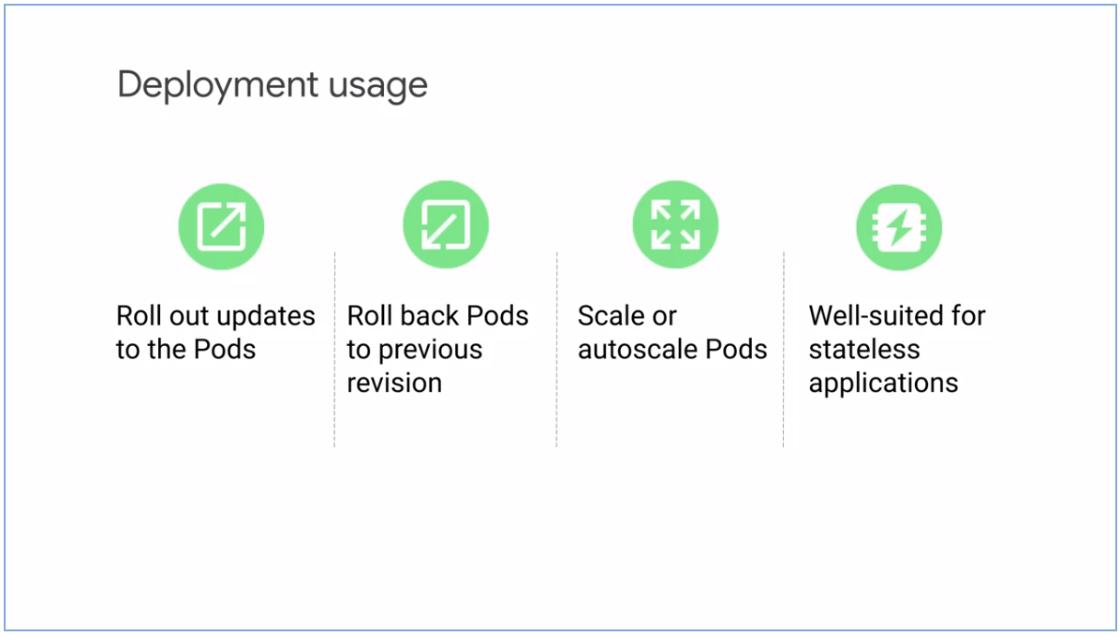

* Deployment .yaml file consists of the characteristics of the pod and how to operationally run these pods and handle their lifecycle events.
* After you submit the yaml file to Kubernetes Master, it creates a deployment controller.
* A controller is a loop prosses that takes care of meeting the desired state.
* A replica set is created to match the number of pods described.

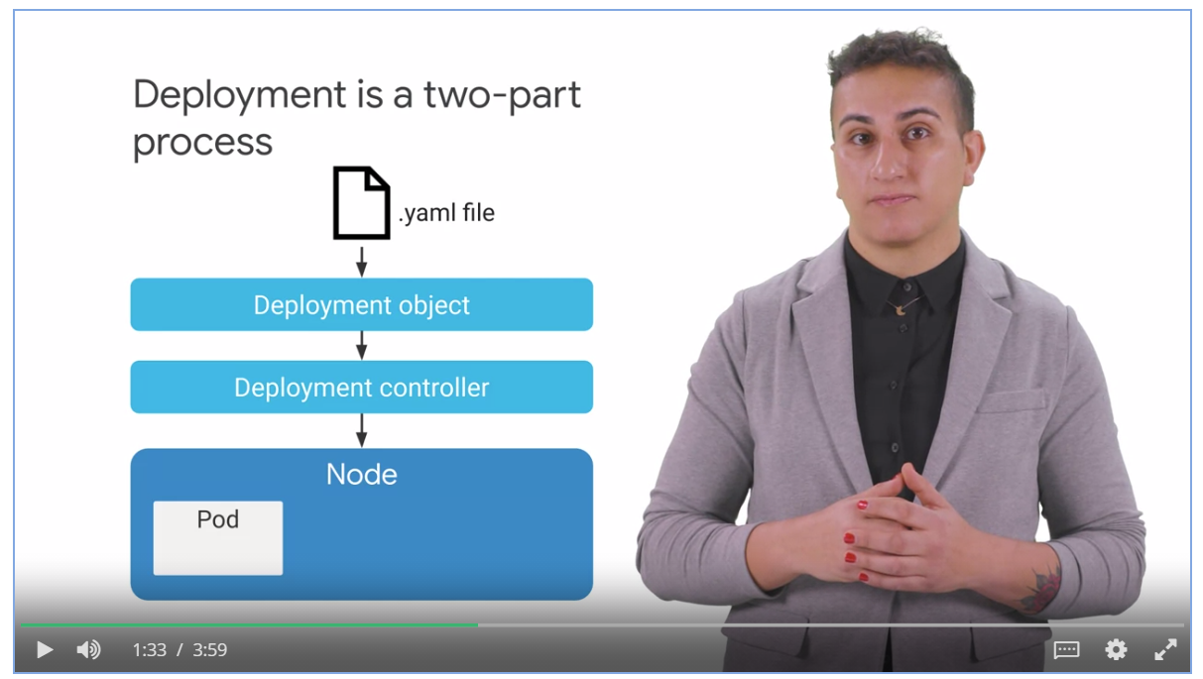

#### Example of deployment object file in YAML format

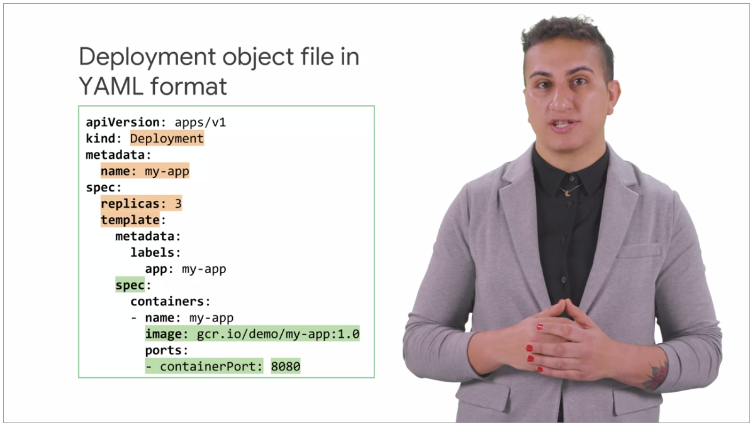

#### Deployment Lifecycle States

* Progressing state: such as creating a replica set, scaling up or scaling down a replica set.
* Complete state: all replicas are available and running
* Failed state: creation of a new replica set cannot be completed.

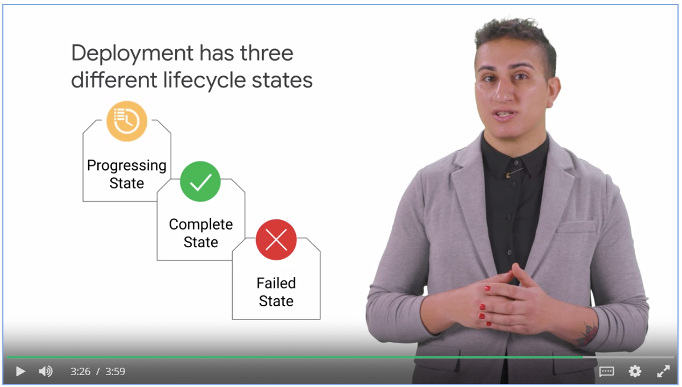

How to manage complexity

* When you apply many small fixes across many rollouts, that translates to a large number of revisions to manage complexity.
* Keep your yaml files in a source code repository to manage complexity.

### Ways to Create Deployments

* Declaratively with yaml file.
* Imperatively with commands
* Use GKE workloads menu in GCP console.

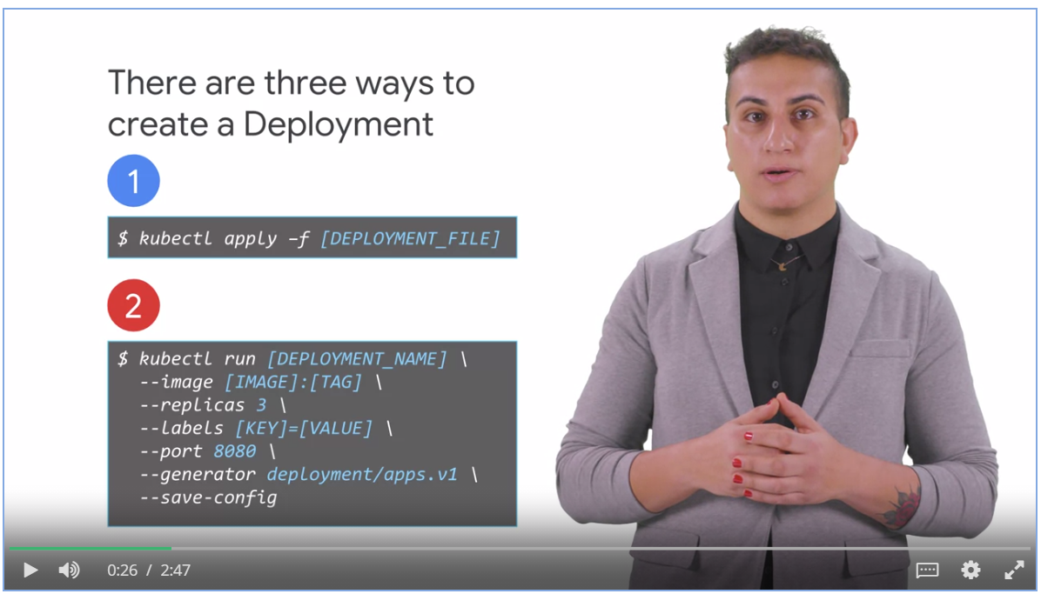

* Use kubectl to get a list of deployment
* Use kubectl to convert deployment to a yaml file for reusability.

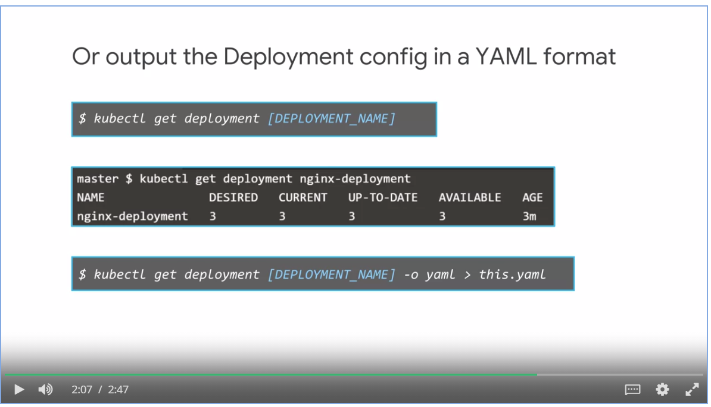

### Serving and Scaling

* Manual scaling
* Automatic scaling creates a Horizontal Pod Autoscaler (**HPA**).
* HPA performs the scaling to match the target CPU utilization.

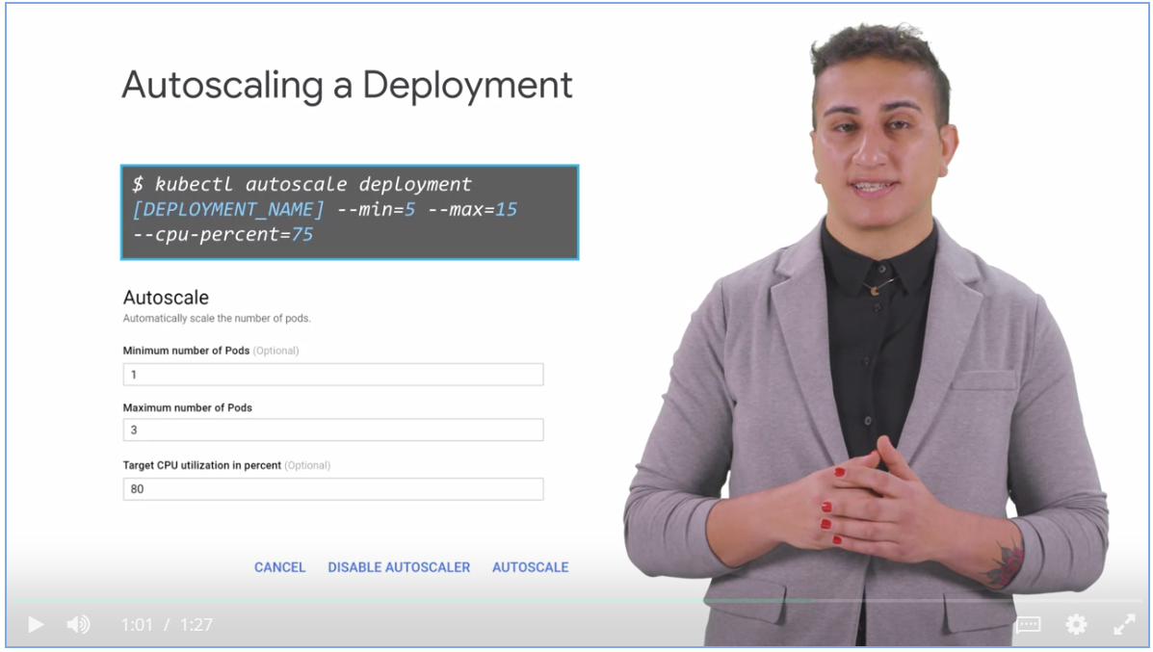

* Thrashing is a problem when the number of deployed replicas frequently fluctuates, because the metrics used to control scaling also frequently fluctuates.
* The horizontal pod auto-scaler has a cool-down or delay feature to control thrashing.

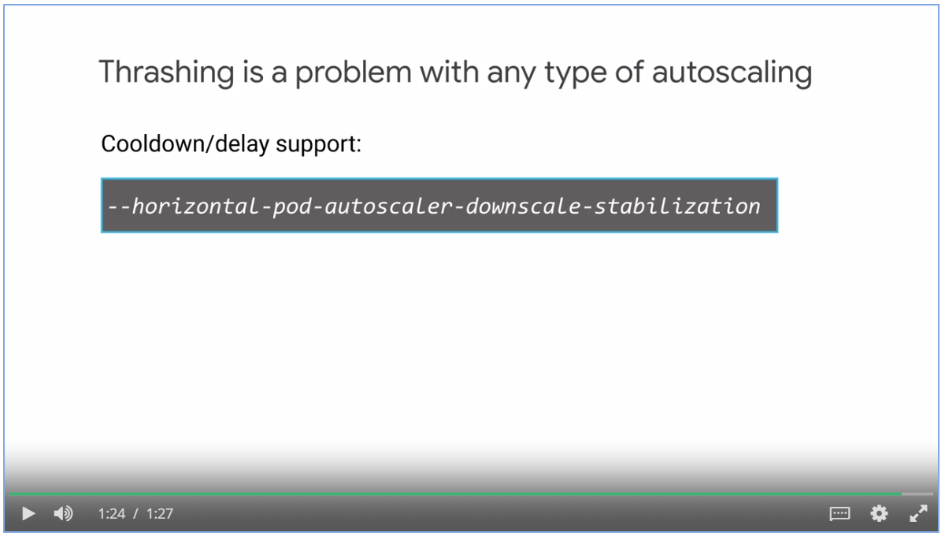

### Updating Deployments

Ways to update a deployment:

* Use **kubectl apply** command with an updated deployment specification YAML file.
* Use **kubectl set** command, opens the spec file in editor, once saved, deployment is updated automatically.
* **Edit** a deployment manifest from the **GCP console** and perform a **rolling update**.

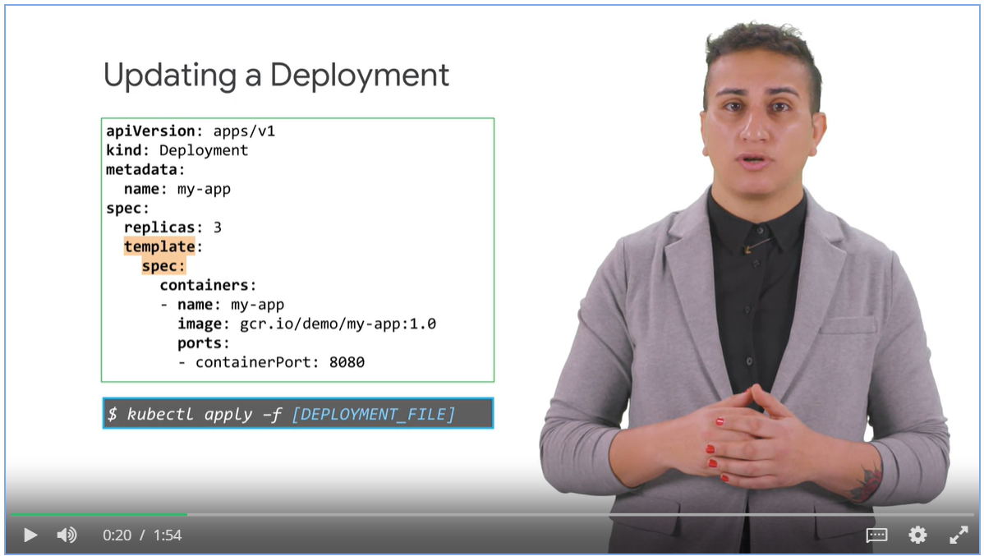

Process behind updating a deployment

* New pods are created in the new replica set one by one
* Old pods are removed from old replica set one by one
* This is known as **rolling updates** or a **rampt strategy**.
  + Availability of application is insured
  + No control over traffic between new and old replica.

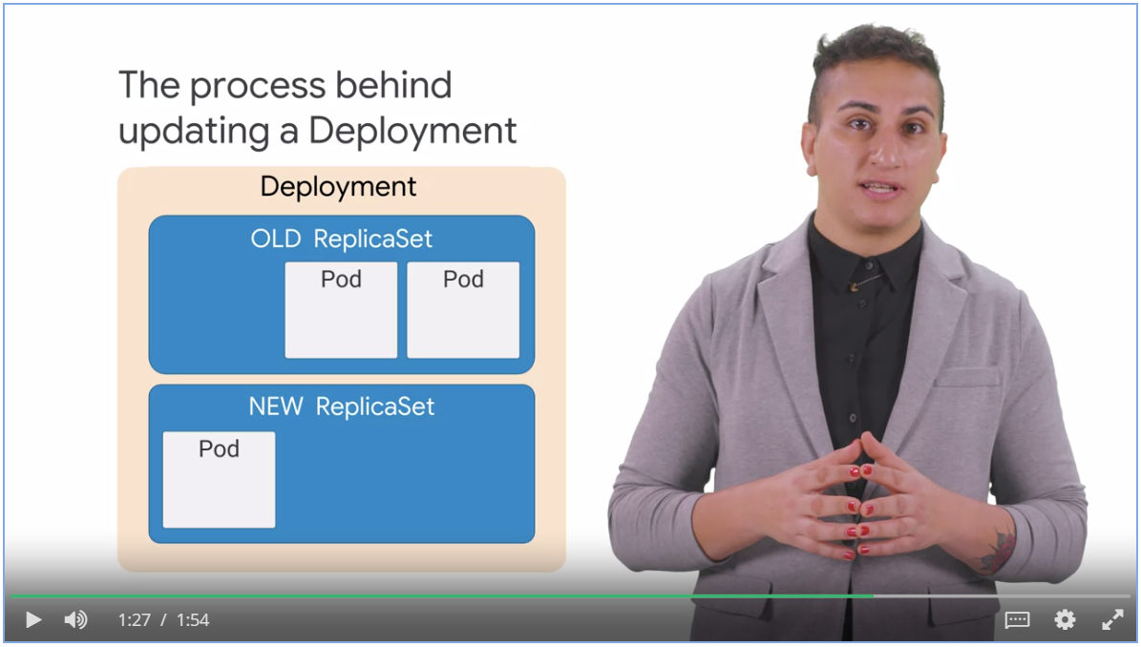

### Rolling Updates

In rolling updates strategy, the ***“max unavailable”*** and ***“max surge”*** fields control how the pods are update.

* Max unavailable lets you specify the maximum number of pods that can be unavailable during the roll out process
* Max surge allows you to specify the maximum number of pods that can be created concurrently in a new replica set.

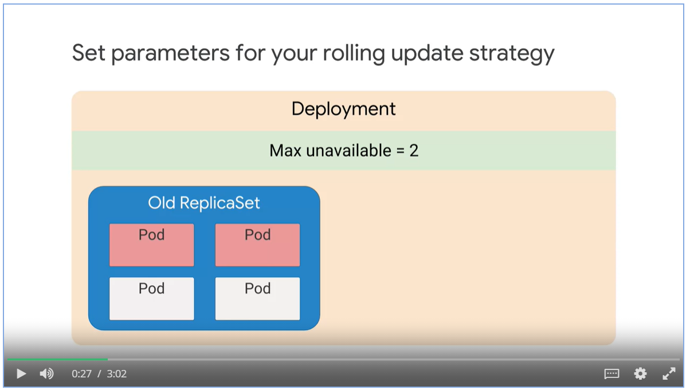

#### Example of rolling update

1. 5 new pods are created because max surge is 5.
2. Max unavailable is 30%, 10 * (1 – 0.3) = 7. Which means 7 pods need to be up and running
3. 10 old pods + 5 new pods – 7 up and running = 8. 8 pods to be removed from the old replica set
4. 5 more new pods created in the new replica set. 2 old pods removed.

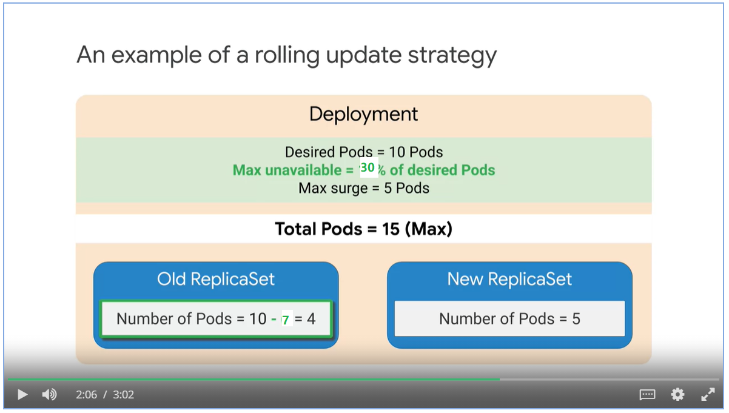

#### Recreate strategy

* Recreate is a strategy type where all the old pods are deleted before new pods are created.
* If the contract information between parts of your application is changing, you need a clean break between the system, use create strategy.

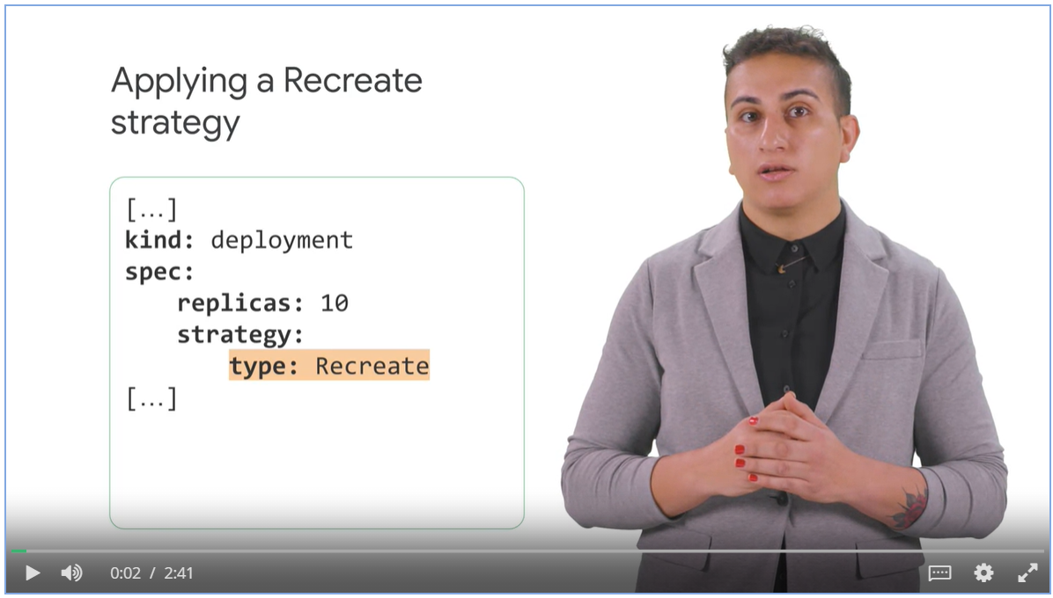

#### Blue-Green deployment strategy

* Deploy a new version of an application, also make sure that the application is available during update.
* New versions or deployment is created, old deployment is redirected to new version and shut down.
* Kubernetes service selects the pod using a label selector.

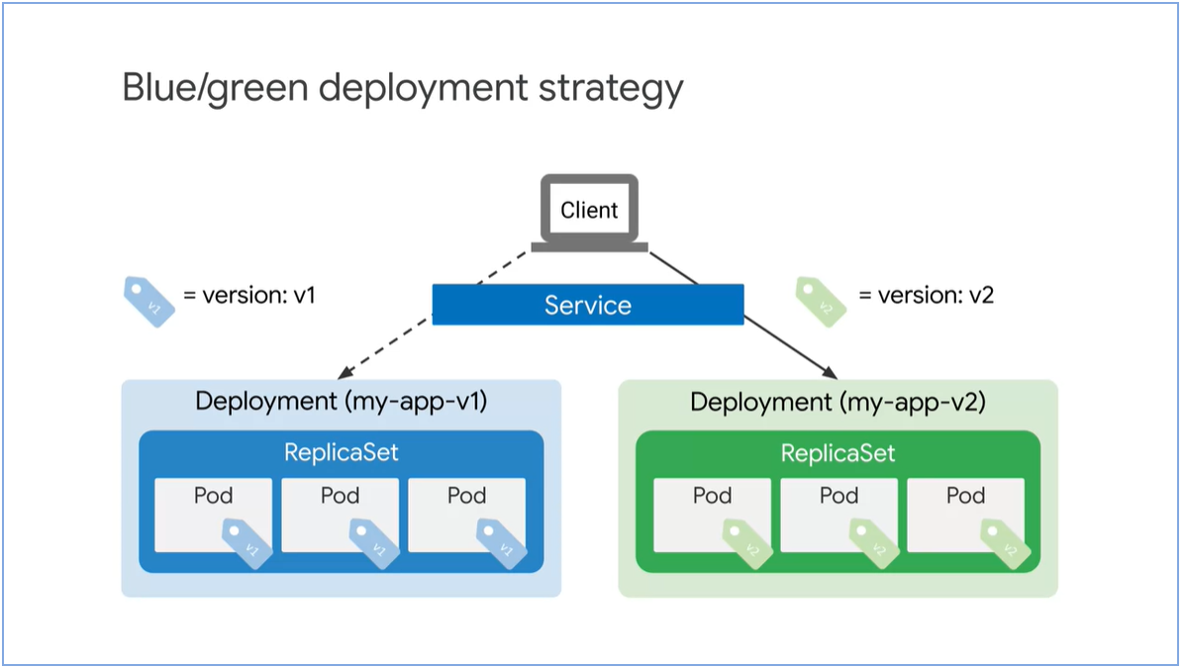

Apply a blue/green deployment strategy.

* Specify a new version label as part of a selector.

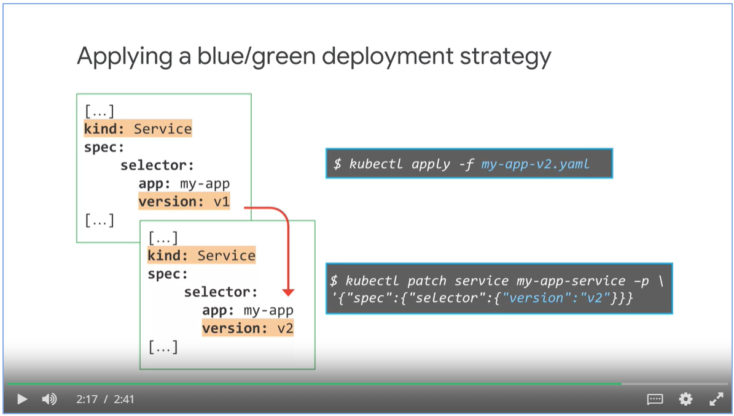

#### Canary deployment

* Canary deployment strategy is based on the blue-green strategy
* Traffic is gradually shifted to the new version.

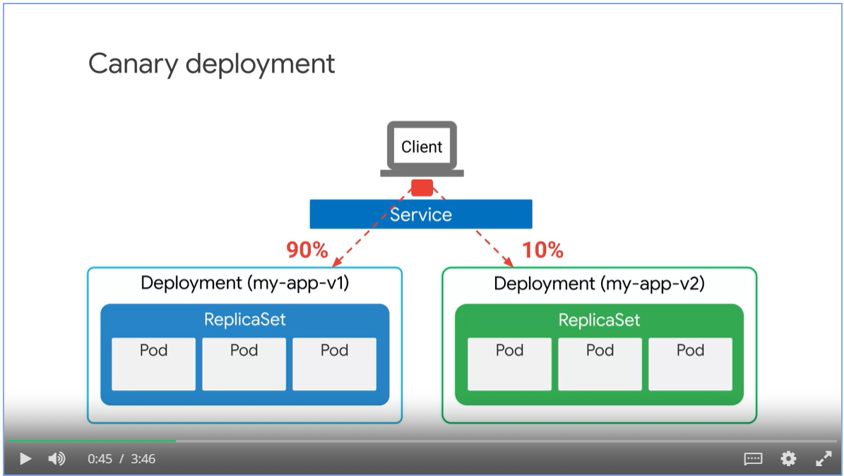

* Selector does not specify a version, only the app name

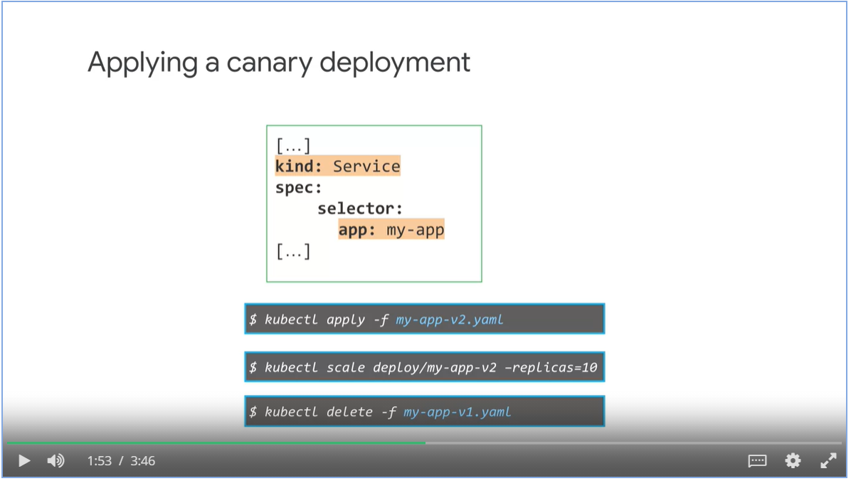

##### Session affinity

* Sometimes, we need to make sure that requests from the same user sessions are sent to the same version of pods.
* Set the session affinity fields to client IP

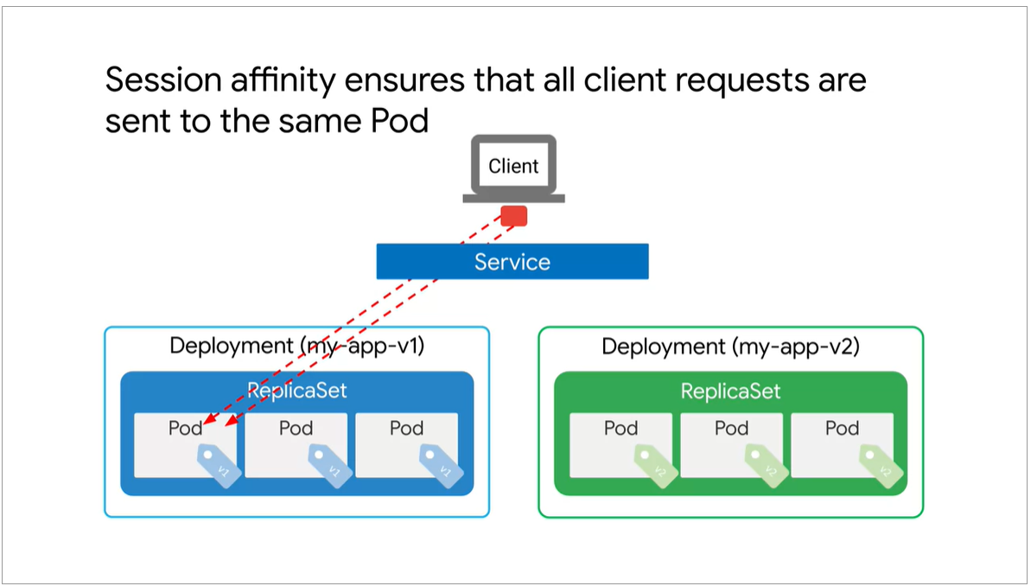

#### Rolling back a deployment

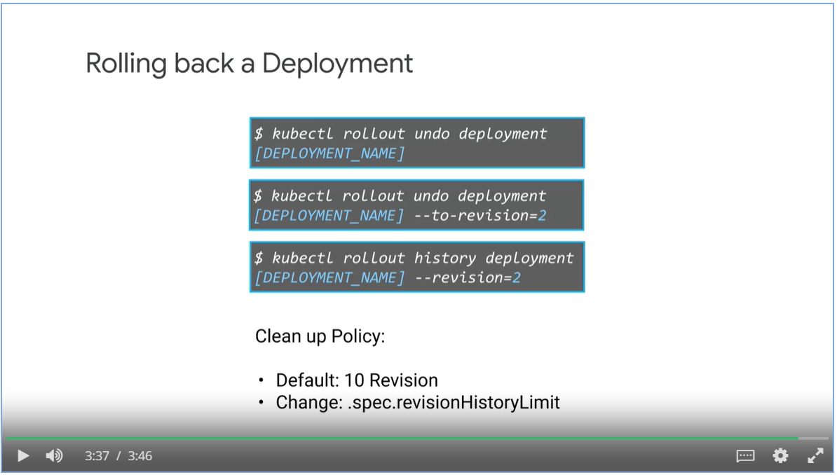

### Jobs

* A jobs is a Kubernetes object like a deployment, a job creates one or more pods to run a specific task reliably.
* When the task is completed, it will terminated the pod and report that the job has successfully finished.

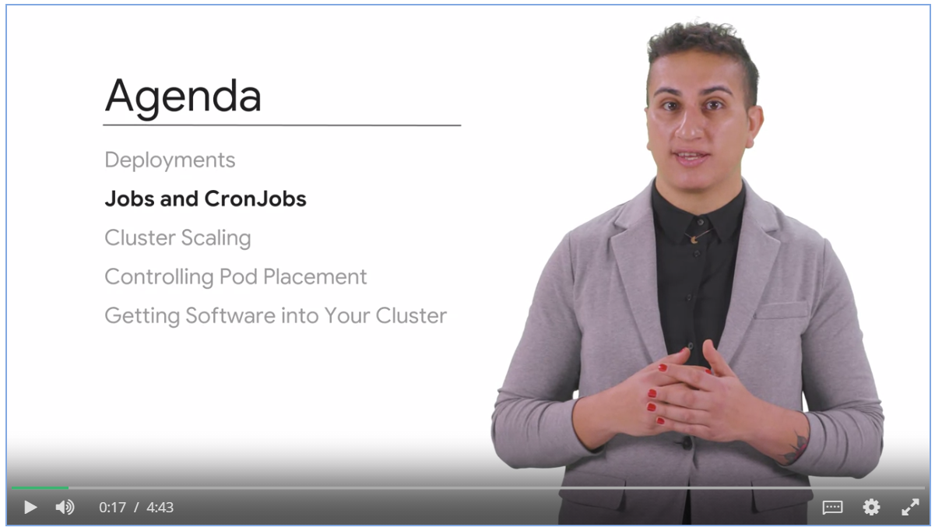

#### Running a job

* The user uploads a video file for transcoding
* Web server creates a job manifest
* A job controller takes the manifest and schedule a pod for the job on a node.
* If the job fails, the job controller schedules the job on another node
* When job is completed, nodes are deleted.

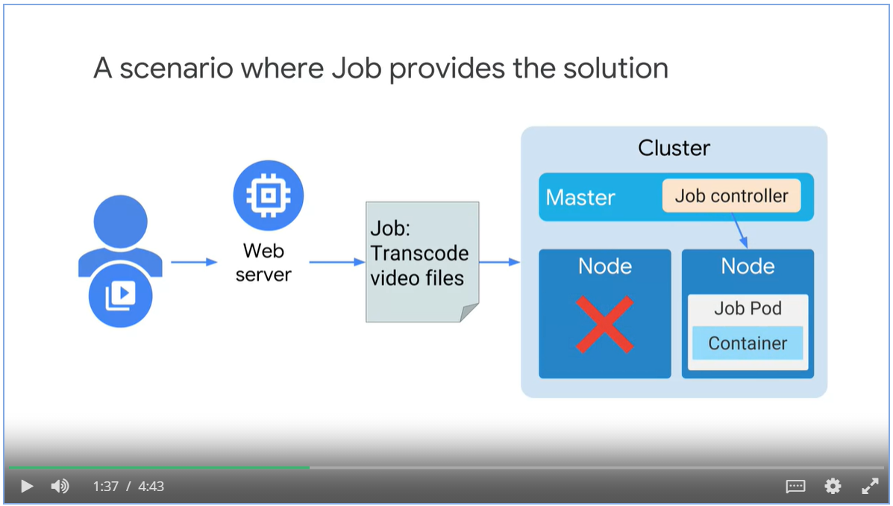

#### Non-parallel job manifest

* Kind: job
* restartPolicy: never, when job fails, don’t restart it
* BackoffLimits controls how many restart attempts before declare the job as failure. Job restart interval doubles every time.

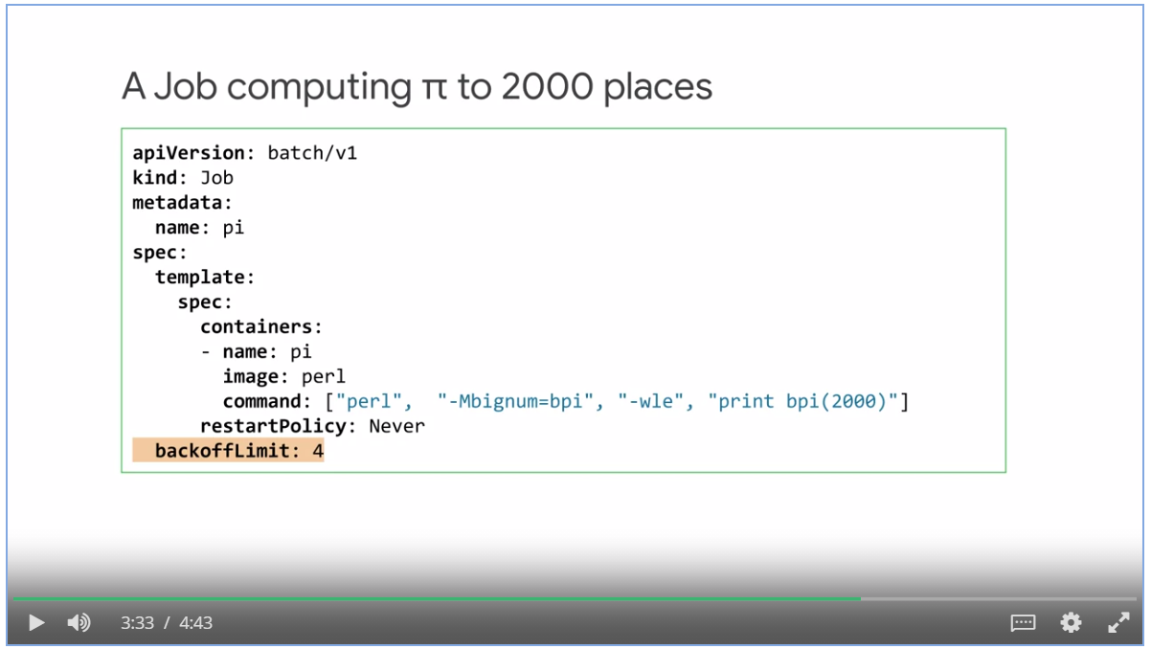

#### Parallel Jobs with completion count

* Parallel jobs creates multiple pods that work on the same task at the same time.
* Two types of parallel jobs:
  + With fixed task completion count
  + Process a work queue
* Parallel job with a fixed task completion count.

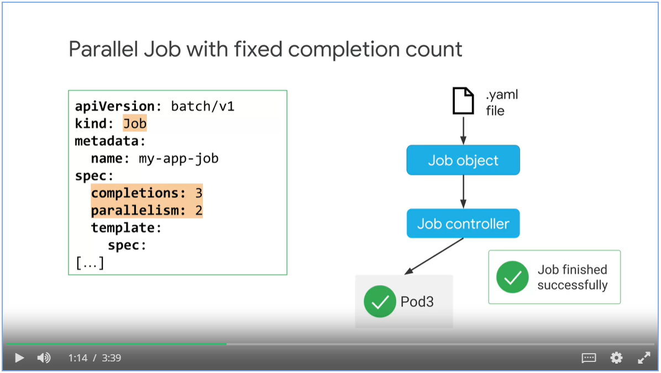

#### Parallel jobs with a worker queue

* Specify the value for parallelism, leave the completion value empty
* As long as one of the pod finishes the workload, the job is considered as finished and remaining pods are shut down.

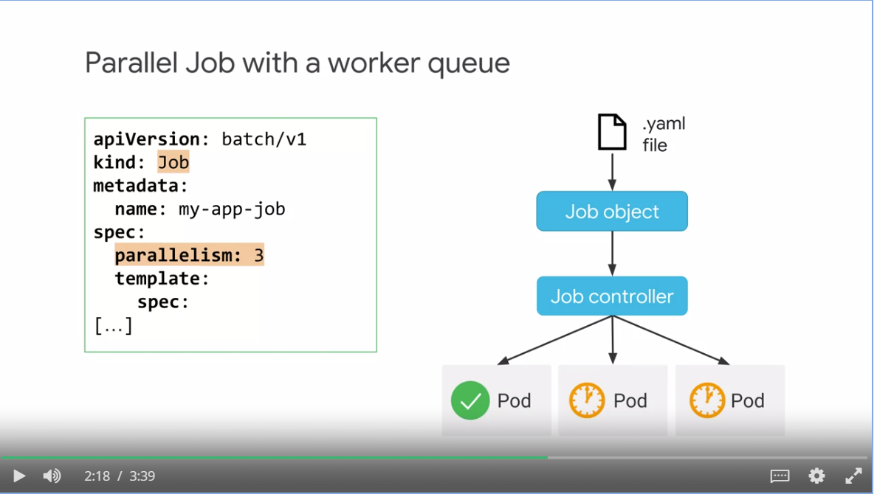

#### Failing jobs

* Use activeDeadlineSeconds to fail a job if it is running longer than the value
* activeDeadlineSeconds takes precedent over backoffLimit.

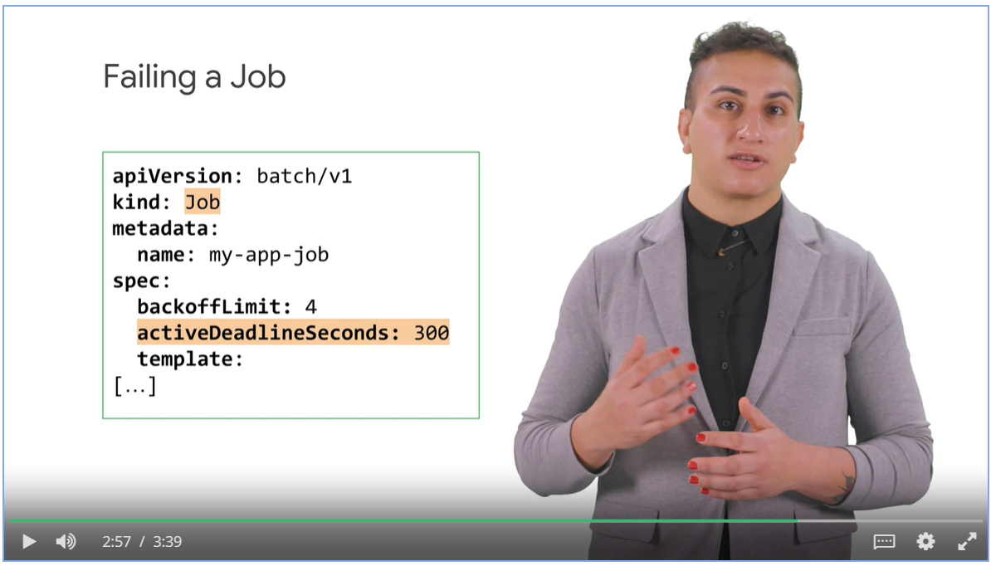

#### CronJobs

* A Cron job is a Kubernetes object that creates jobs in a repeatable manner to a defined schedule.,
* Cron is the stand Unix/Linux mechanism for scheduling a process.

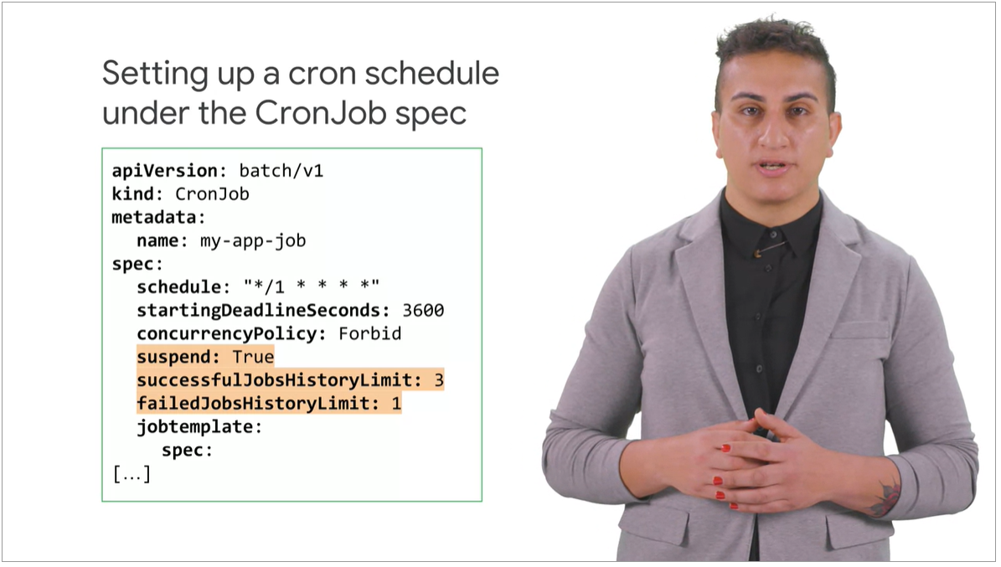

## Week 2: Introduction to AI Platform Pipelines

### Overview:

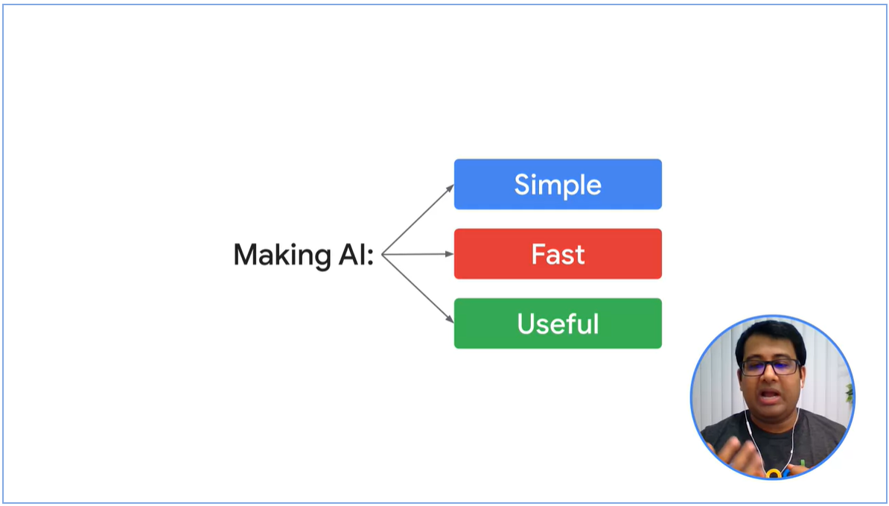

Three Common AI problems

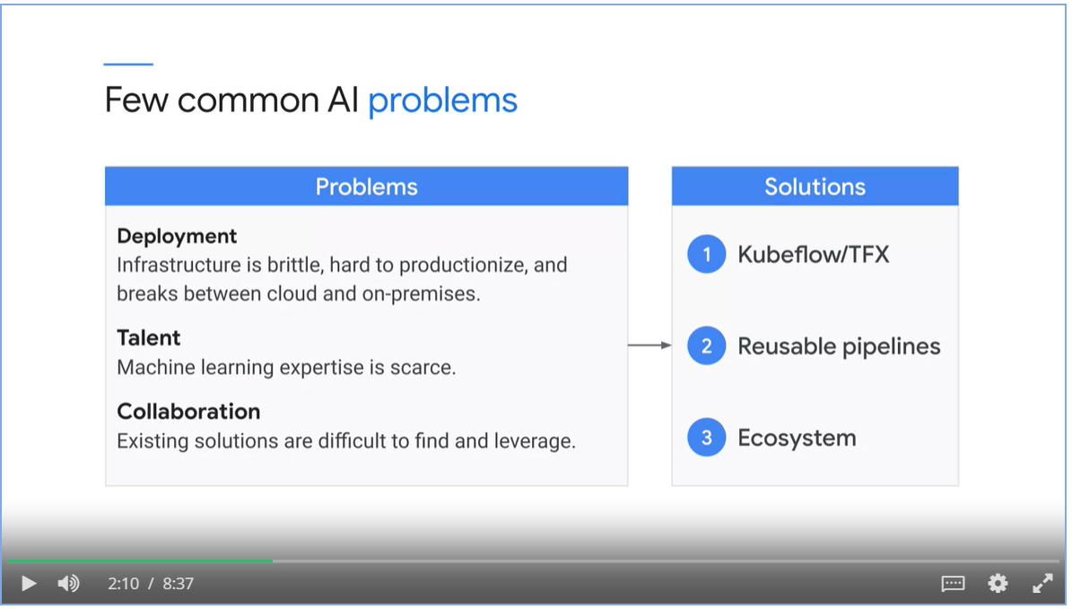

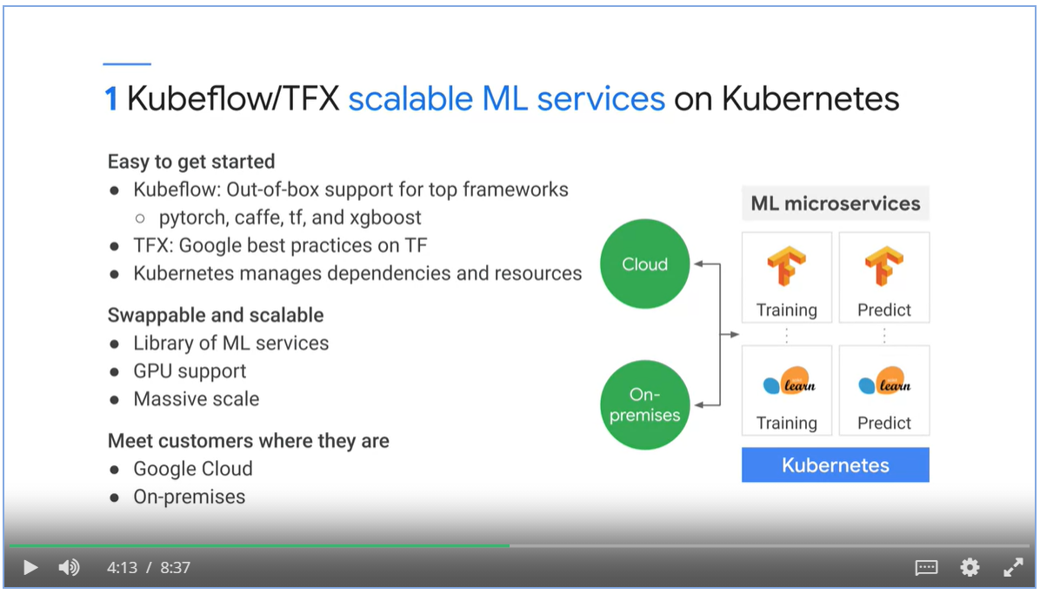

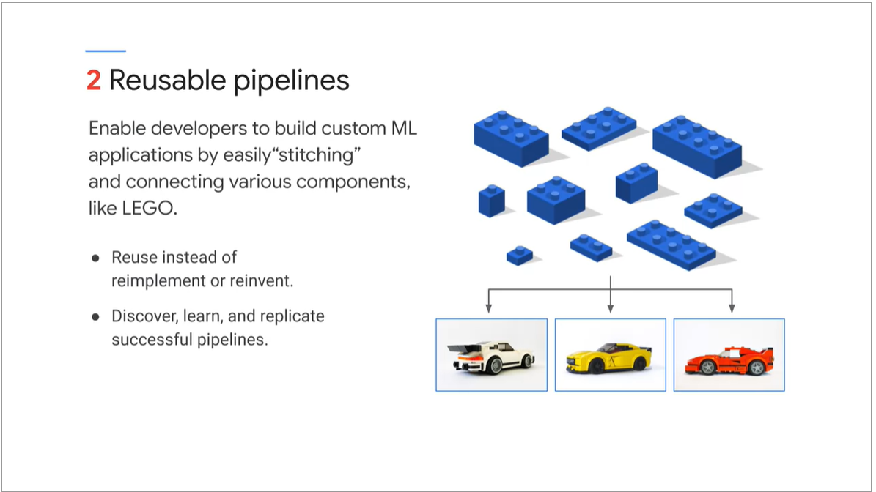

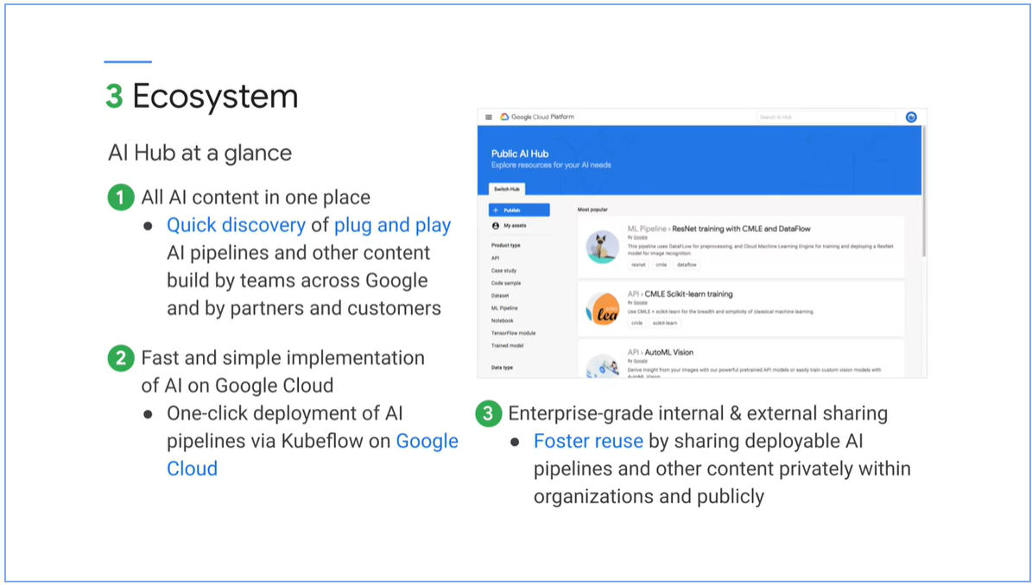

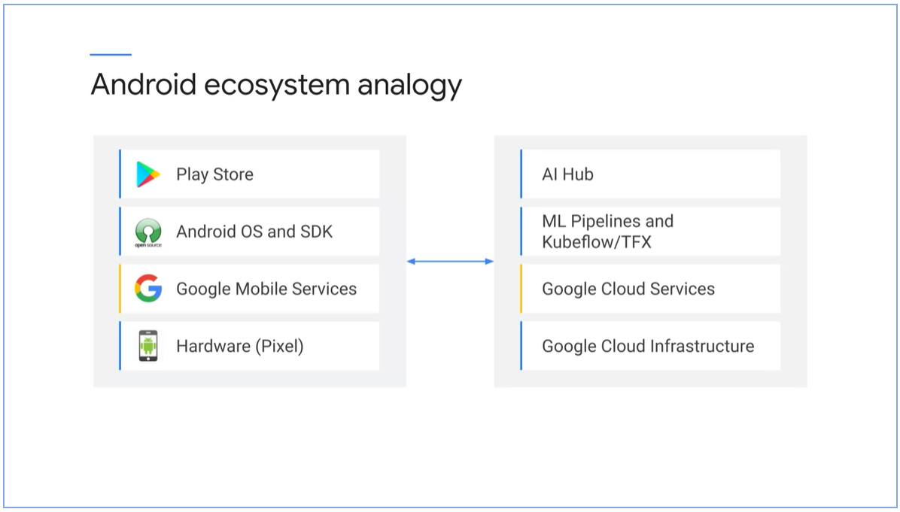

#### AI Platform Pipelines

* ML pipelines are portable, scalable ML workflows based on containers.
* ML pipelines are composable of set of input parameters and list of tasks

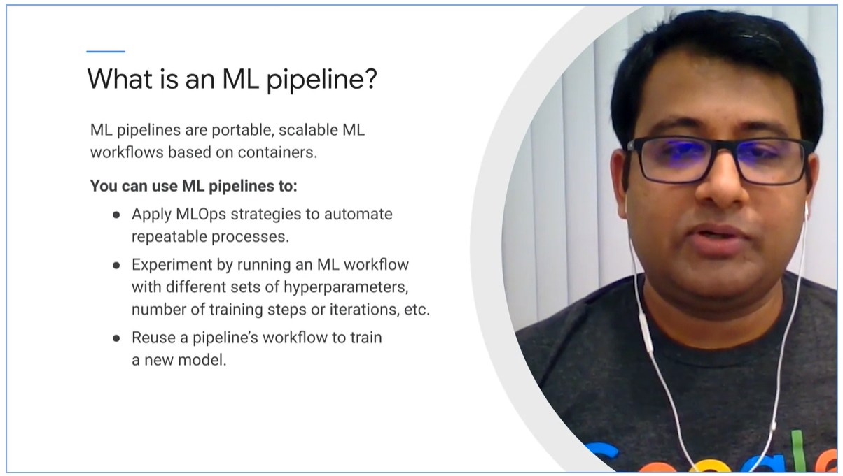

#### Pipeline components

* Self -contained set of code to perform various operations
* Set of input/output parameters and location of container image
* Container image: package that includes executables and definition of environment.

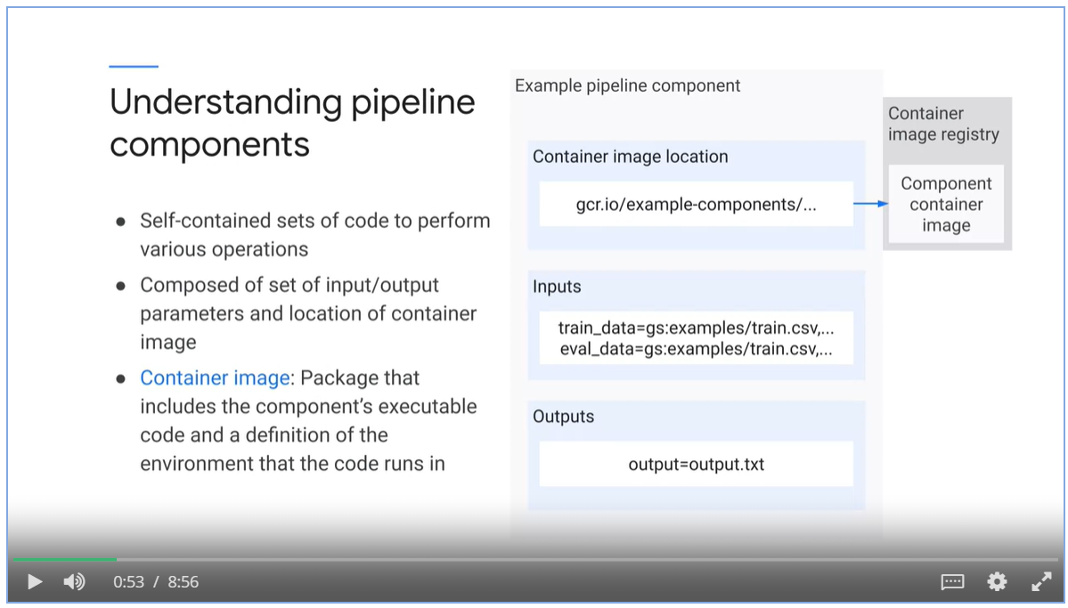

* Each task in a pipeline performs a step in the pipeline workflow. Task is an instance of pipeline component.
* Kubeflow pipelines / AI Platform pipelines uses dependencies to define the pipelines workflow as DAG.

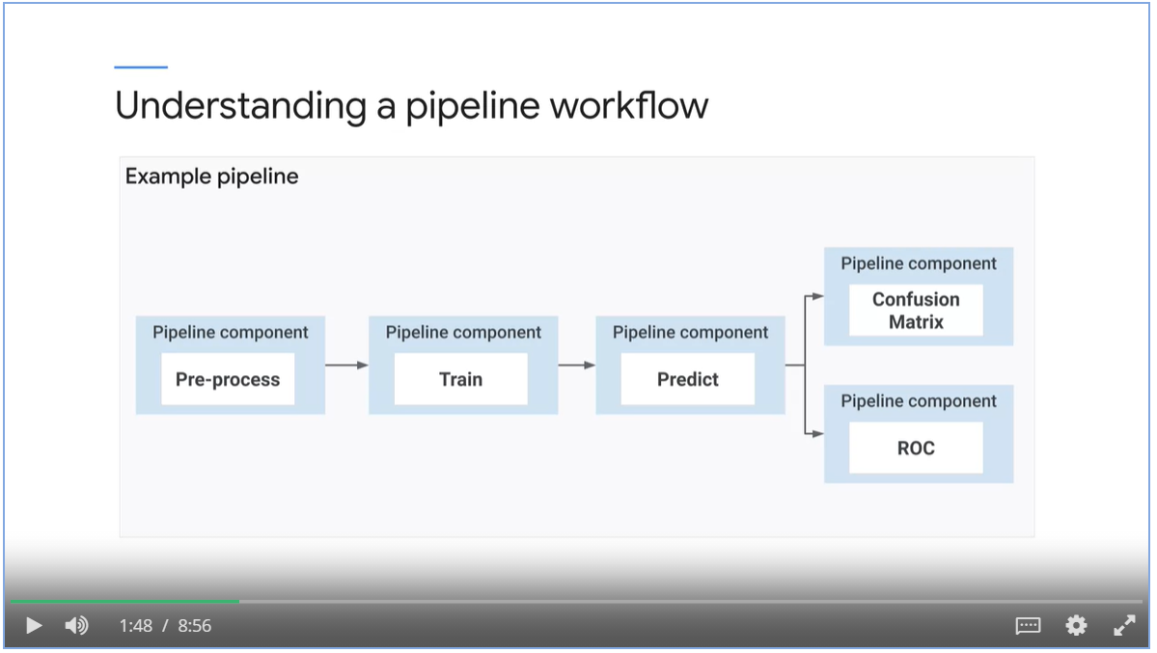

#### Process of Building an MLOps pipeline

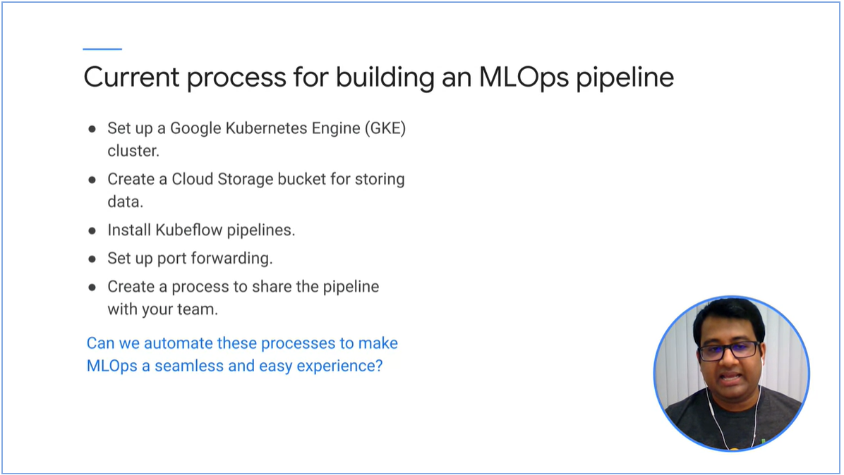

AI Platform Pipelines as an off the shelve product.

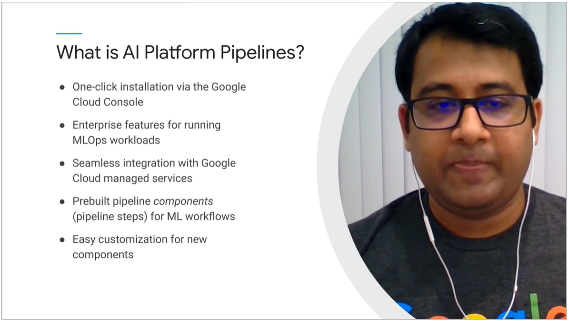

### AI Platform Pipelines

#### Concepts

* Create pipeline components using Kubeflow Pipeline SDK or TensorFlow Extended SDK.
* SDK codes are submitted to AI Pipeline Rest API server
* Argo Workflow Engine executes pipeline tasks.
* Pipeline components can leverage GCP services such as data-flow, AI platform training and prediction, BigQuery and so on.

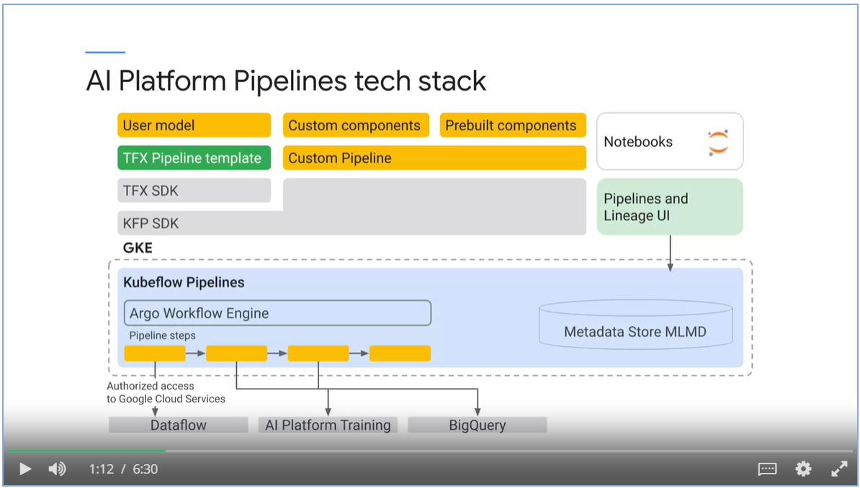

##### Kubeflow Pipelines vs TensorFlow Extended

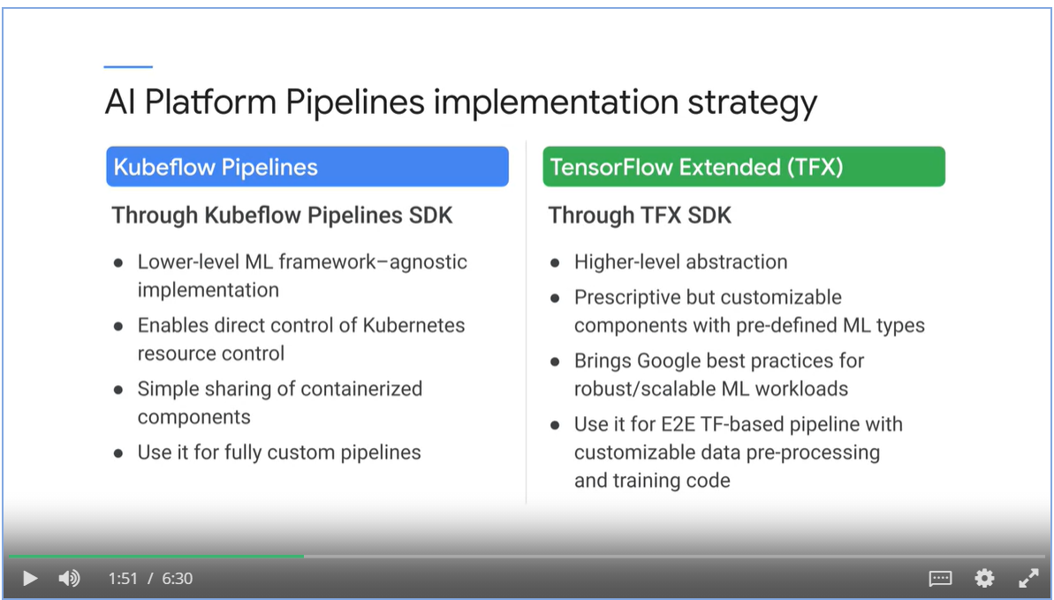

##### TFX templates scaffolds step-by-step guidance.

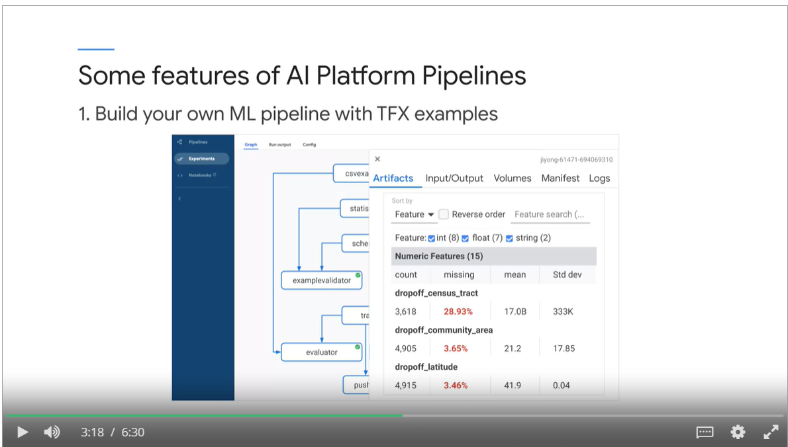

##### Versioning and grouping

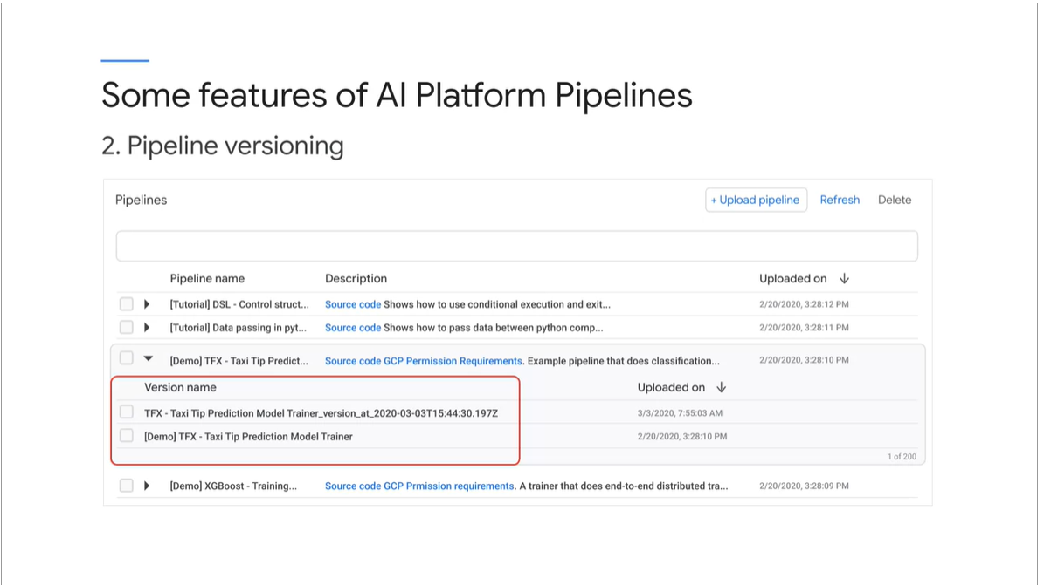

##### Artifacts tracking.

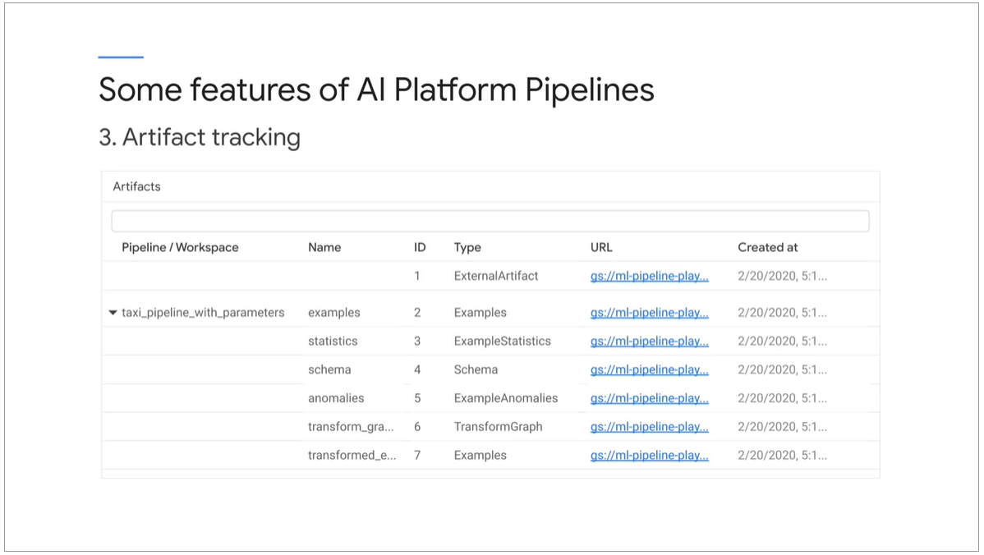

##### Lineage tracking

* Lineage tracking shows the history and versions of your model.

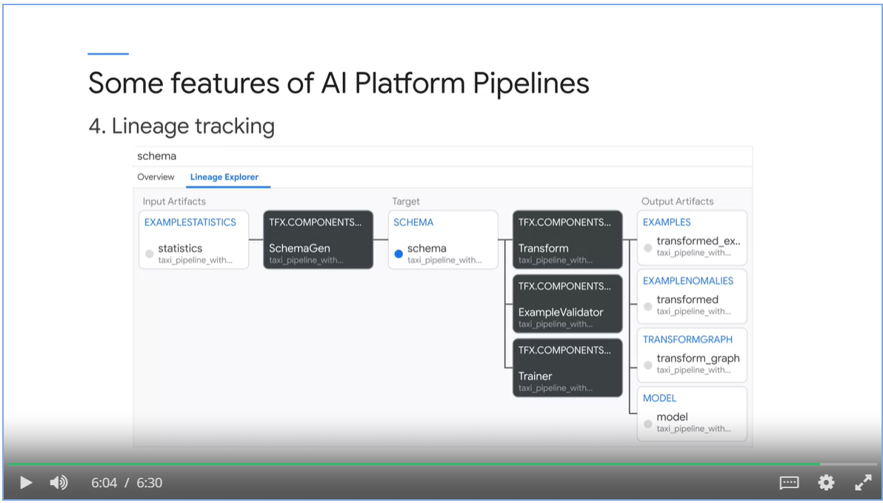

#### When to use

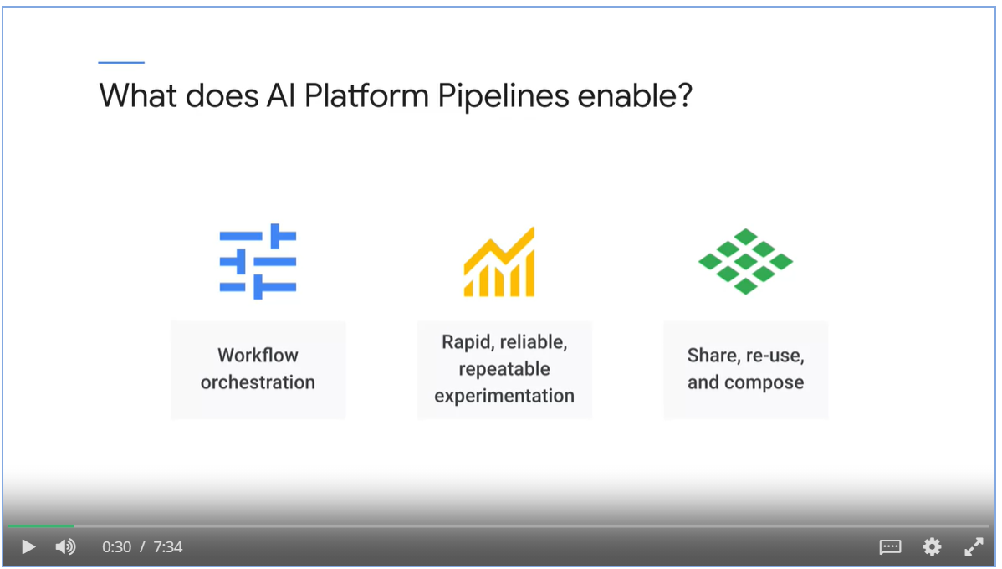

#### Ecosystem

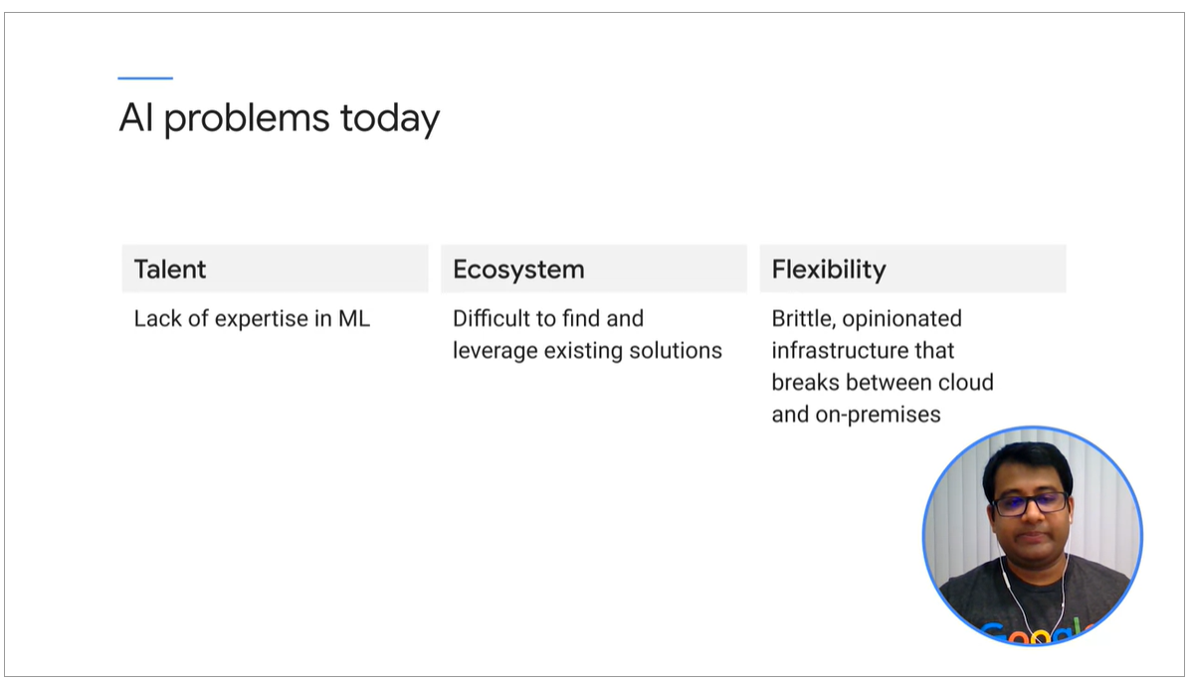

Reusable pipelines

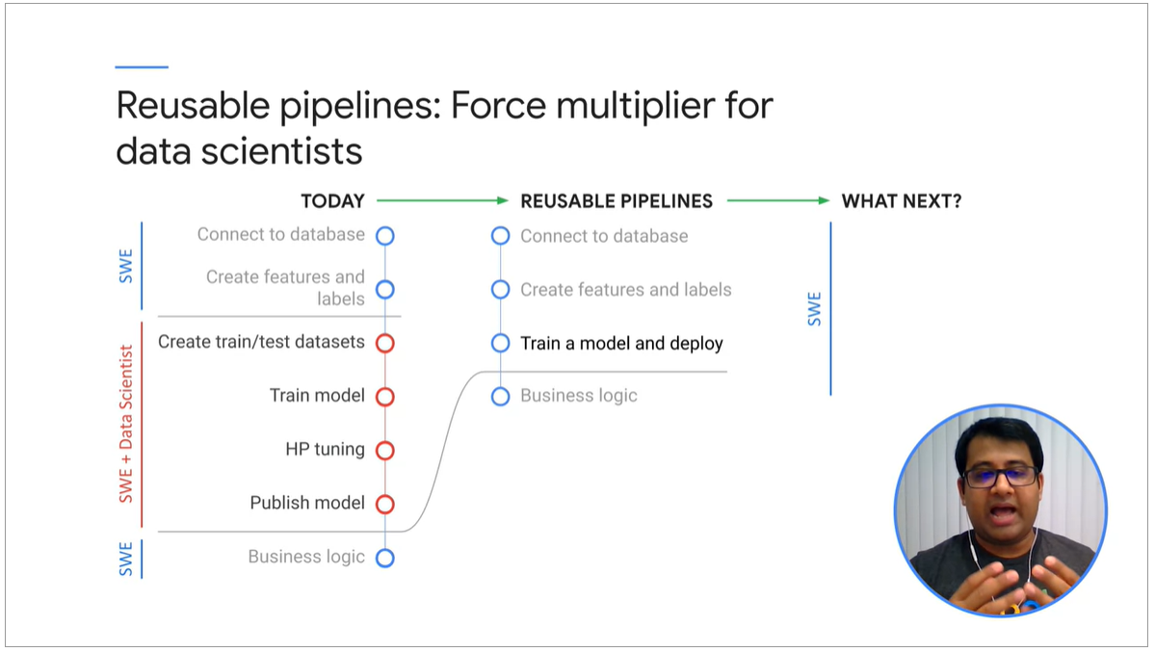

AI Hub

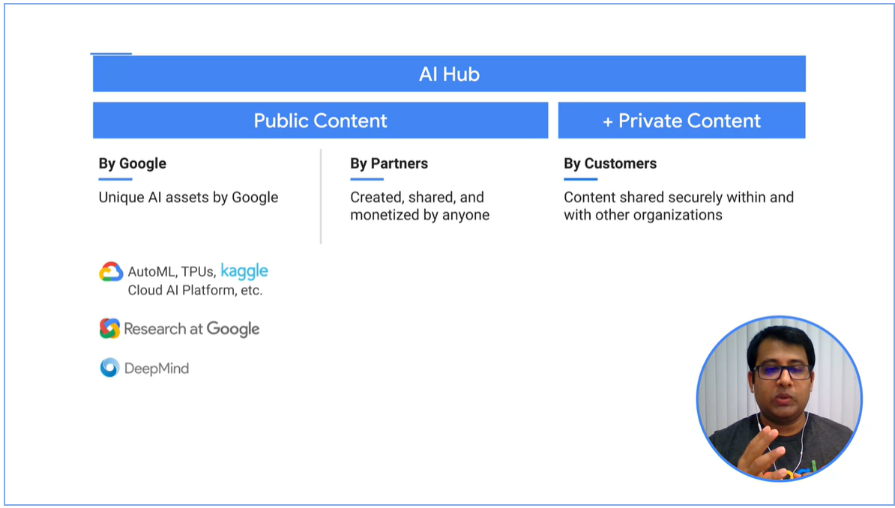

## Week 2 Training, Tuning and Serving on AI Platform

### Overview

To build and operationalize the model, there are 3 steps

* Implement the model in Jupyter Notebook.
* Package the model in docker file
* Configure and start an AI platform job with an YAML file.

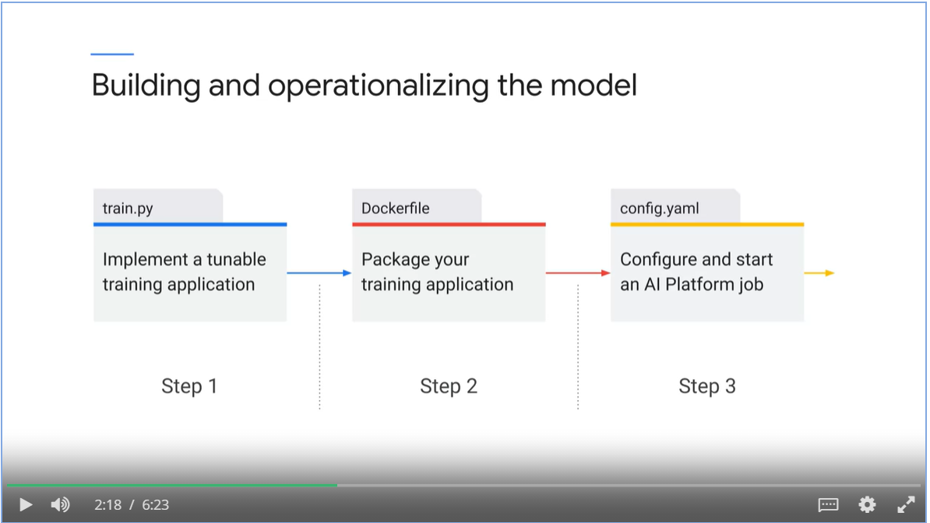

#### MLOps building blocks on GCP

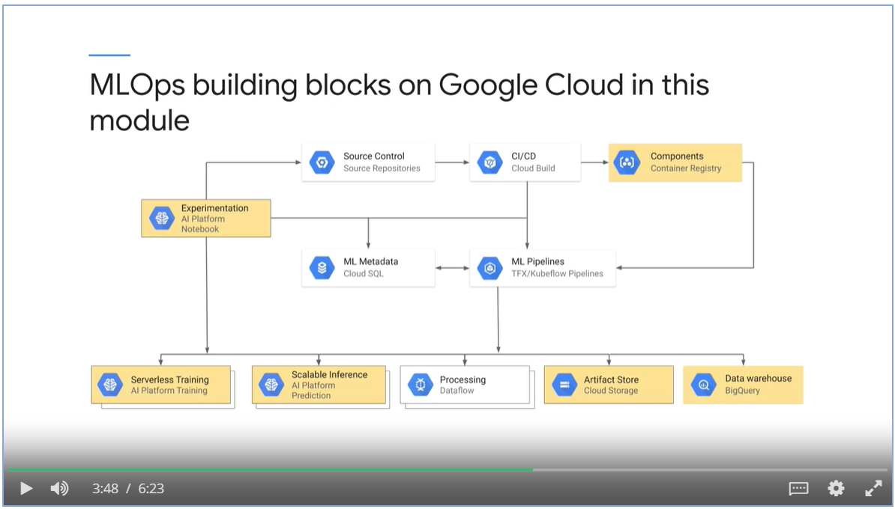

#### Activities in ML project

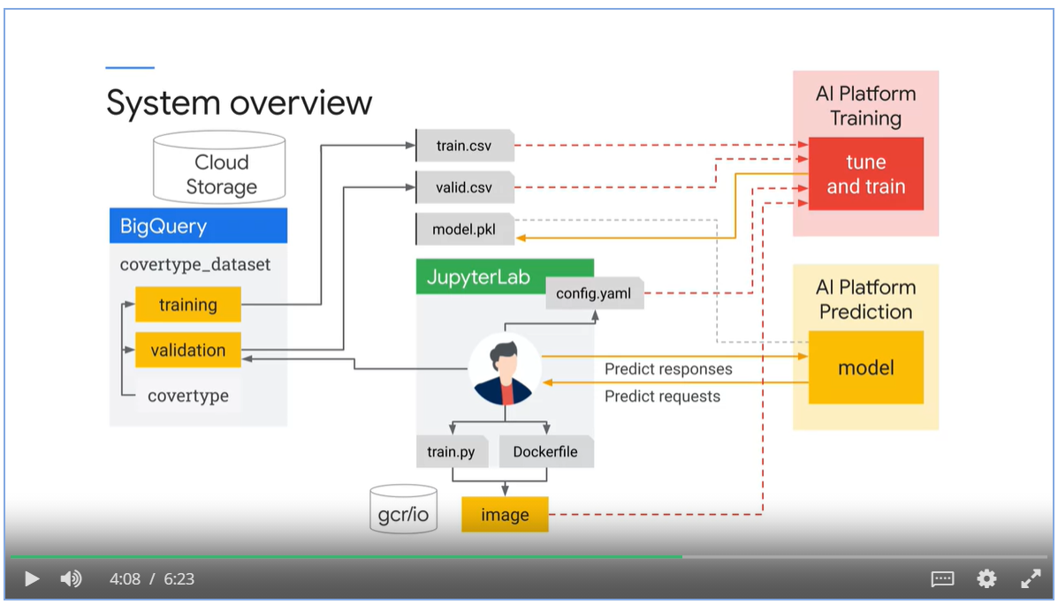

#### Automated ML pipelines

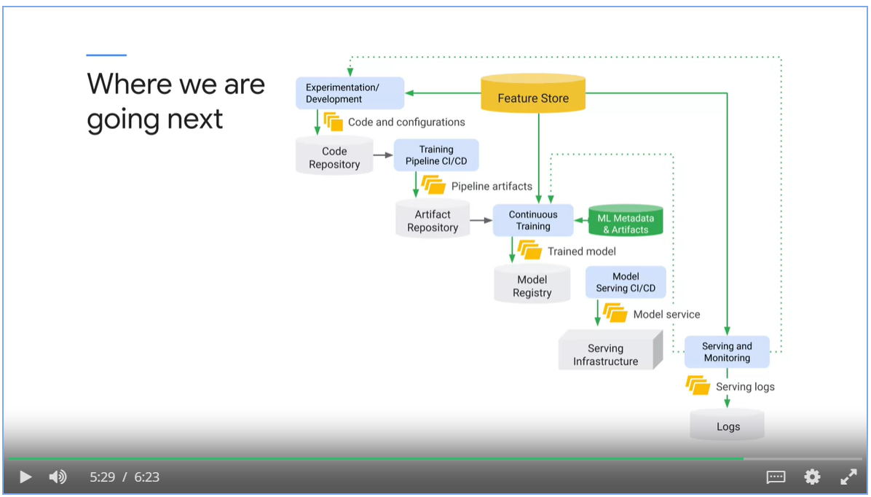

### Create a Reproducible Dataset

* Use the Covertype dataset.
* Predict forest cover type from features such as elevation, slope or soil type.

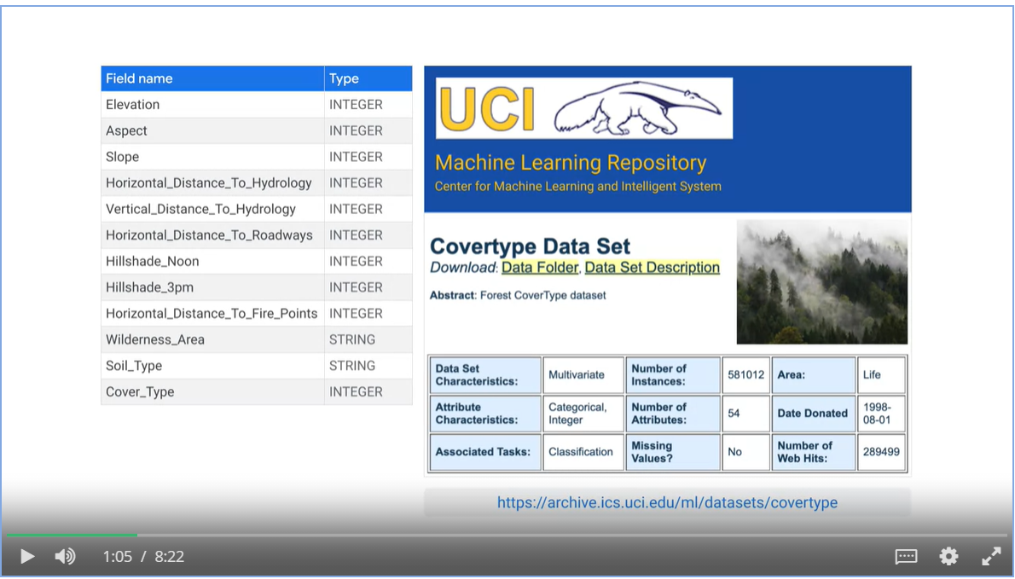

#### Train, validate and split

* A training set used by gradient descent to learn model parameters.
* A validation set used to choose best hyperparameter and best architecture of the model.
* A test set to report the performance metrics of the model with data the model has never seen before.

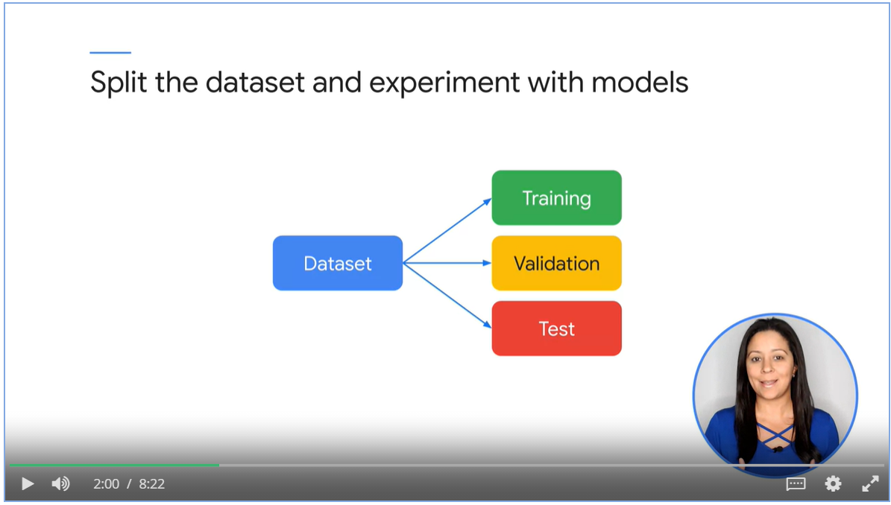

#### Use RAND() function to split the data

* By random, not reproducible
* Training data might not be a good representation of the population

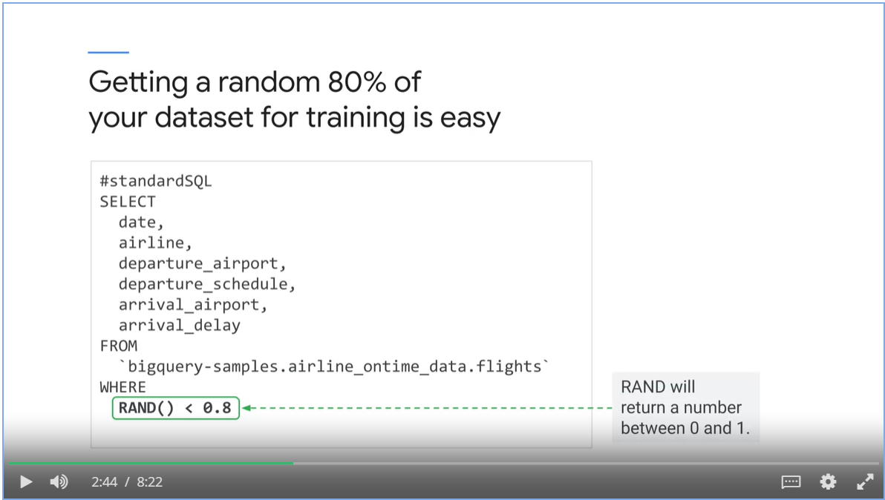

#### Hashing and Modulo Operator

* For training: MOD(ABS(FARM_FIGERPOINT(field_to_hash)), 10) < 8
* For validation: MOD(ABS(FARM_FIGERPOINT(field_to_hash)), 10) = 8
* For training: MOD(ABS(FARM_FIGERPOINT(field_to_hash)), 10) = 9

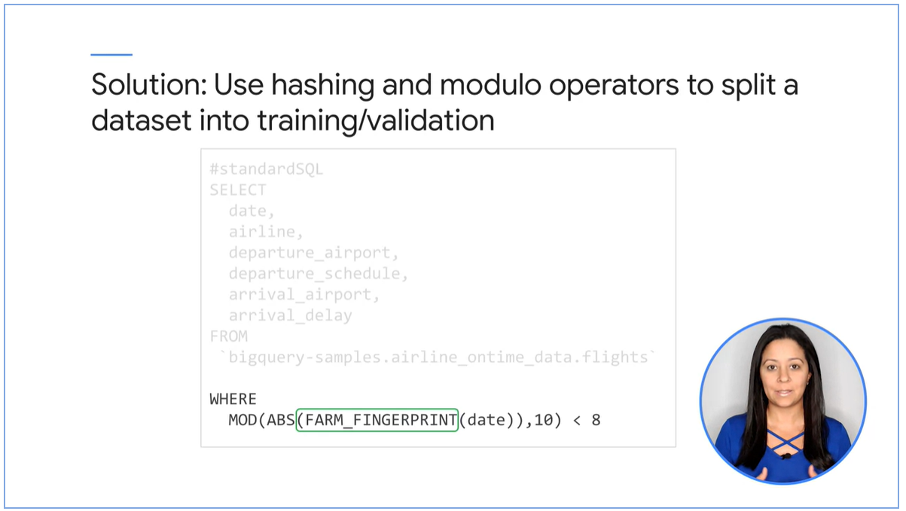

#### Which field to hash on?

* Choose a non-correlated label. We need to feed correlated features into the model for it to learn.
* Granular enough for your desired module split.

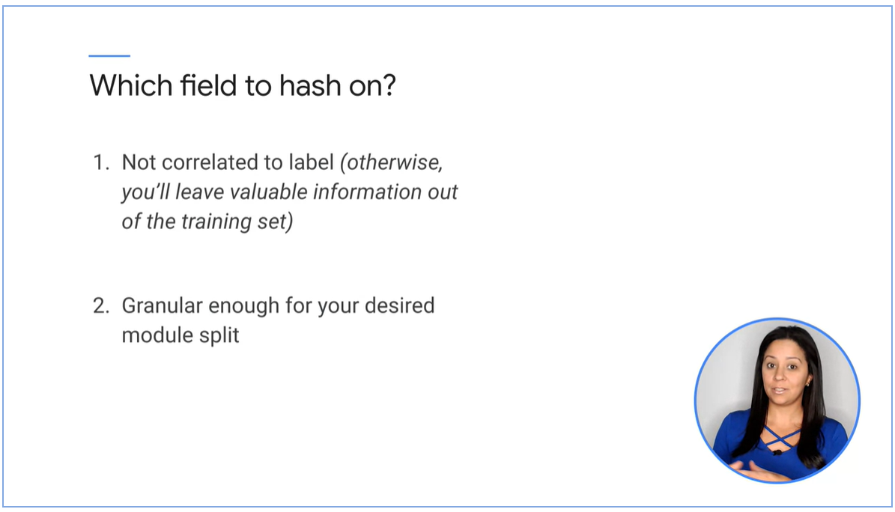

* Concatenate all the fields as JSON string and hash on that

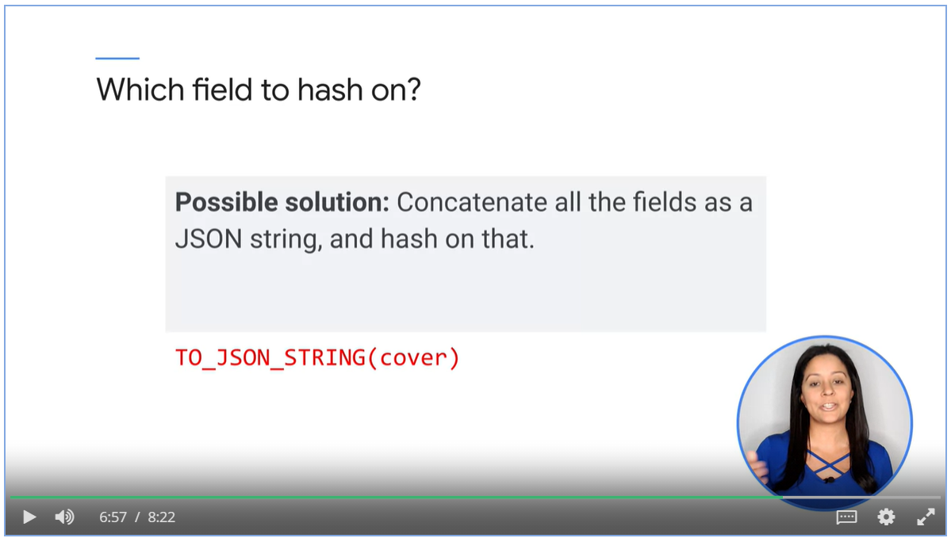

#### Use BigQuery

* To create training dataset
* To extract into csv files.

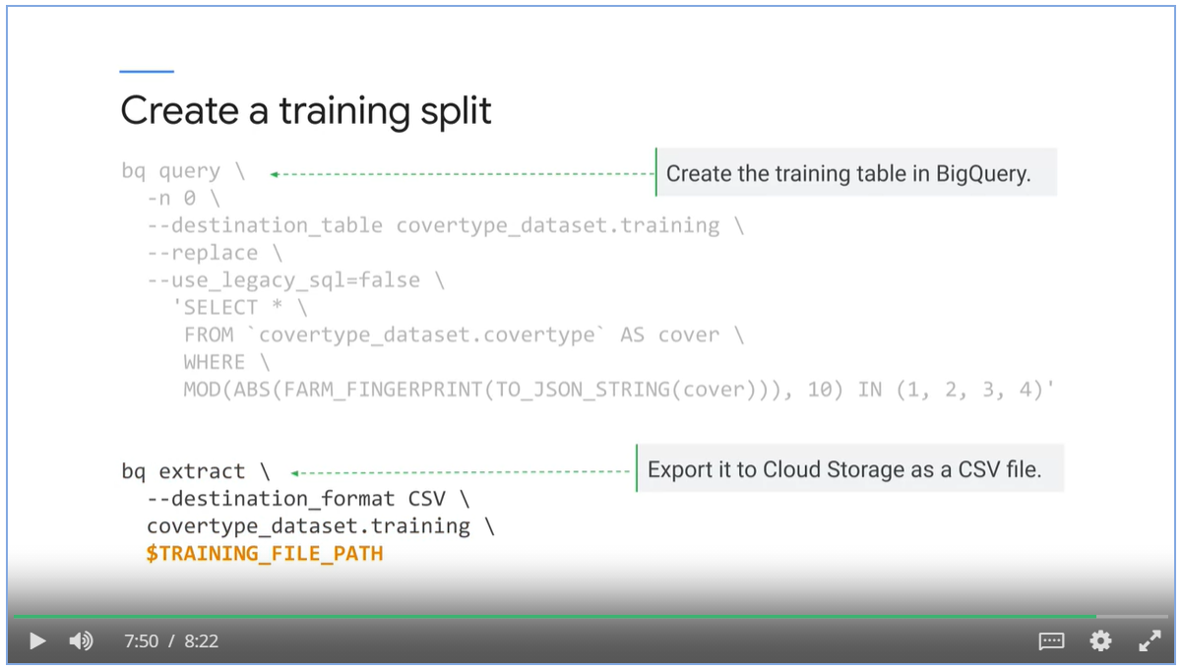

### Implement a Tunable Model

Create a Model using Scikit Learn

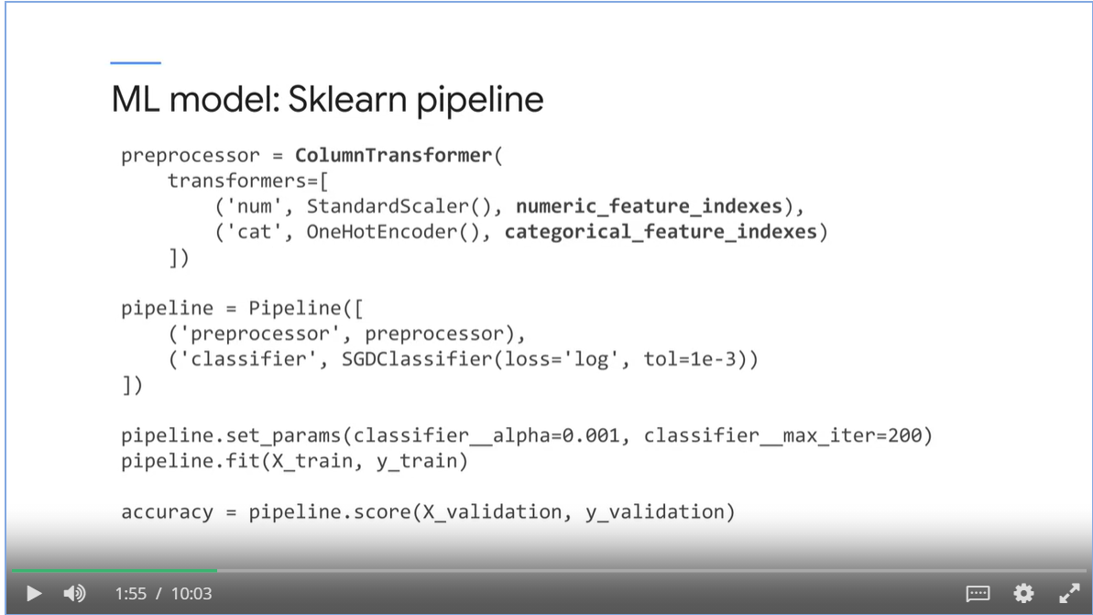

#### AI Platform Hypertune

* Make hyperparameters command line arguments
* Ste up cloudml-hypertune to record training metrics
* Export the final trained model
* Supply hyperparameters to the training job.

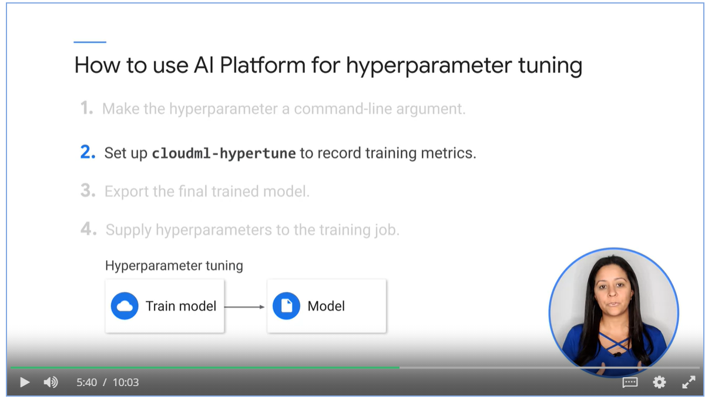

1. Make hyperparameters command-line argument using python fire package.

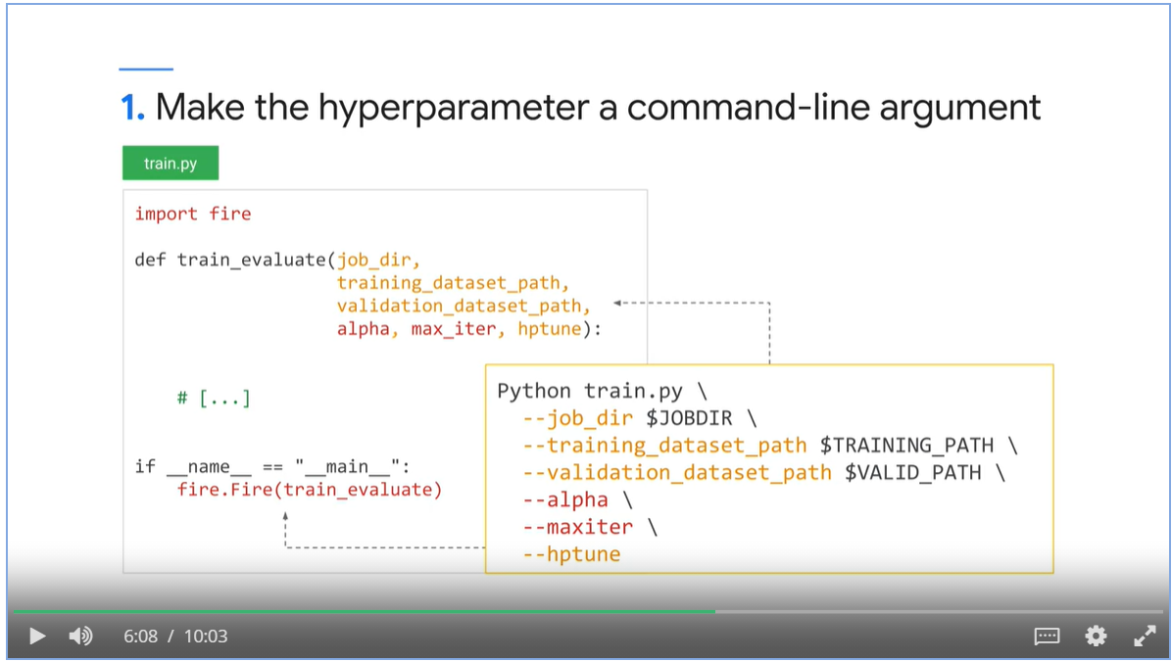

1. Set up cloudml-hypertune to record training metrics

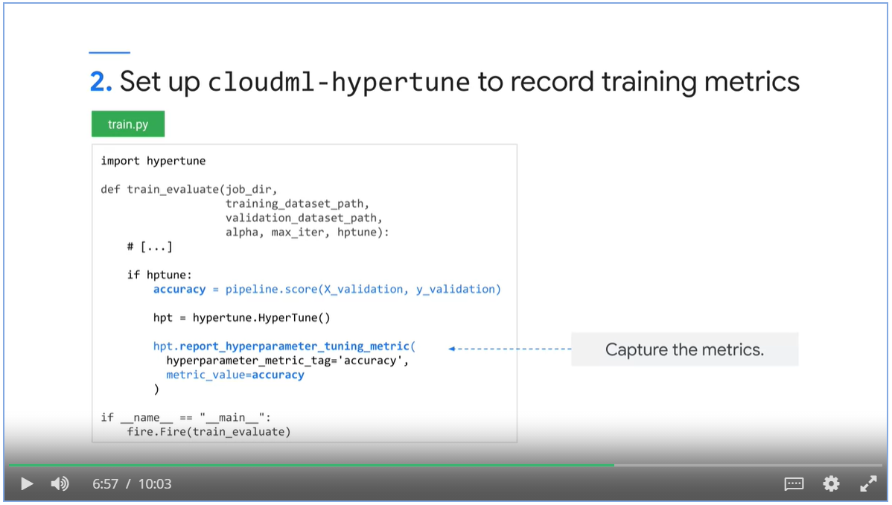

1. Export the final model when not tuning with pickle

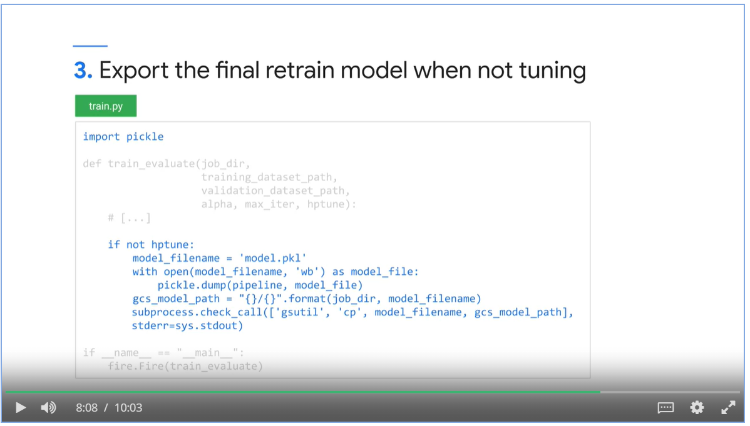

1. Supply hyperparameters to the training job and submit the training job.

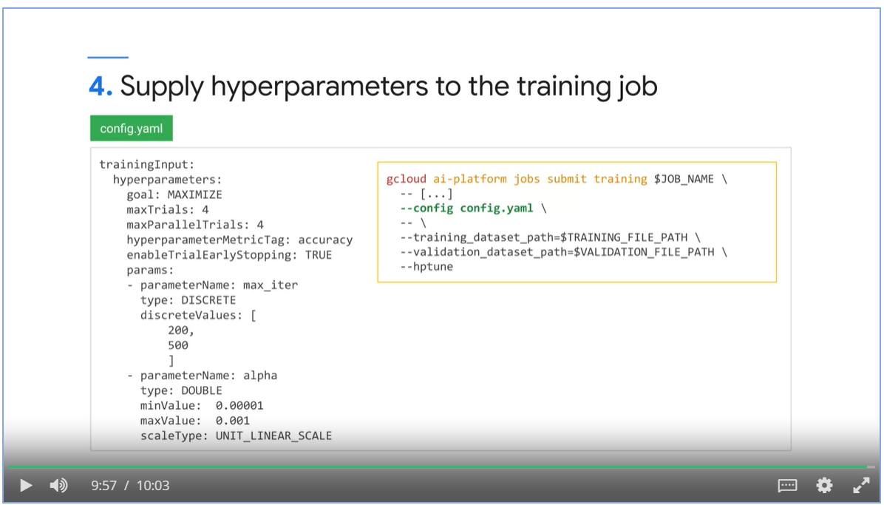

### Build and Push a Training Container

* Build a docker file and push it to Container Registry.

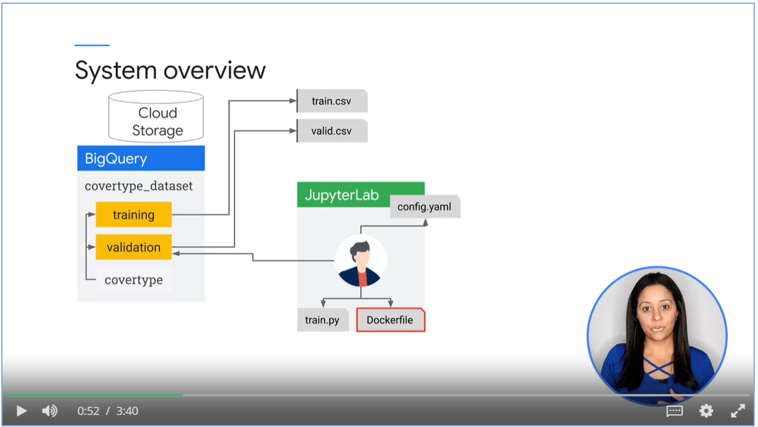

* An example of a docker file.
* Submit jobs

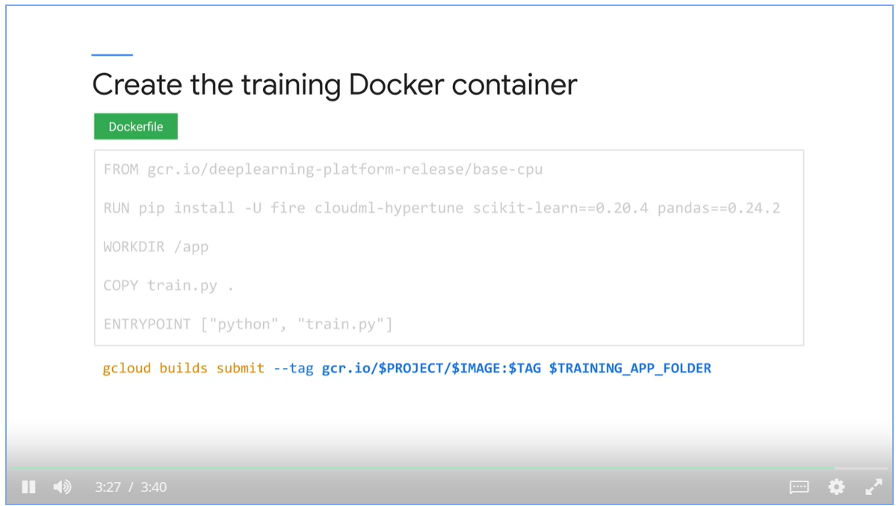

### Train and Tune and Model

#### Start training job on AI platform

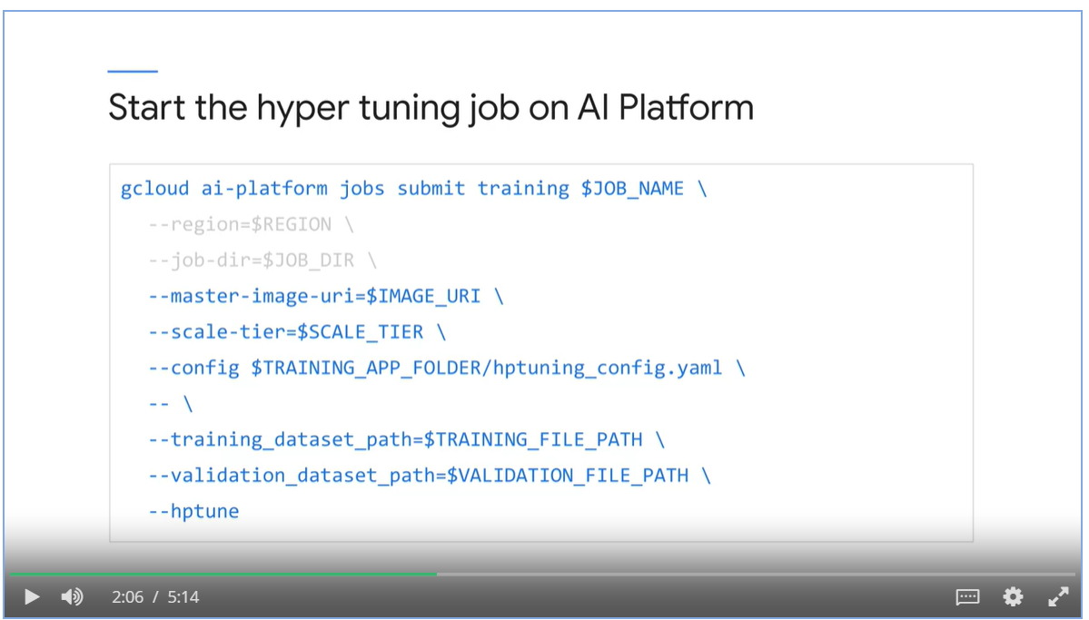

#### Exam the best model in GCP console

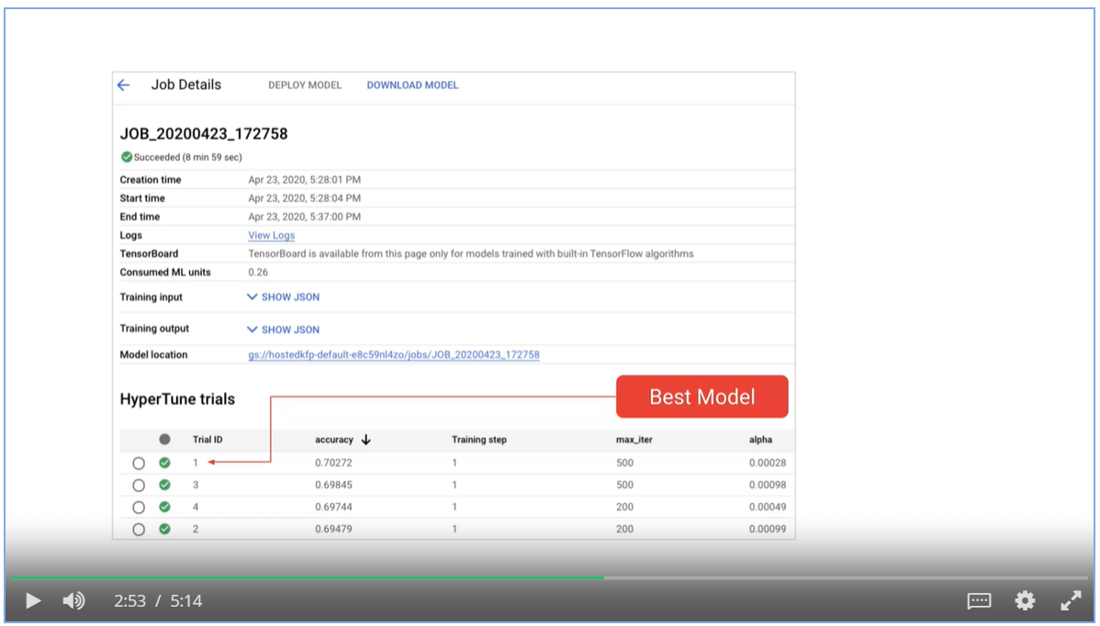

#### Query AI Platform Training for best hyperparameters

* Query automatically
* from googleapiclient import discovery

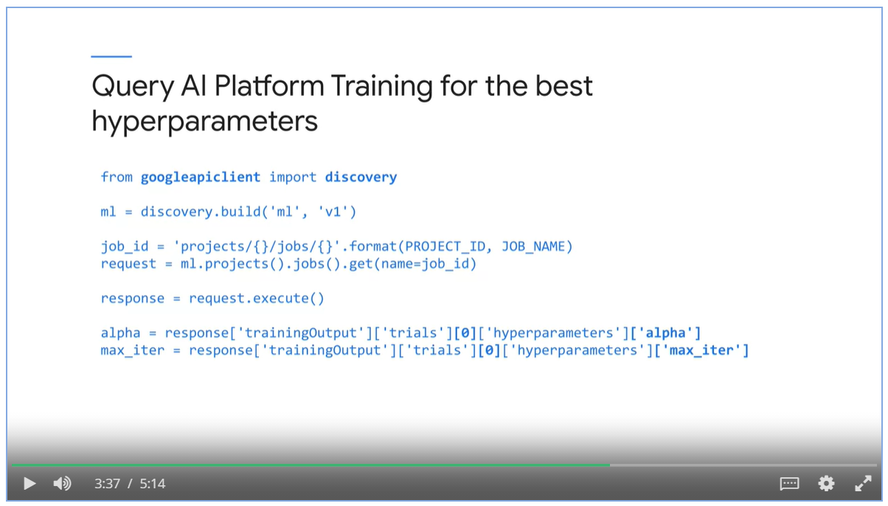

#### Retrain with the best hyperparameters and export

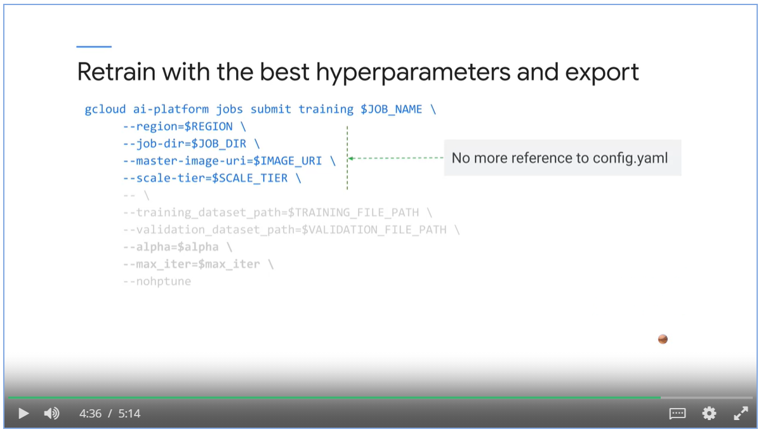

### Server and Query the Model

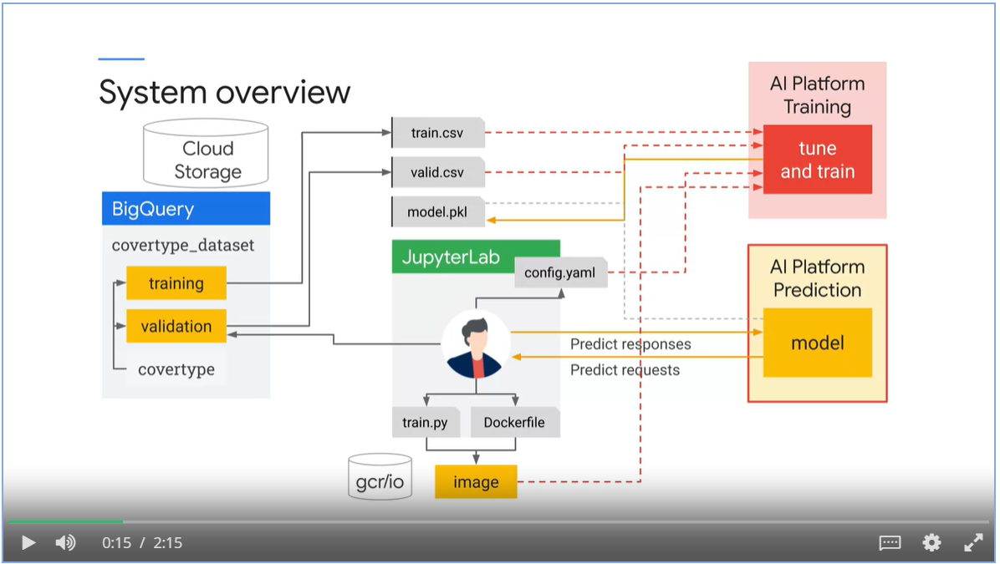

#### 3 steps to create a model

1. Create a model

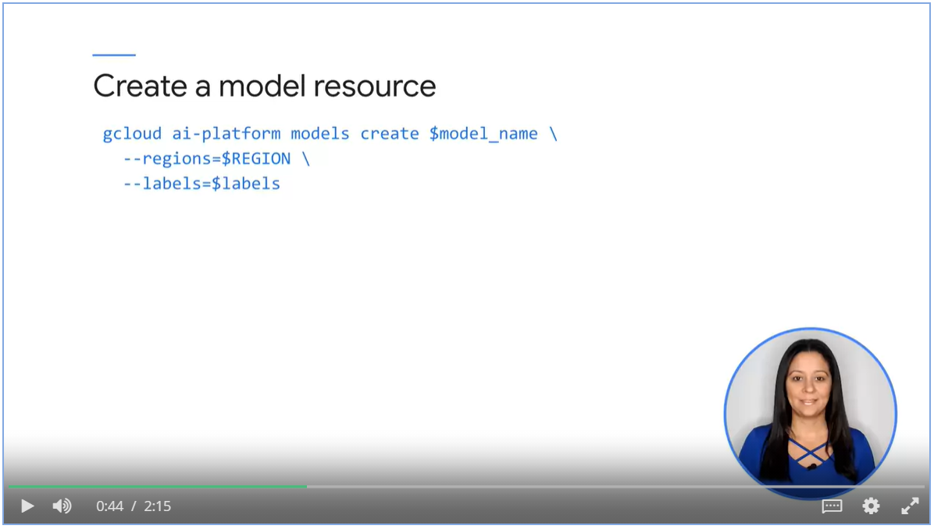

1. Create a version of the model

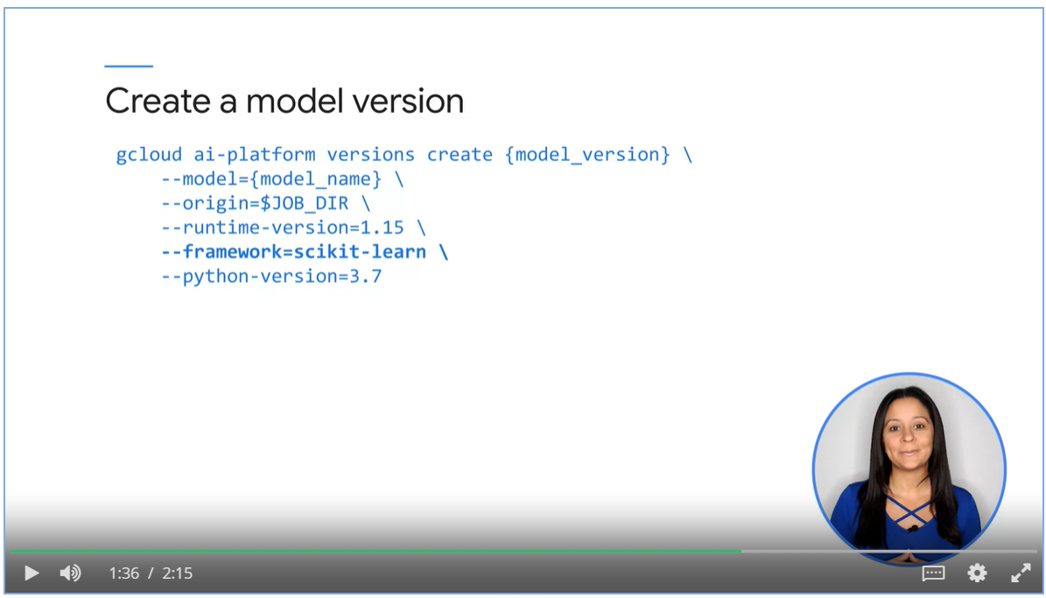

1. Query the model

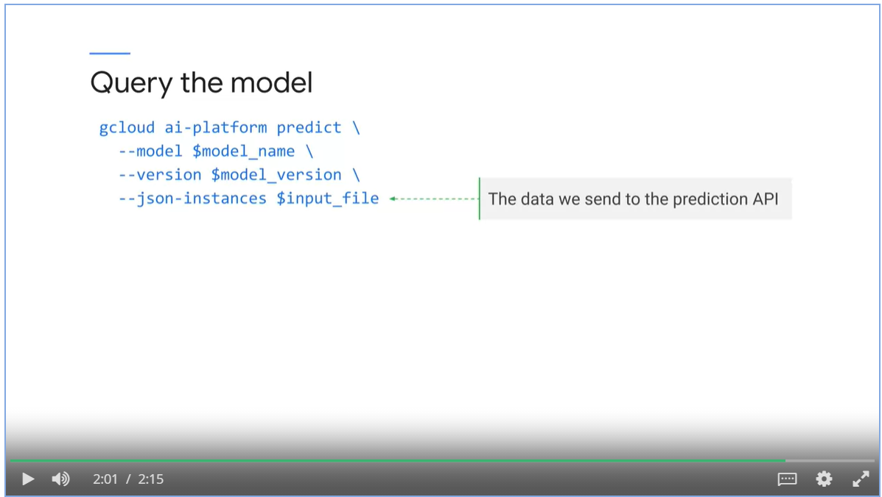

## Week 3: Kubeflow Pipelines on AI Platform

### Overview

* In previous modules, we looked at how to run a machine learning pipeline manually in AI Platform Notebook.
* With Kubeflow, we can automate various steps in the pipeline.

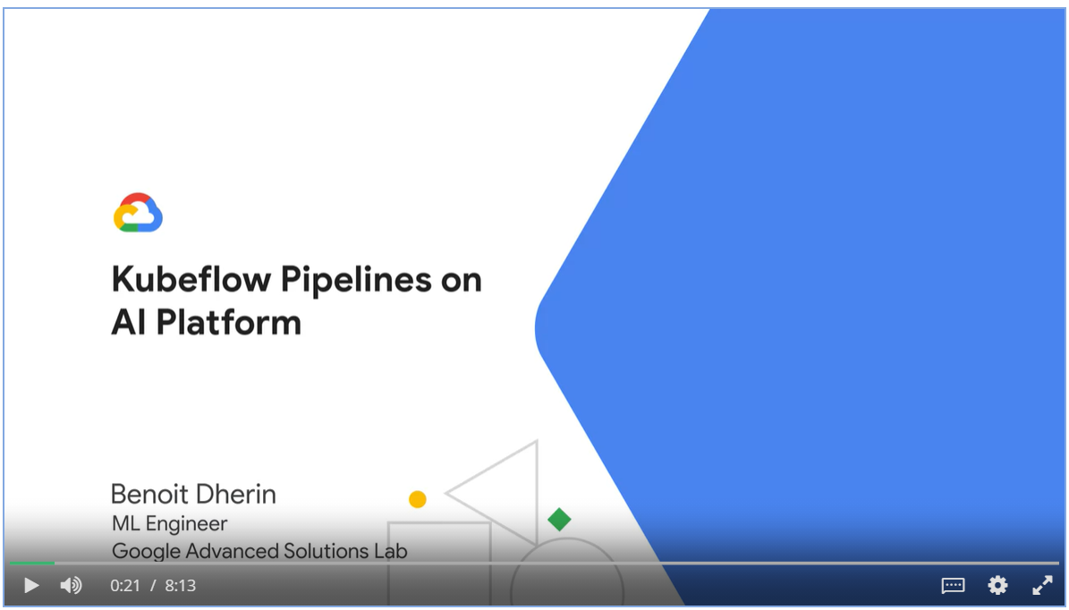

* A ML process is fairly standardized and can be expressed in a DAG:

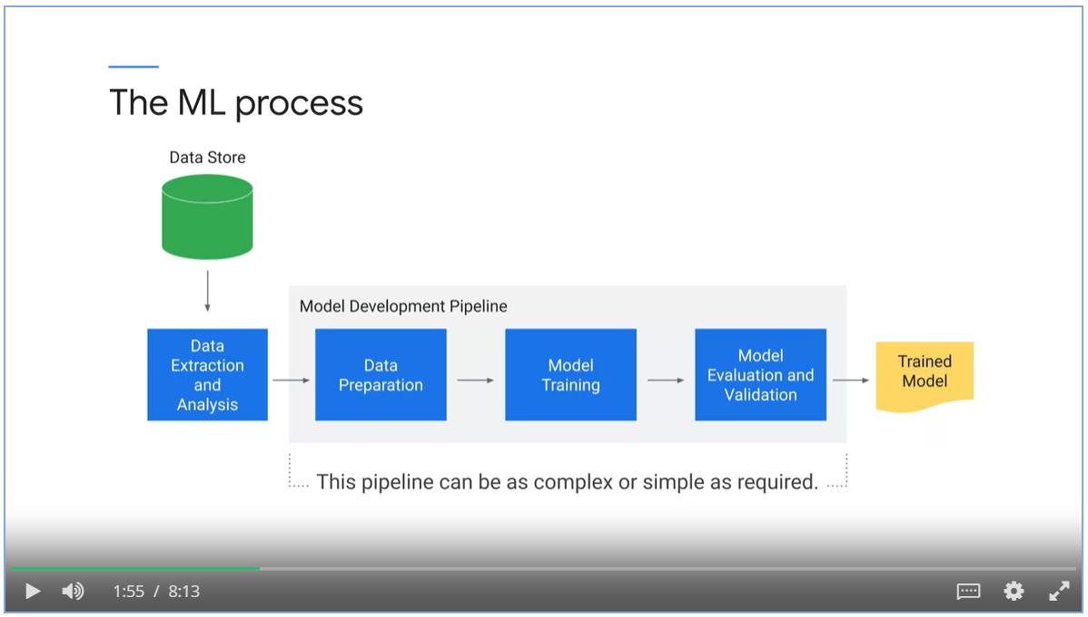

* The challenge of an ML pipeline is to keep track of different models, parameters and versions

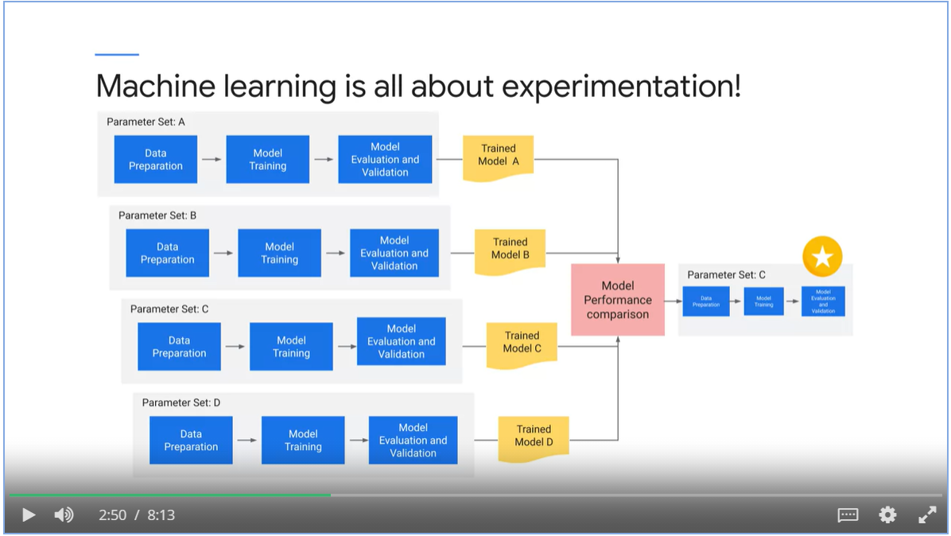

Build MLOps pipelines with Kubeflow

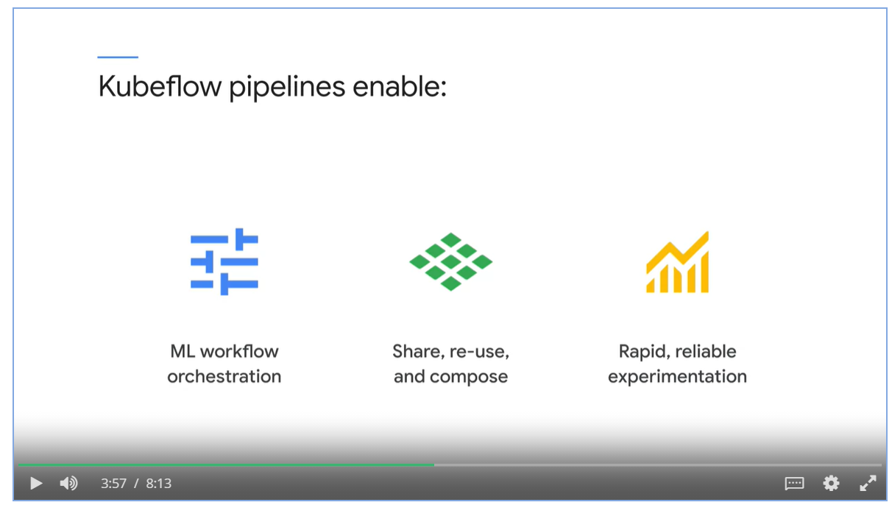

What constitutes a Kubeflow pipeline?

* Tasks are containerized and can invoke other services such as AI Platform, Dataflow or Dataproc
  + Containerized tasks are portable and scalable
* Specify sequences of steps via Python SDK
* Execute pipeline components via jobs.

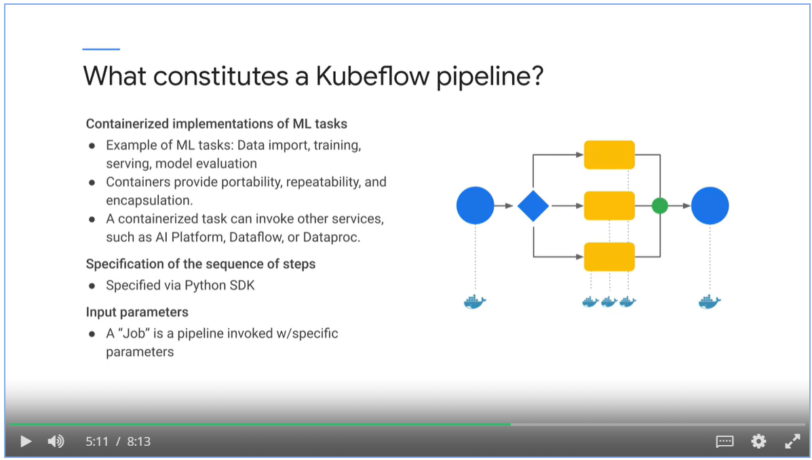

A Visual depiction of pipeline topology

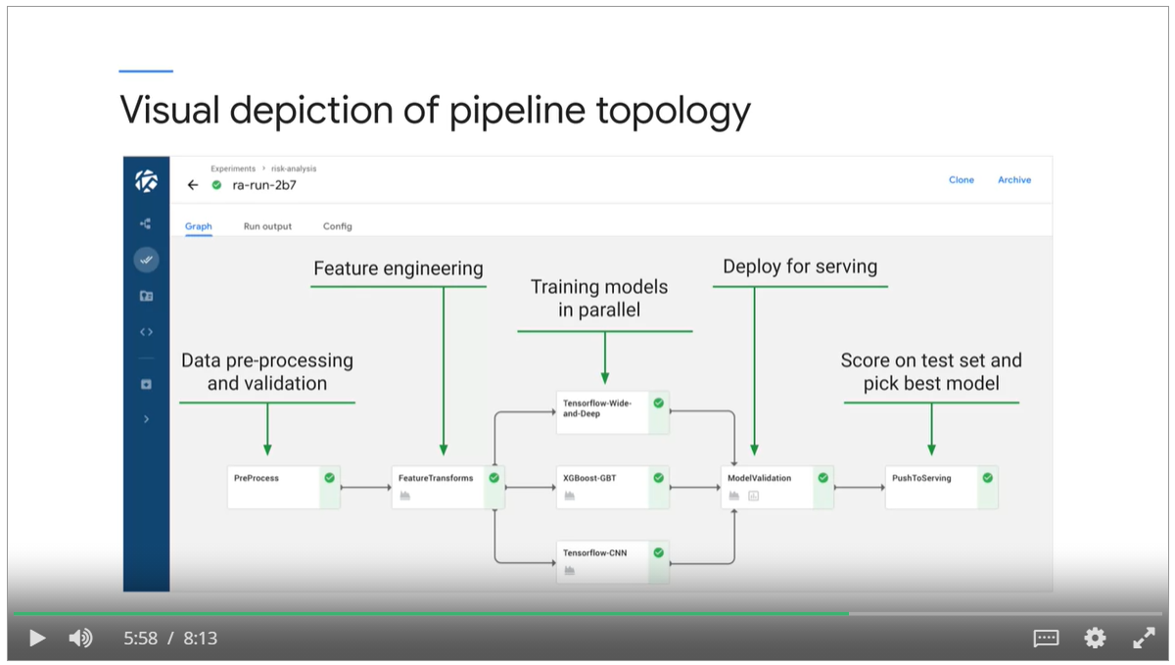

### Describe Kubeflow Pipeline with Python SDK

#### DSL

* Kubeflow offers a Domain Specific Language (DSL) in python to organize ML pipelines into DAG.

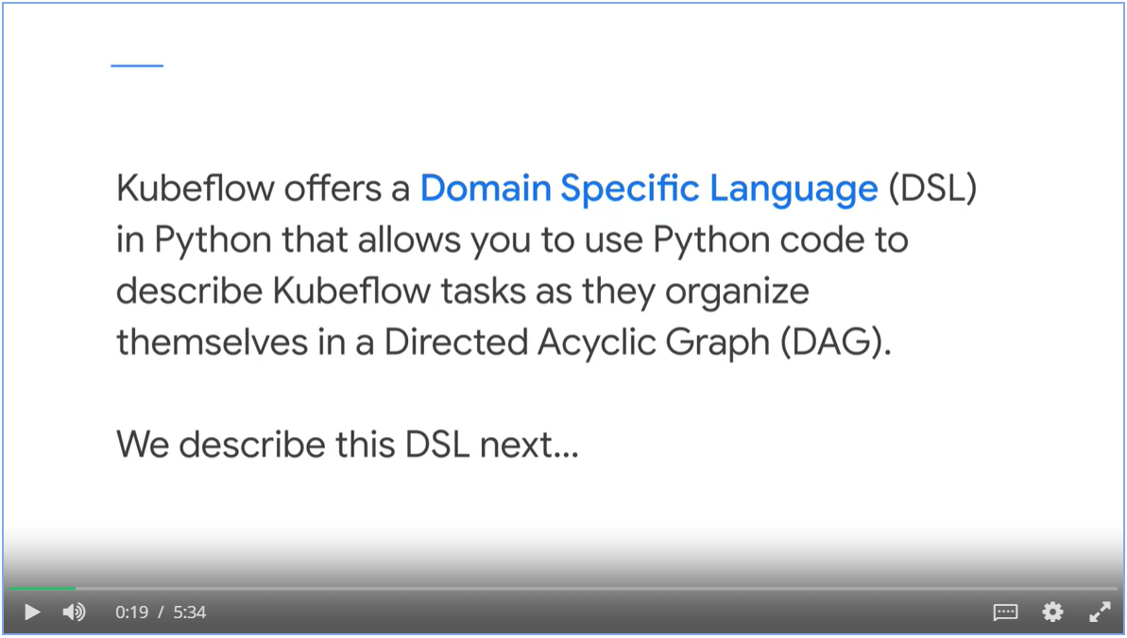

#### Decorator

* Decorate your python functions with @kfp.dsl.pipeline

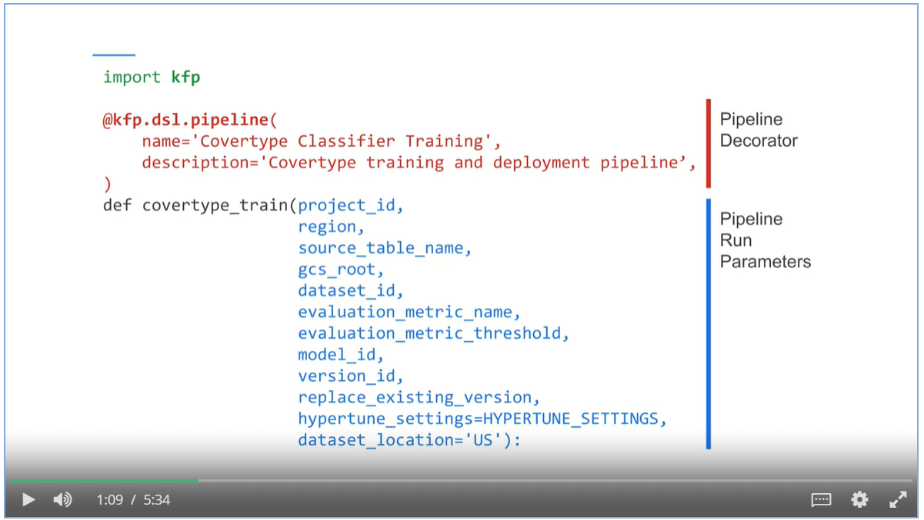

#### Input parameters

* Decorated function should have input parameters that match with those in the Kubeflow UI.

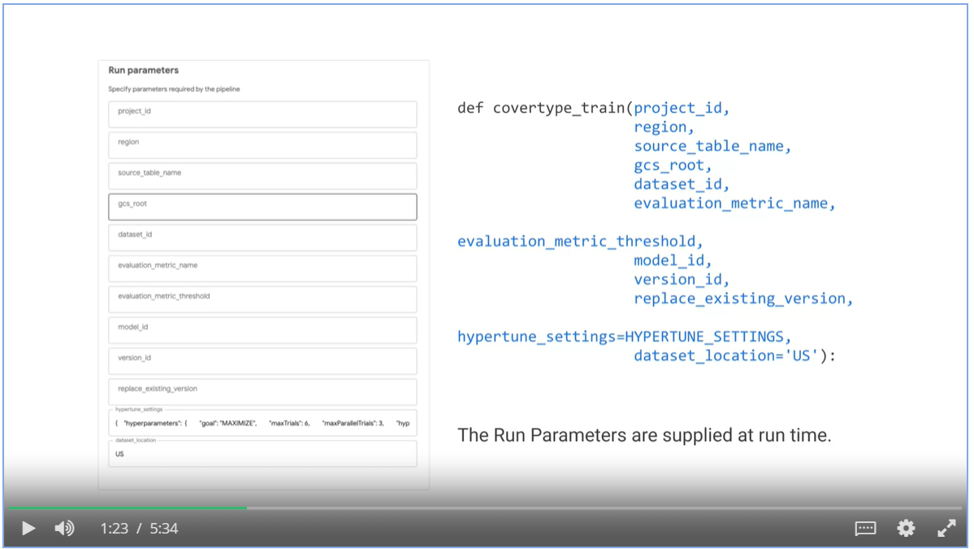

#### Build components and DAG within function body

* Within function body, we create the ops and compose them into DAG.

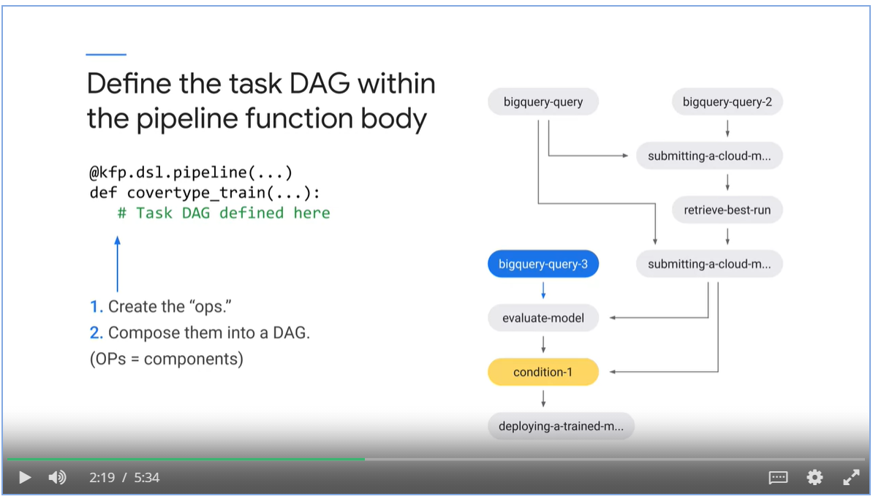

#### Three types of Kubeflow components

* Pre-built components – load and run
* Lightweight Python components - implement your logic but don’t care about containerization
* Custom components
  + Implement code
  + Package into Docker container
  + Write component description

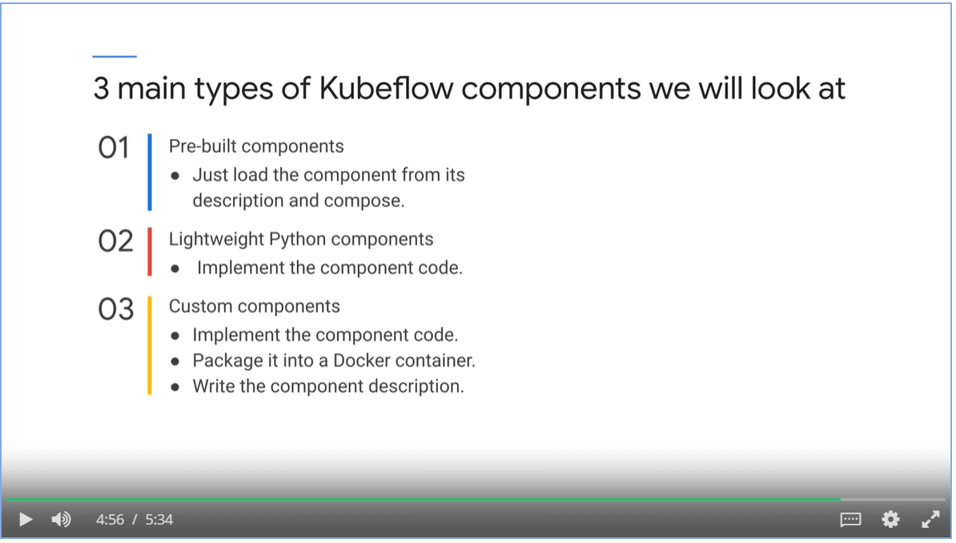

### Kubeflow Components

#### Pre-built Components

* Load pre-built components with an uri to the github

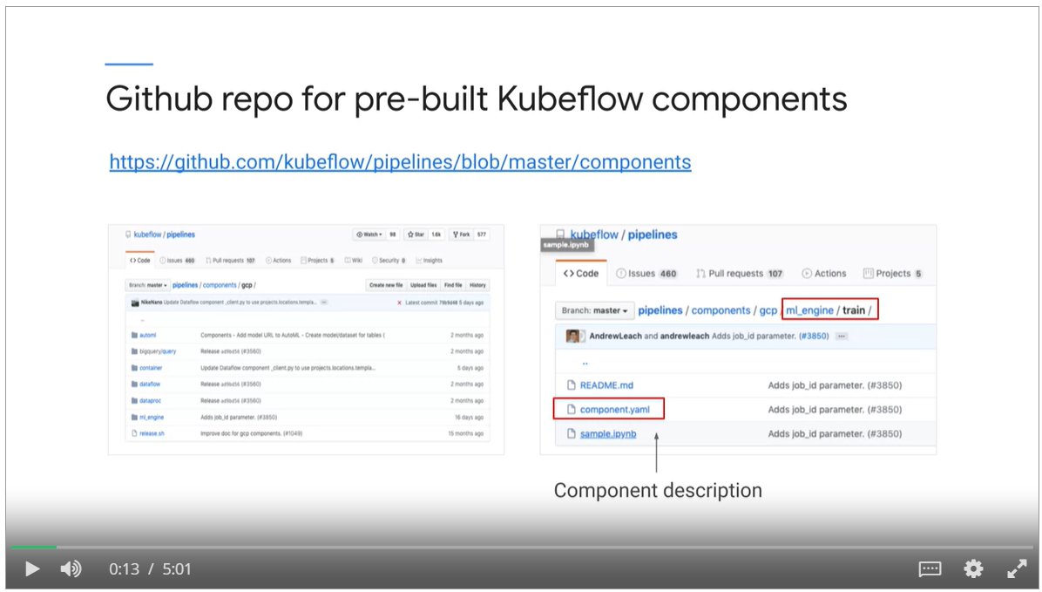

* Code to load pre-built components

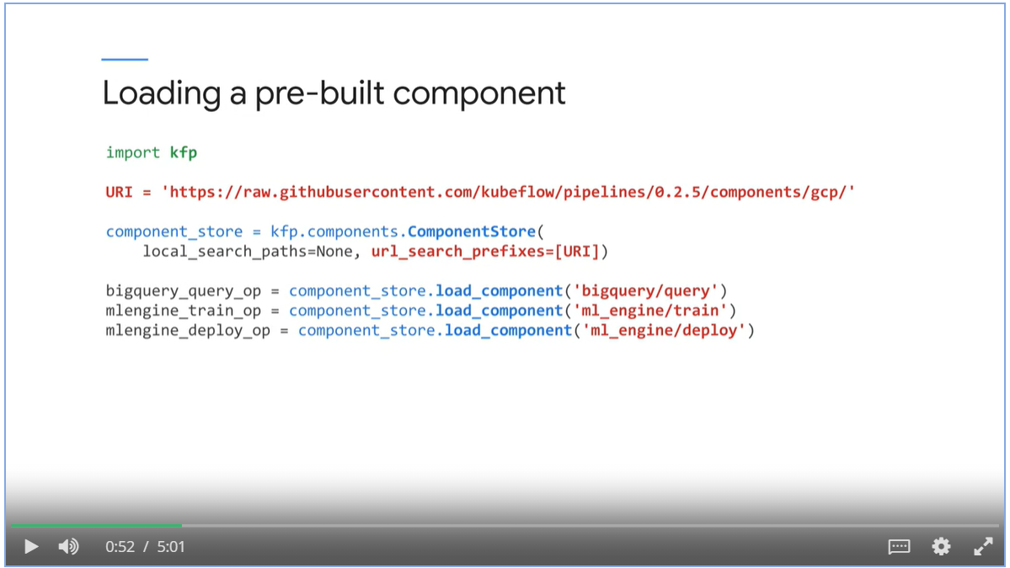

* Supply parameters to pre-built bigquery_query_op() component

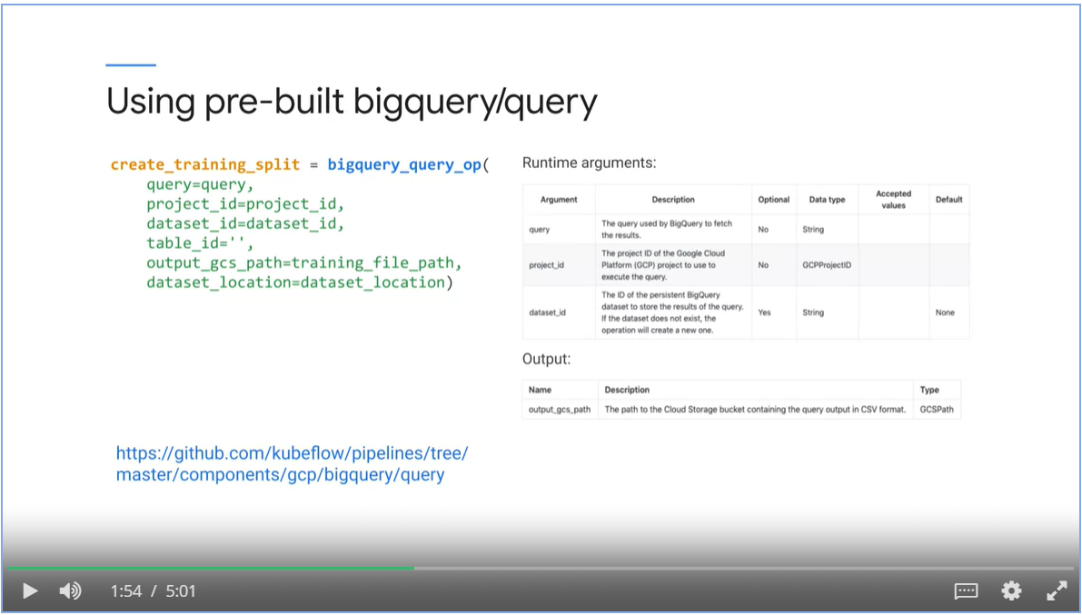

* Use pre-built ml_engine/train component

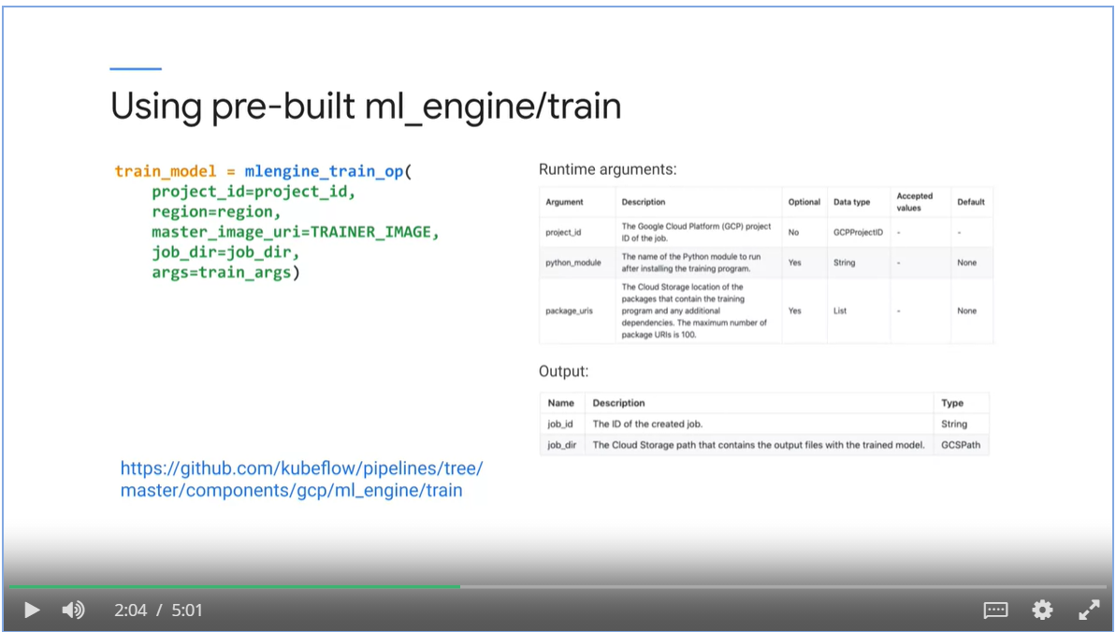

* Use pre-built training component and supply hyperparemeters in python dictionary

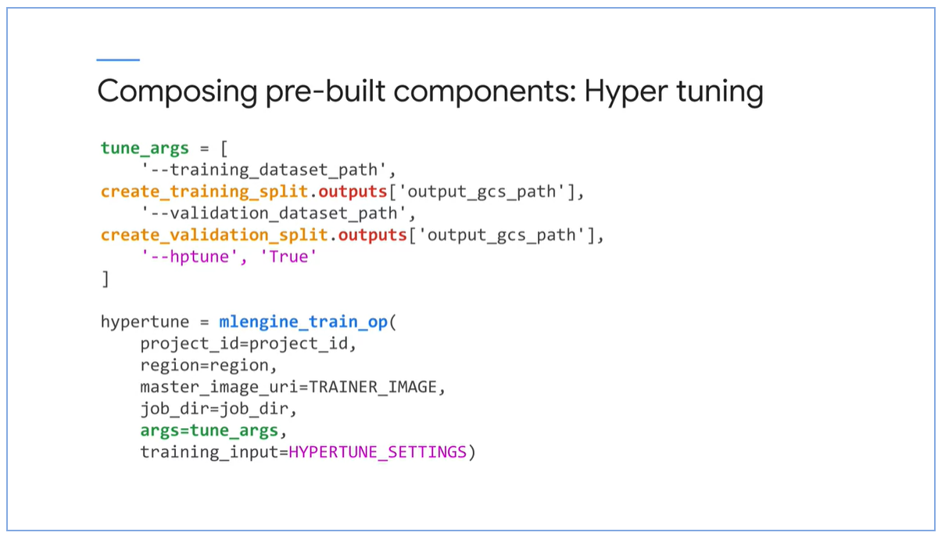

* Perform final training with hyper-tune turned off and the final model saved in a destination

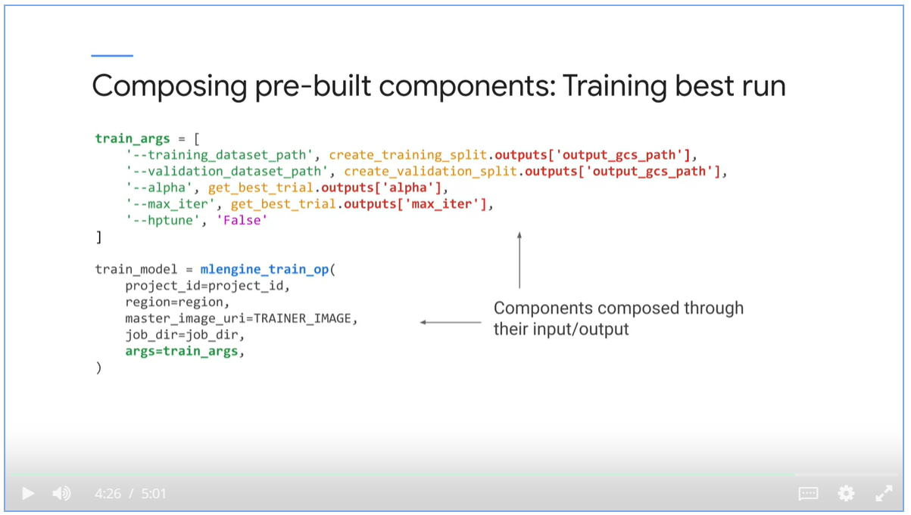

#### Lightweight Python Components

* Create custom python functions

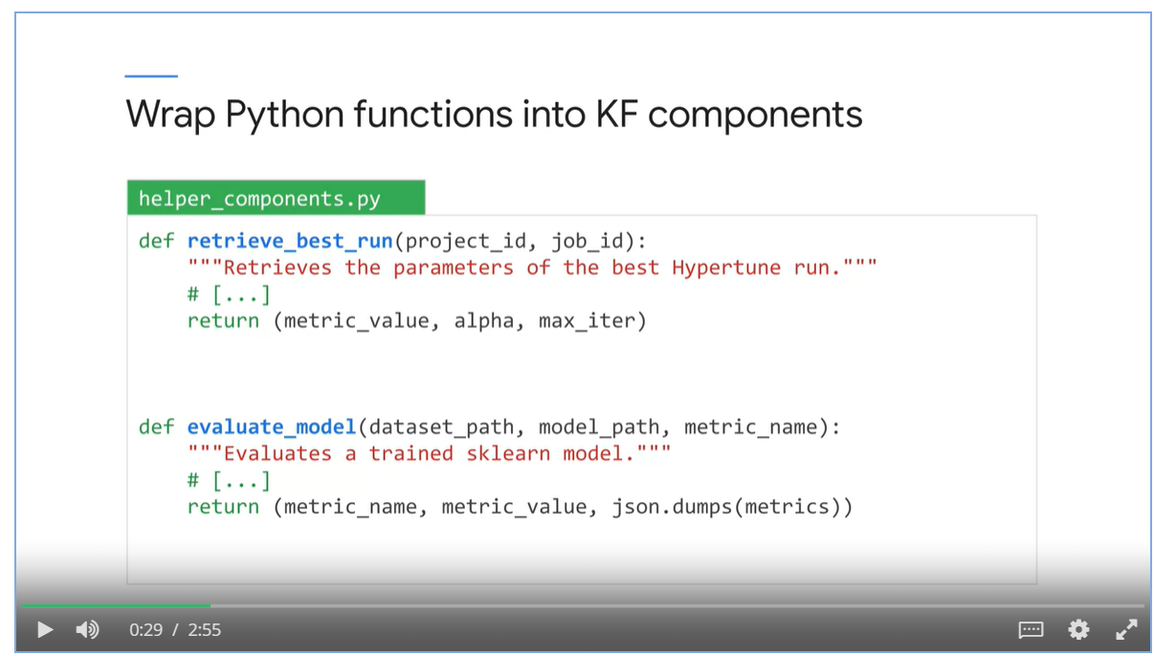

* Wrap custom functions into container_operation

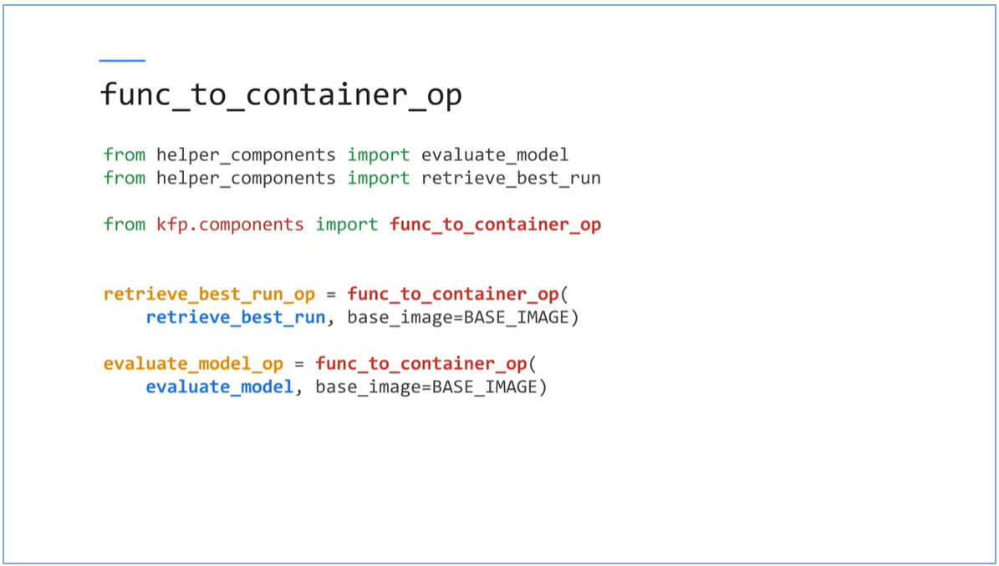

* Invoke custome_container_ops

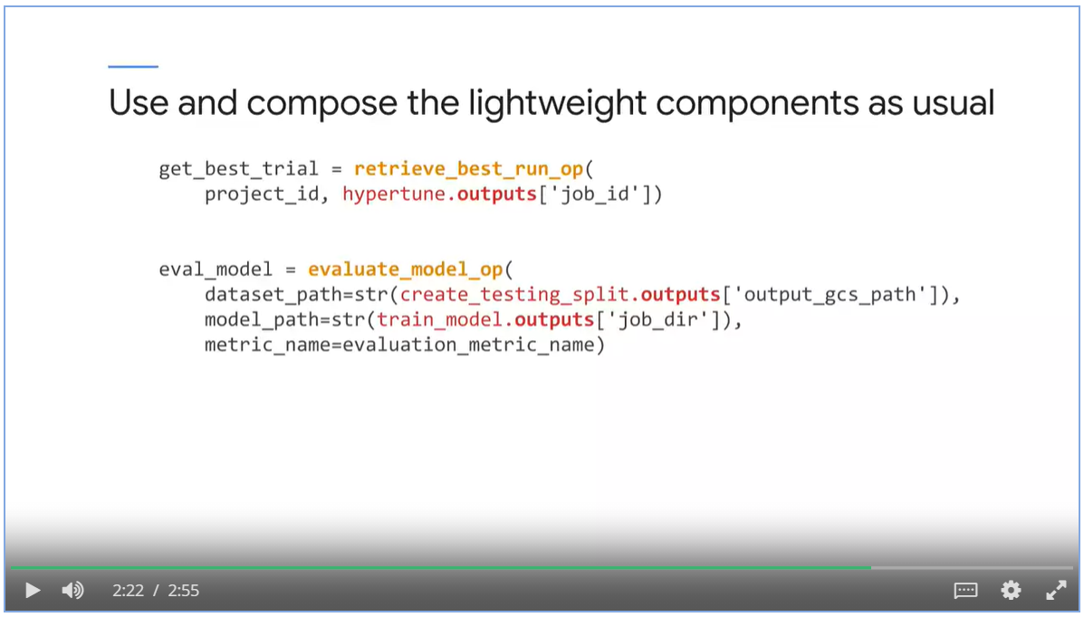

#### Custom Components

Steps of building custom component

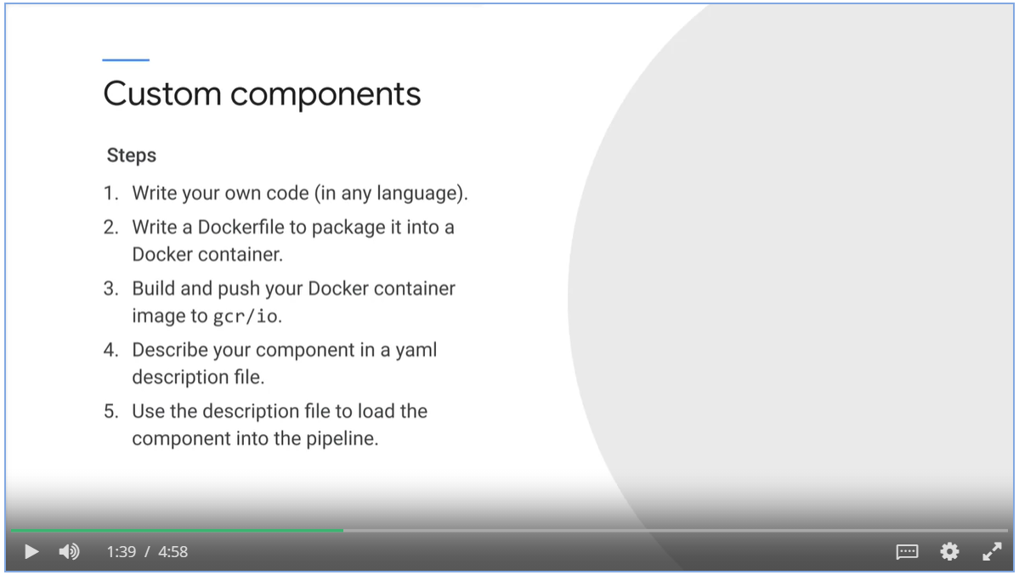

### Compile, Upload and Run

1. Build and push the trainer container

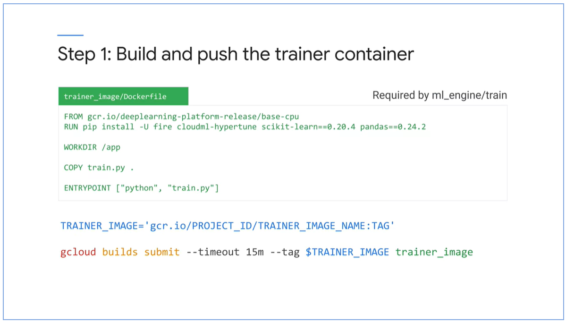

1. Build and push base containers required by python light weight ops

Here the base containers are fire, scikit-learn, pandas and kfp

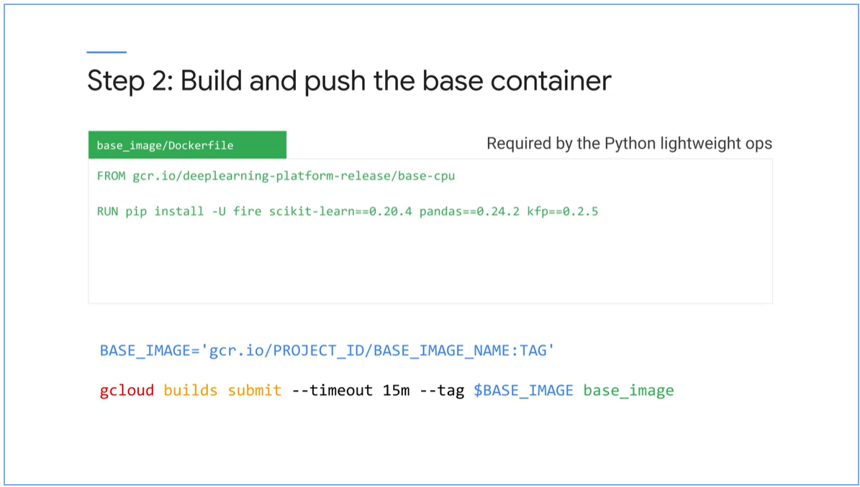

1. Compile the Kubeflow Pipeline into a yaml

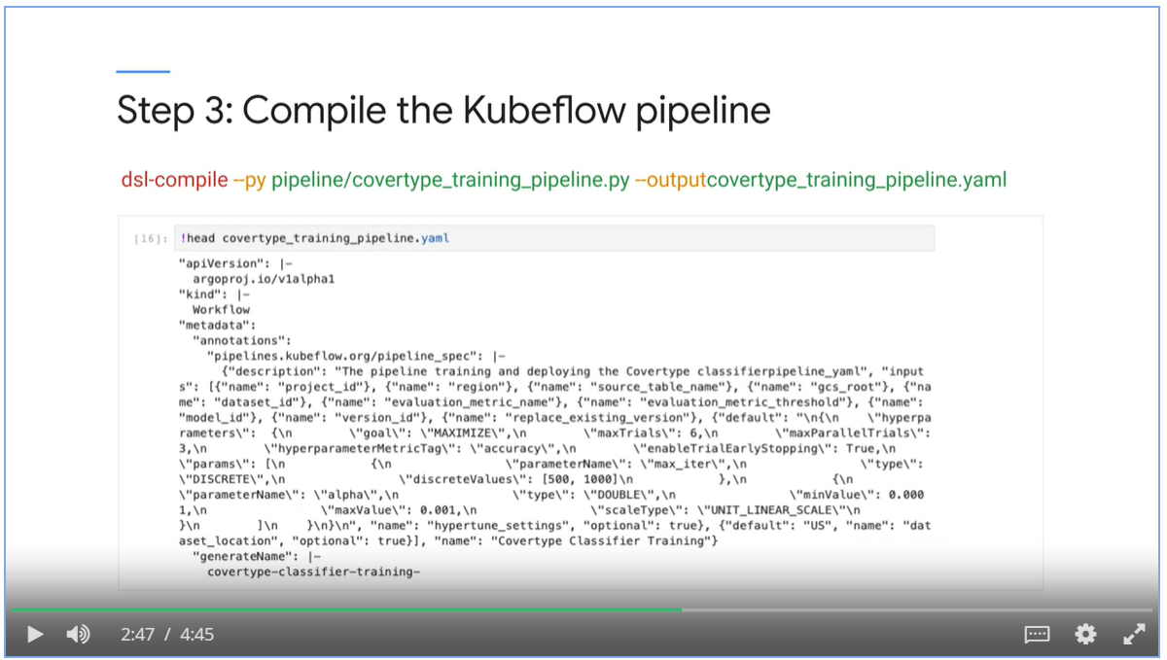

1. Upload the pipeline to the KF cluster

Use the kfp command, describe it with a pipeline name and and yaml file.

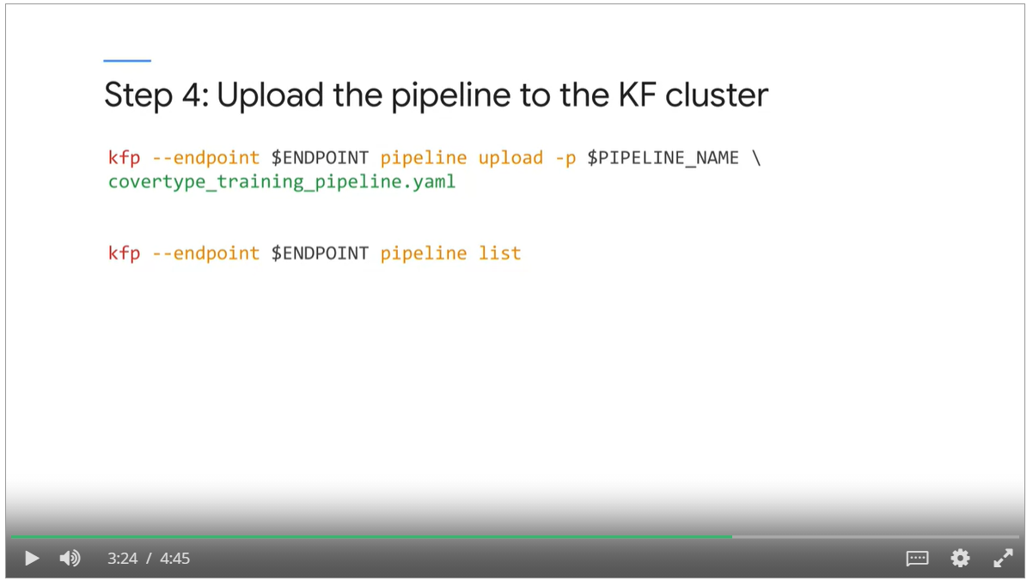

1. Run the pipeline command

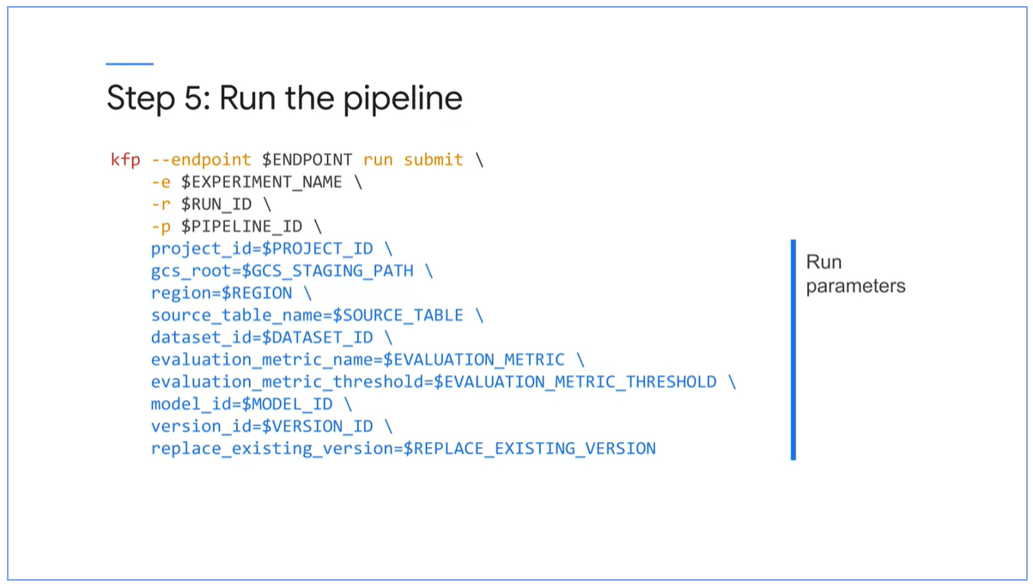

## Week 3: CI/CD using Kubeflow

### Concept Overview

* We experiment fast with our models, when we are ready, we push the new code to our GitHub repo.
* All assets are rebuilt and available in production automatically.

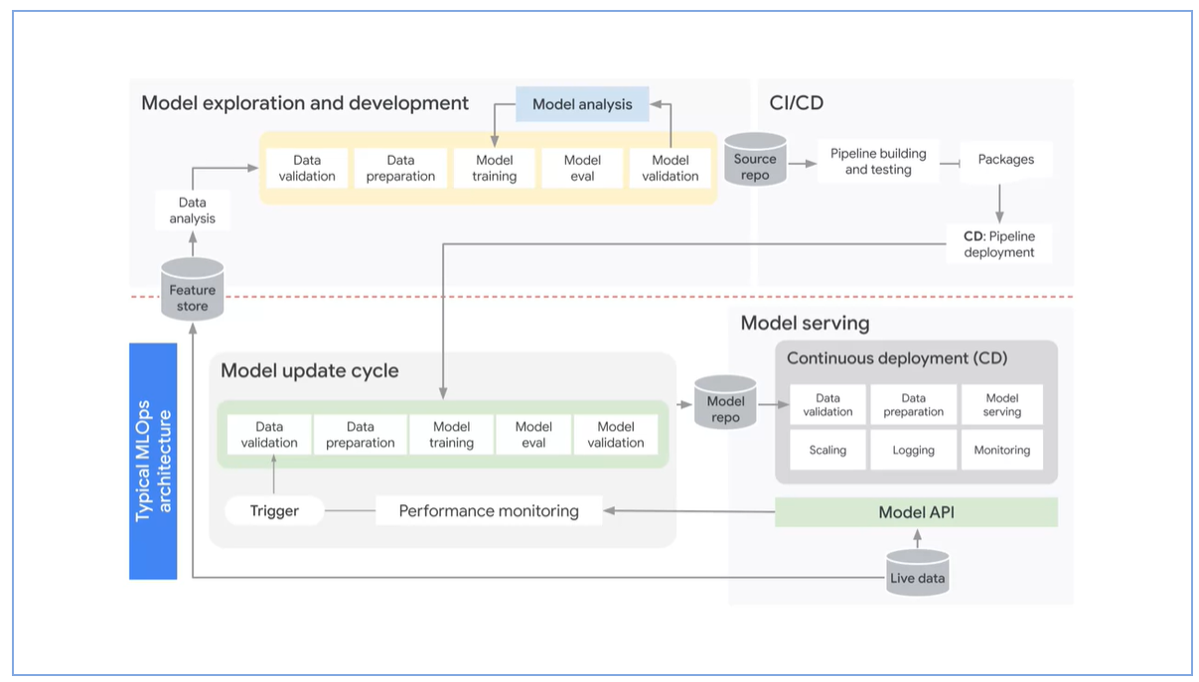

* Every container is a self-contained directory in repo
* When files in a directory changes, we want to rebuild the image and pushed to the container registry automatically.

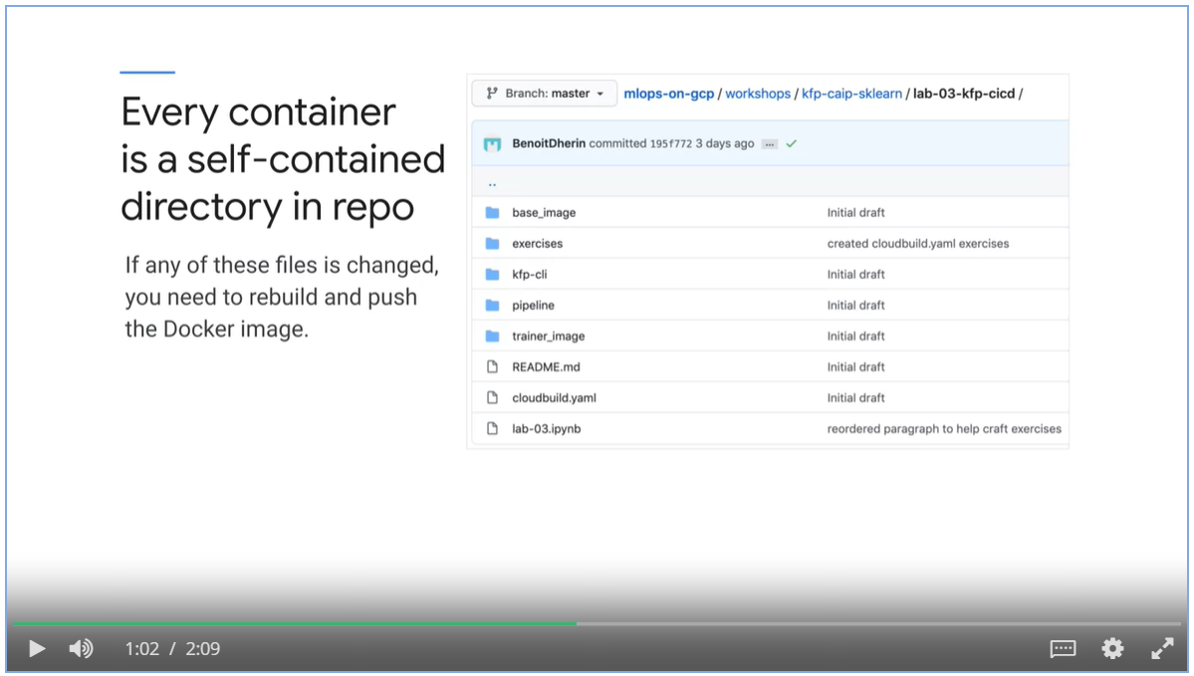

* Connect the GitHub repository to your Google Cloud account
* Trigger a Cloud Build from GitHub trigger.

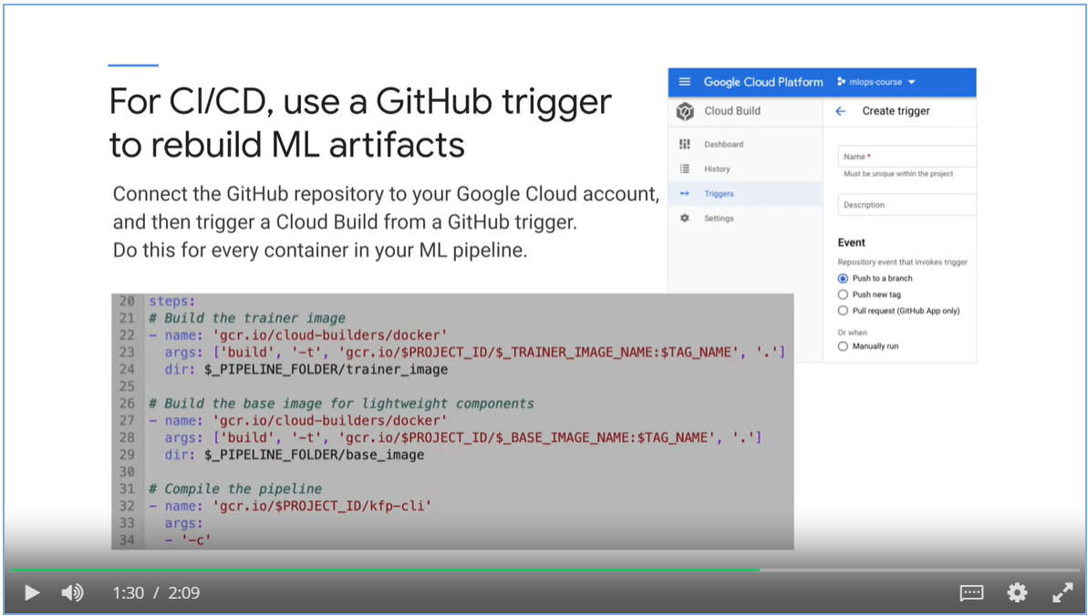

Where we are

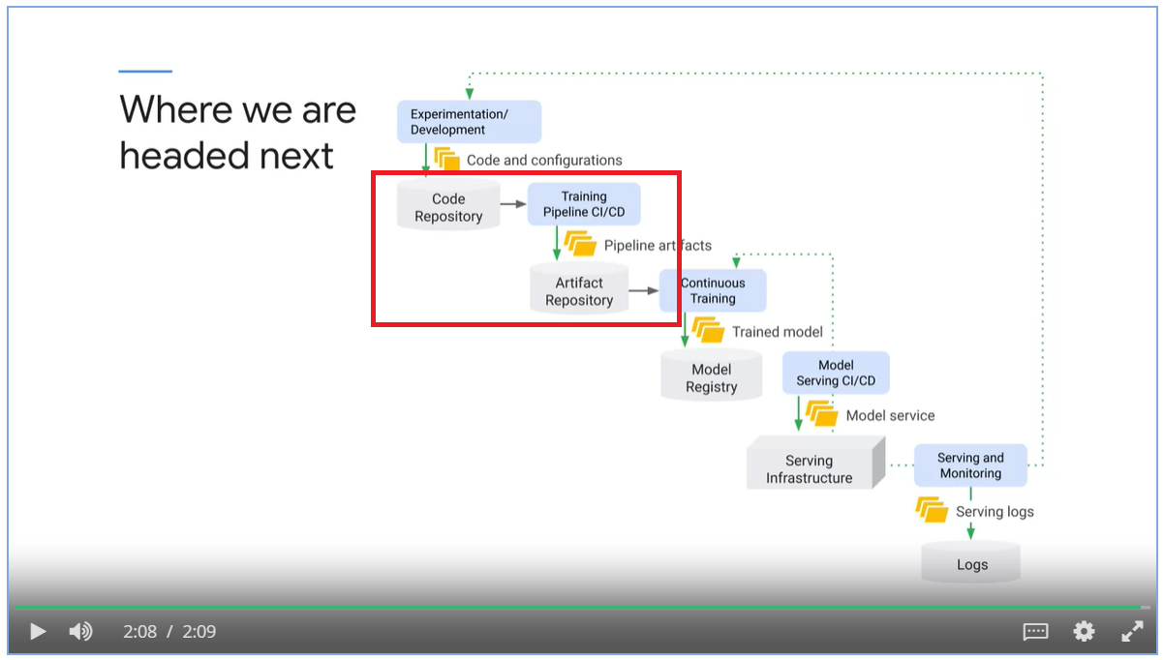

### Cloud Build Builders

What are cloud builders:

* They are Cloud configuration/provisioning actions that are packaged as Docker containers.

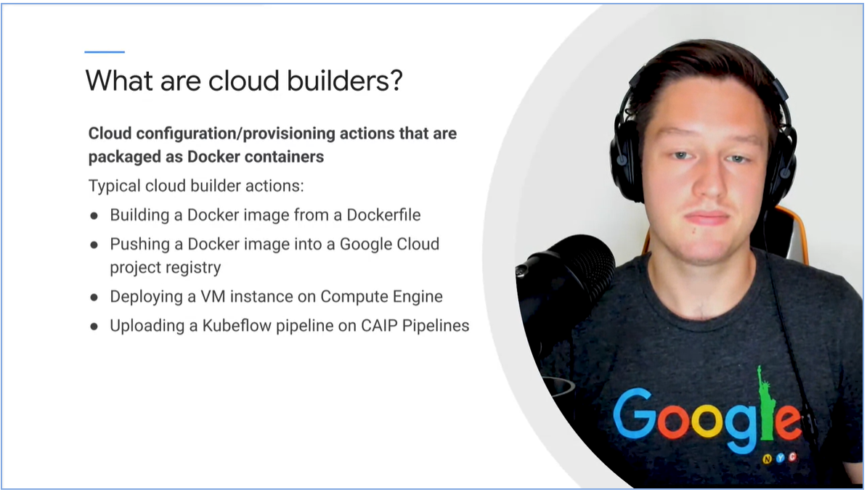

Standard vs custom cloud builders

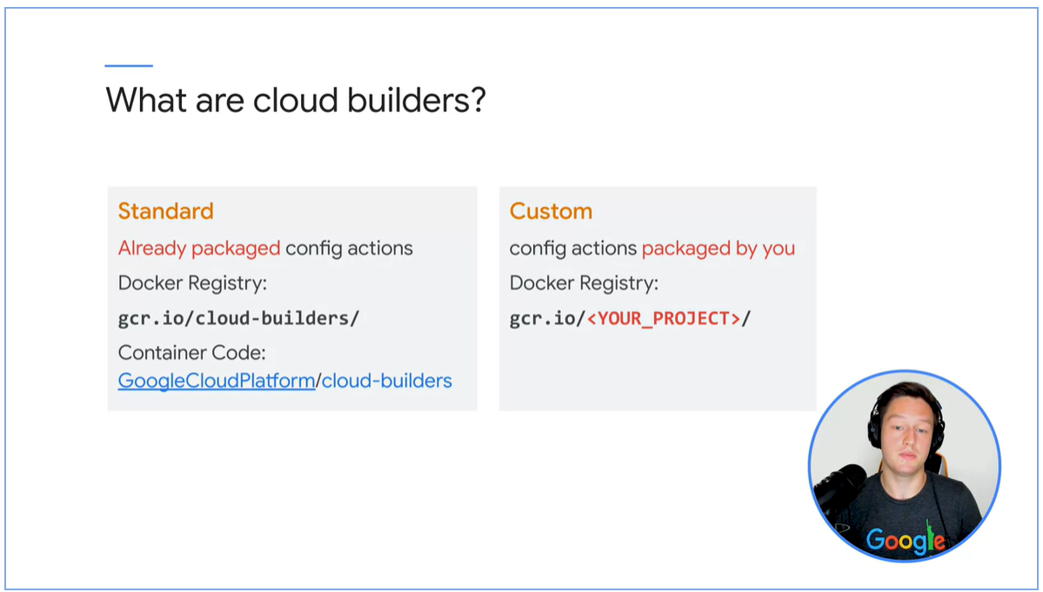

### Cloud Build Configuration

* Cloud Build Configuration tells Cloud Builder which containers to run
* Supply with arguments

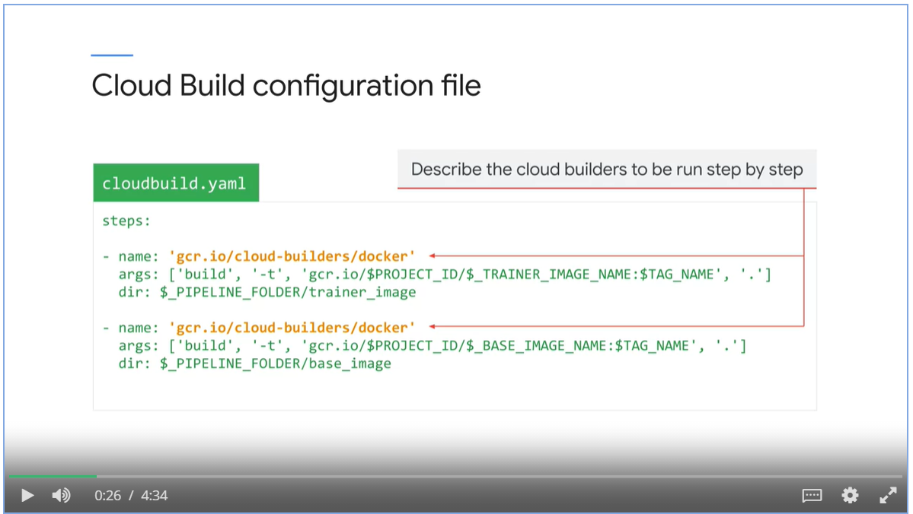

Running Cloud Build

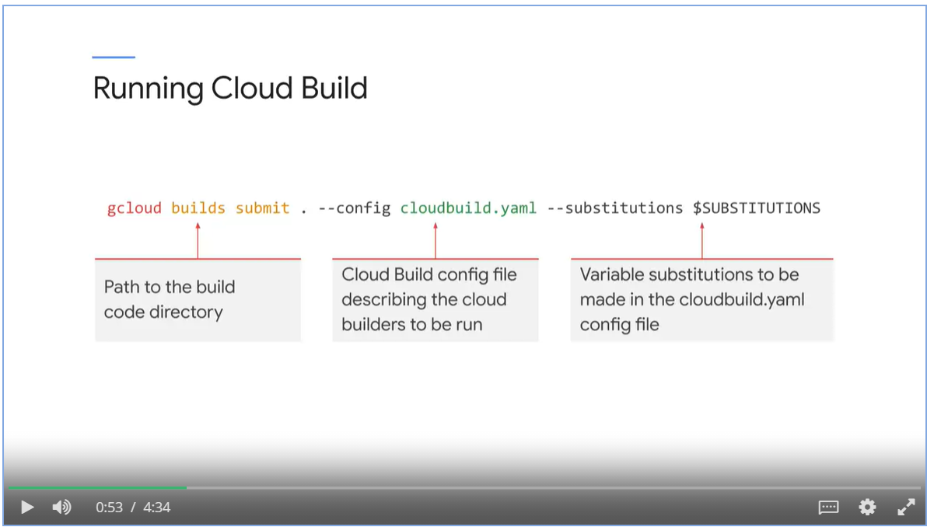

Share resources between steps using the **dir** argument

* Default to /workspace/<path>
* Will still be shared between steps if the path is relative.

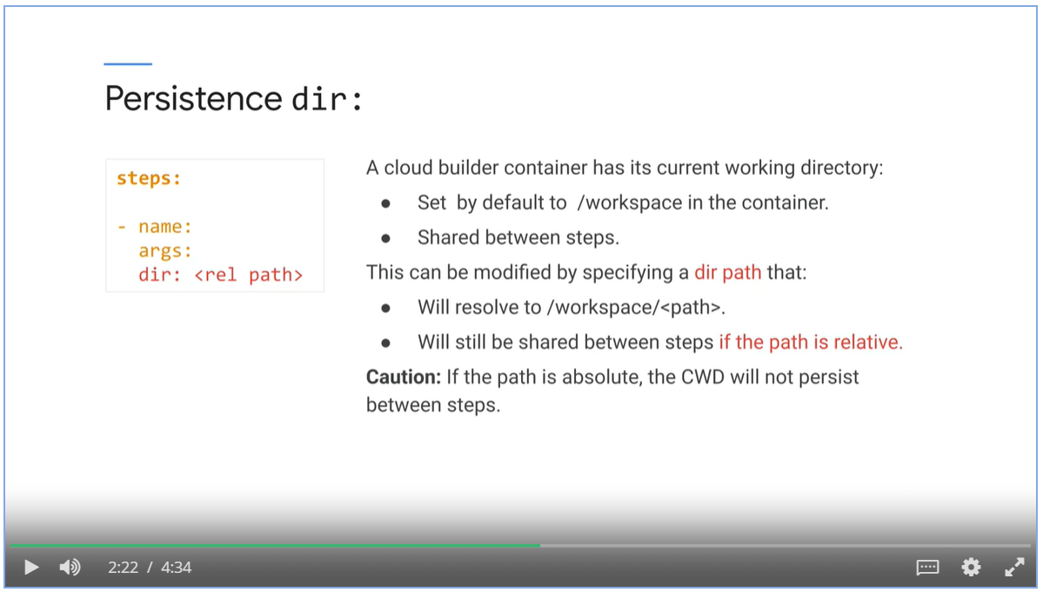

Before running build, substitute with variables

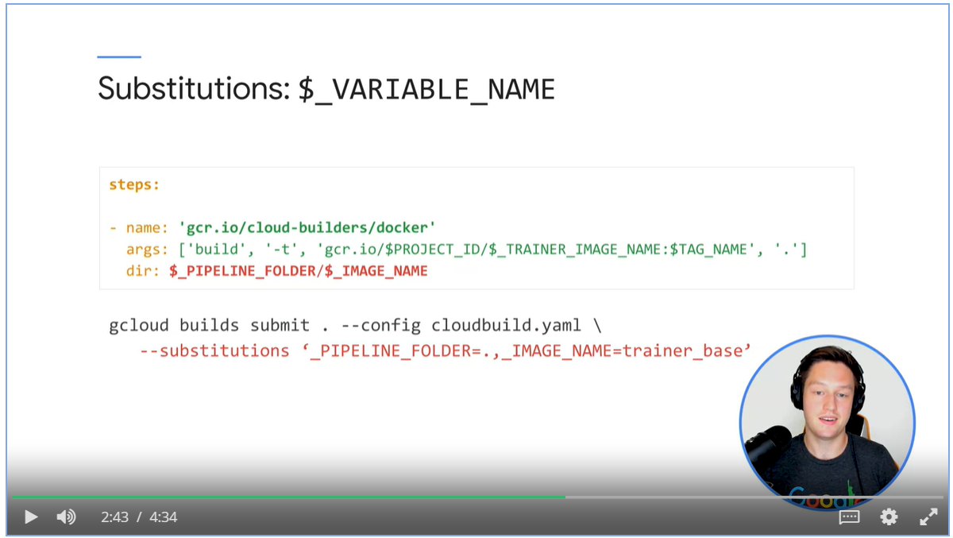

Passing environment variables

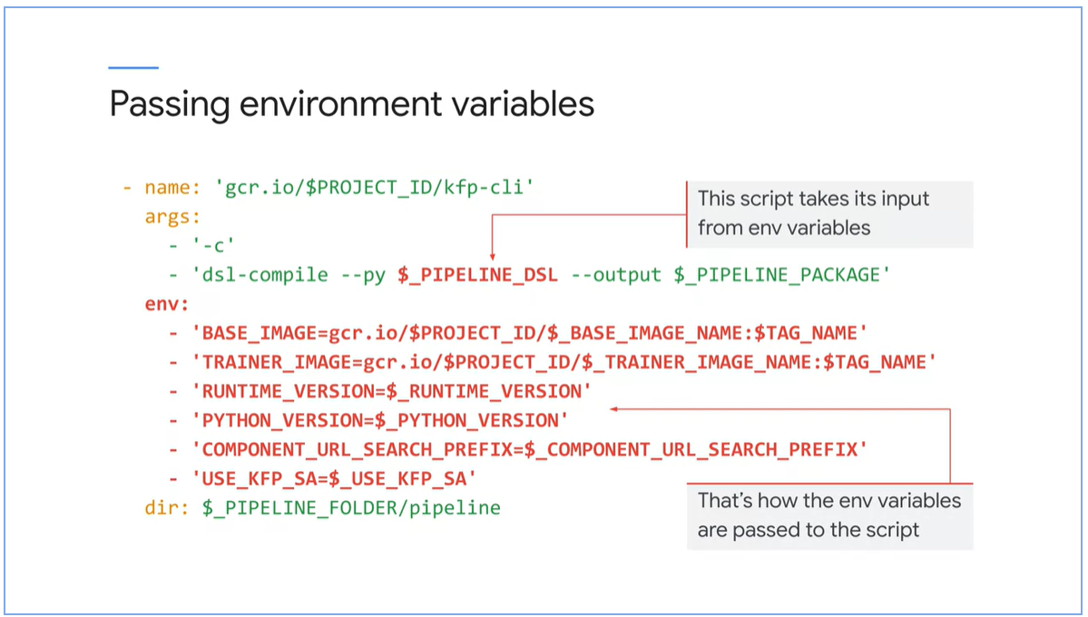

* Build image locally on build node
* Push the image to the registry

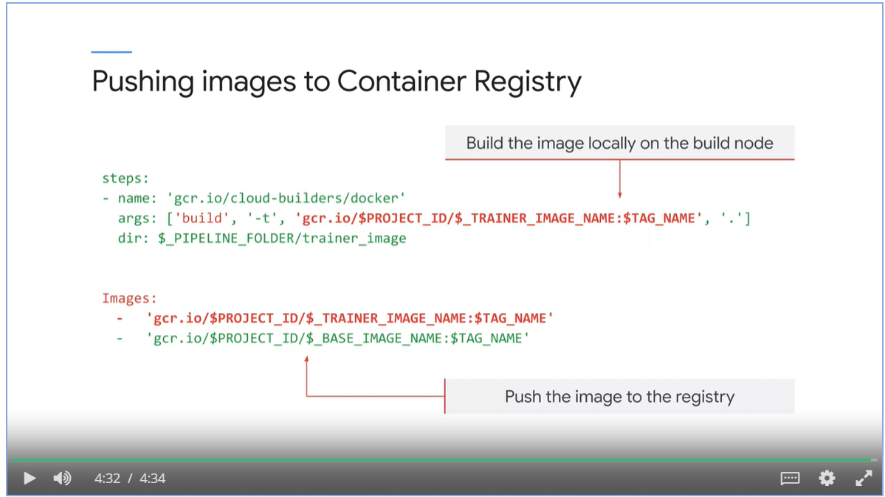

### Cloud Build Triggers

1. Link GitHub repo to Google Cloud Project

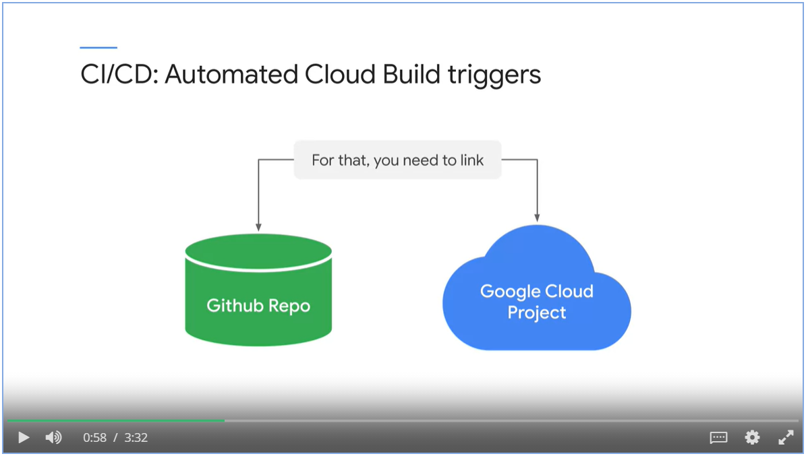

1. Setup a trigger

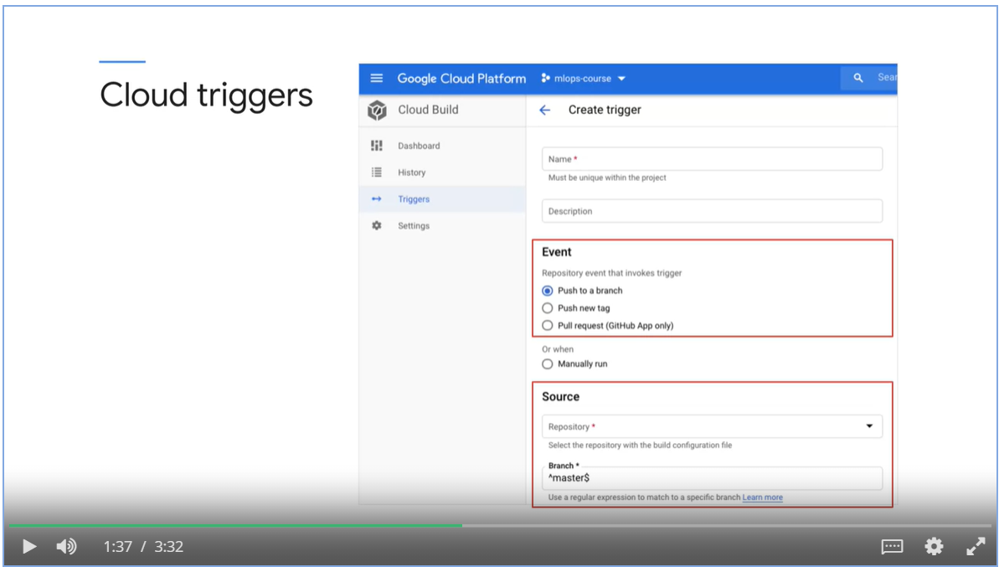

Example:

A Google Cloud build is triggered when a new tag is pushed to github repository

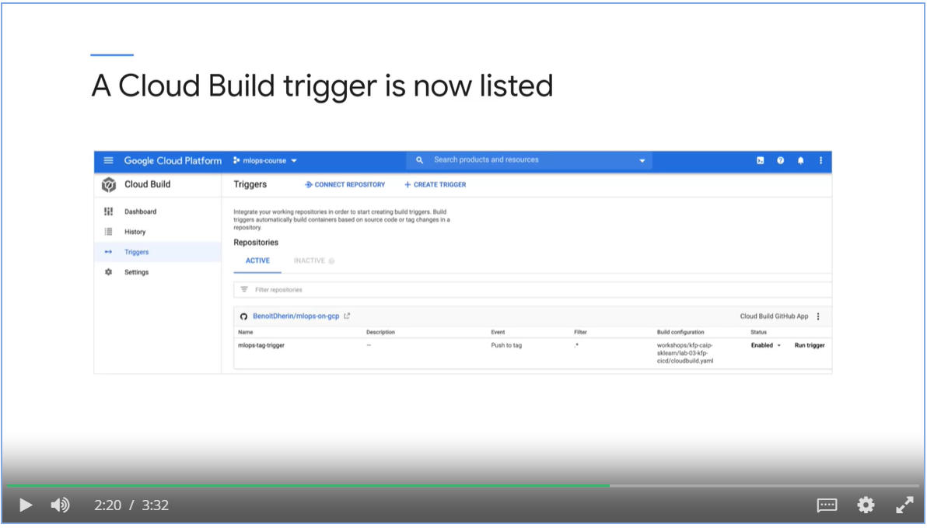

After the build, new artifacts are automatically pushed to the registry.

